** **

**Final Year Project**

**CENTRALIZED SCHEDULING SYSTEM FOR LAB BOOKING AND LECTURER’S CONSULTATION HOUR**

**By**

**MD EASIR ARAFAT**

**TP039768**

**UC3F1805 SE**

A project submitted in partial fulfillment of the requirements of Asia Pacific University of Technology and Innovation for the degree of

**BSc (Hons) in Software Engineering**

Supervised by DR. SUMAIRA MUHAMMAD HAYAT KHAN

2nd Marker: MRS. HEMALATA VASUDAVAN

16th January-2019

# Acknowledgement

Firstly, I would like to thanks **Dr Sumaira Muhammad Hayat Khan** who supervising me for my final year project, and she has given me all the support and guidance to write and develop my FYP project and documentation throughout last few months. I would also like to thank my 2nd Marker Mrs. Hemalata Vasudavan. They supported me in every task I was responsible to accomplish within a given time frame. Their Support and motivation kept me finishing my tasks on time. It was indeed a greater opportunity for me to Learn & polish up my skills in software engineering through last few months. I would also like to express appreciation to Mr. Dhason Padmakumar, who always helped me to maintain the progress in track and submit it on time.

At last, but not least I would like to thanks ‘**Asia Pacific University of Technology & Innovation’** for giving me the opportunity to achieve this. I would like to thank especially to my beloved parents who inspiring me every now and then to go forward and achieve something very best.

# Abstract

The main purpose of this project is to develop an android application “MScheduling” for centralized scheduling system to provide convenience in scheduling lecture time-table, available computer lab booking, lecturer’s consultation hour booking. This application would be helping students in an easier way to book the consolation hour with the lecturers. Moreover, it will also help lecturers to reduce time to set their available consultation hour and available IT lab booking.

Table of Contents

Acknowledgement 1

Abstract 2

CHAPTER 1: INTODUCTION TO THE STUDY 11

1.1 Background to the project 11

1.2 Problem context 12

1.3 Rationale 13

1.4 Potential benefits 14

1.4.1 Tangible benefits 14

1.4.1 Intangible benefits 14

1.5 Target User 15

1.6 Scope and objectives 15

1.6.1 Aims 15

1.6.2 Objectives 15

1.6.3 Deliverables 16

1.6.4 Nature of Challenges 17

1.7 Overview of this Investigation report 18

1.8 Project Plan 19

CHAPTER 2: LITERATURE REVIEW 20

2.1: Introduction 20

2.2: Domain research 21

2.3: Similar System/s 26

2.4: Summary 32

CHAPTER 3: TECHNICAL RESEARCH 33

3.1: Programming language chosen 33

3.2: IDE (Interactive Development Environment) chosen 37

3.3: Database Management System chosen 39

3.4: Operating System Chosen 41

3.5: Summary 44

CHAPTER 4: SYSTEM DEVELOPMENT METHEDOLOGY 45

4.1 System Development Methodology chosen 45

4.2 Justification 47

4.3 Description of system development methodology chosen 48

CHAPTER 5: RESEARCH METHODS 54

5.1: Introduction 54

5.2 Design 55

5.2.1 Questionnaire 58

5.3 Summary 64

CHAPTER 6: REQUIREMENTS VALIDATION 65

6.1 Analysis of Data 65

6.2 Analysis of data collected through interview 80

6.2 Summary 82

CHAPTER 7: SYSTEM ARCHITECHTURE 83

7.1 Introduction 83

7.2 Abstract Architecture 83

7.2.1 System Design 83

7.2.2 Database Design 104

7.2.3 Interface Design 109

CHAPTER 8: PROJECT PLAN 117

8.1 Features for “MScheduling” Application 117

8.2 Release Plan for “MScheduling” Application 119

8.3 Test Plan 119

8.3.1 Test Plan for Unit Testing 119

8.3.2 Test Plan for Integration Testing 129

8.3.3 Test Plan for User Acceptance Testing 132

CHAPTER 9: IMPLEMENTATION 134

9.1 Screenshots 134

9.1.1 Screenshots for Register Activity 134

9.1.2 Screenshots for Login Activity 135

9.1.3 Screenshots for Main Menu Activity (Admin) 136

9.1.4 Screenshots for Main Menu Activity (Student) 137

9.1.5 Screenshots for Main Menu Activity (Lecturer) 138

9.1.6 Screenshots for Add New Lab 139

9.1.7 Screenshots for Labs list Activity 140

9.1.8 Screenshots for Book lab Activity 141

9.1.9 Screenshots for LecTimetable Activity 142

9.1.10 Screenshots for LecProfile Activity 143

9.1.11 Screenshots for LabBookDetails Activity 144

9.1.12 Screenshots for Consultation List 145

9.1.13 Screenshots for Consultation details 146

9.1.14 Screenshots for Consultation Booking 147

9.1.15 Screenshots for Lecturer List 148

9.1.16 Screenshots for Lecturer Profile details(student) 149

9.1.17 Screenshots for Lecturer chat list (student) 150

9.1.18 Screenshots for Lecturer and student chat (student) 151

9.2 Sample Codes 152

9.2.1 Register and Login 152

9.2.2 Add New Lab 156

9.2.3 Book Lab 157

9.2.4 Lecturer Timetable 158

9.2.5 Consultation Booking 160

9.2.6 Lecturer List for students 161

CHAPTER 10: SYSTEM VALIDATION 163

10.1 Unit Testing 163

10.1.1 Sign Up 163

10.1.2 Login (Students/Lecturers) 164

10.1.2 Login(Admin) 165

10.1.3 Add New Lab(Admin) 166

10.1.4 Lecturers List(Student) 167

10.1.5 Lecturer Profile(Student) 168

10.1.6 Book Consultation Timetable(Lecturer) 168

10.1.7 Lab List(Lecturer) 169

10.1.8 Book Lab(Lecturer) 170

10.1.9 Book Consultation(Student) 171

10.1.10 Edit Lecturer Profile(Lecturer) 172

10.1.11 Consultation details(Lecturer/student) 173

10.2 Integration Testing 174

10.3 User Acceptance Testing 177

User Acceptance Analysis 177

10.4 Summary 178

CHAPTER 11: CONCLUSION AND REFLECTION 180

11.1 Critical Evaluation 180

11.1.1 Degree of Success 180

11.1.2 System Limitations 181

11.1.3 Future Enhancement 182

11.1.4 Problems Faced 182

11.1.5 Challenges 183

11.1.6 Learning Outcomes 183

11.2 Conclusion 184

References 185

APPENDICES 189

Gantt Chart 189

Project Proposal Form (PPF) 192

Project Specification Form (PSF) 201

Fast-track ethical approval form 215

Project Log Sheet – Supervisory Session 220

List of Figures

Figure 1 Worldwide smart connected device forecast (Forbes.com. 2018) 22

Figure 2 UniConnect application screenshot 28

Figure 3 UMM Appointment application 30

Figure 4 Interface of Android studio 38

Figure 5 The agile SDLC (Ambler, 2014) 48

Figure 6 Extreme Programming (XP) Diagram (Wells, 2013) 51

Figure 7 Use Case Diagram 84

Figure 8 Class Diagram 92

Figure 9 Sequence diagram(student register) 93

Figure 10 Sequence diagram(lecturer register) 94

Figure 11 Sequence diagram (student login) 94

Figure 12 Sequence diagram(lecturer login) 95

Figure 13 Sequence diagram(Admin login) 95

Figure 14 Sequence diagram(Add New Lab) 96

Figure 15 Sequence diagram(Lecturer Timetable) 97

Figure 16 Sequence diagram(Book Lab) 98

Figure 17 Sequence diagram(Lecturer details) 99

Figure 18 Sequence diagram(Book consultation) 100

Figure 19 Sequence diagram (lecturer feedback) 101

Figure 20 Sequence diagram(student feedback) 102

Figure 21 system architecture design 103

Figure 22 Entity Relationship Diagram 104

Figure 23 sign up (interface) 109

Figure 24 sign in (interface) 109

Figure 25 Admin sign in (interface) 110

Figure 26 Main menu (interface) 110

Figure 27 Add new lab (interface) 111

Figure 28 Lecturer list (interface) 111

Figure 29 Lecturer profile (interface) 112

Figure 30 Lecturer chat (interface) 112

Figure 31 Lab list (interface) 113

Figure 32 Book Lab (interface) 113

Figure 33 Timetable(interface) 114

Figure 34 Lecturer Profile(interface) 114

Figure 35 Book consultation (interface) 115

Figure 36 Consultation feedback (interface) 115

Figure 37 Consultation details(interface) 116

Figure 38 Sign-Up Activity 134

Figure 39 Login (Students) Activity 135

Figure 40 Login (Admin) Activity 136

Figure 41 Login (Student) Activity 137

Figure 42 Login (Lecturer) Activity 138

Figure 43 Add New Lab (Admin) Activity 139

Figure 44 Labs List (Admin) Activity 140

Figure 45 Book Lab (Lecturer) Activity 141

Figure 46 Lecturer Consultation Timetable (Lecturer) Activity 142

Figure 47 Lecturer’s Profile (Lecturer) Activity 143

Figure 48 Lab Booking Details (Lecturer) Activity 144

Figure 49 Consultation List (Lecturer/Student) Activity 145

Figure 50 Consultation Details (Lecturer/Student) Activity 146

Figure 51 Book Consultation (Student) Activity 147

Figure 52 Lecturer’s List (Student) Activity 148

Figure 53 Lecturer’s Profile Details (Student) Activity 149

Figure 54 Lecturer’s Chat List (Student) Activity 150

Figure 55 Lecturer and student Chat (Student) Activity 151

List of Tables

Table 1 Differences between the proposed system and similar systems 31

Table 2 The comparison between Kotlin and Java ` 35

Table 3The comparison among the database management systems 41

Table 4 The comparison between different operating system 43

Table 5 Comparison between the methodologies 47

Table 6 Actors Specification 85

Table 7Users Specification (Sign Up) 86

Table 8 Users Specification (View Lecturer List) 86

Table 9Users Specification (View Lecturer Timetable) 87

Table 10Users Specification (Book Lab) 88

Table 11Users Specification (Book Consultation Time) 89

Table 12 Users Specification (Add New Lab) 90

Table 13 Users Specification (Live Chat Functionality) 91

Table 14 User database 106

Table 15 Lecturer timetable database 106

Table 16 Lab booking database 107

Table 17 Lab list database 107

Table 18 Lecturer profile database 108

Table 19 consultation booking database 108

Table 20 Features for "MScheduling" Application 118

Table 21 Release Plan for "MScheduling" Application 119

Table 22 Unit Testing Plan (Sign Up) 120

Table 23 Unit Testing Plan for Login (Student, Lecturer) 121

Table 24 Unit Testing Plan for Login (Admin) 122

Table 25 Unit Testing Plan (Add New Lab) 123

Table 26 Unit Testing Plan (Lecturers List) 124

Table 27 Unit Testing Plan (Lecturer profile) 124

Table 28 Unit Testing Plan (Book Consultation Timetable) 125

Table 29 Unit Testing Plan (Lab List) 126

Table 30 Unit Testing Plan (Book Lab) 127

Table 31 Unit Testing Plan (Book Consultation) 127

Table 32 Unit Testing Plan (Edit Lecturer Profile) 128

Table 33Unit Testing Plan (Consultation Details) 129

Table 34 The test plan for integration testing for the “MScheduling” 132

Table 35 Unit Testing Result (Sign Up) 164

Table 36 Unit Testing Result (Login (Students/Lecturers)) 165

Table 37 Unit Testing Result (Login (Admin)) 166

Table 38 Unit Testing Result (Add New Lab(Admin)) 166

Table 39 Unit Testing Result (Lecturers List(Student)) 167

Table 40 Unit Testing Result (Lecturer Profile(Student)) 168

Table 41Unit Testing Result (Book Consultation Timetable(Lecturer)) 169

Table 42 Unit Testing Result (Lab List(Lecturer)) 169

Table 43 Unit Testing Result (Book Lab(Lecturer)) 170

Table 44 Unit Testing Result (Book Consultation(Student)) 171

Table 45 Unit Testing Result (Edit Lecturer Profile(Lecturer)) 172

Table 46 Unit Testing Result ( Consultation details(Lecturer/student)) 173

Table 47 Integration Testing 177

# CHAPTER 1: INTODUCTION TO THE STUDY

## 1.1 Background to the project

Scheduling time for lecturers and lab booking system is one of the most important administrative activities that take place in all academic institutions such as APU. The centralized scheduling system is an online based system that allows student to book consultation hour with lecturer to solve their problems and queries outside the class timetable. This centralized scheduling system will also help lecturer to book available computer lab and availability of their consultation hour with the student through an android application. In this system access is provided to both stuff and student.

This android system considered more user-friendly than current web-based system. Security and integrity are well maintained within centralized scheduling system. This system would be facilitating both the student and the lecturer. In this system a Student can book his consultation hour with the lecturer and lecturer can book available computer lab for any additional classes or any changes of lab classes. There would be an auto generated email processing system in this centralized scheduling android application. once the booking has been confirmed or canceled an auto generated email will be reached to both student and the lecturer.

Currently lecturer scheduling system doesn’t provide lecturer timetable and available consultation hour in a single web-based system. It doesn’t synchronize with the system. So, lecturer need to open multiple tab for setting their available consultation timetable for the student where they need more time to do it. On the other hand, the proposed system would be showing the class timetable to the lecturer in an android application system that they can be setting up their available consultation hour in an easier way for the student. Moreover, this system will help the student to see lecturer’s profile, their email address and the office address.

The main purpose of this project is to develop an android application for centralized scheduling system to provide convenience in scheduling lecture time-table, available computer lab booking, lecturer’s consultation hour booking. This application would be helping students in an easier way to book the consolation hour with the lecturers. Moreover, it will also help lecturers to reduce time to set their available consultation hour and available IT lab booking.

## 1.2 Problem context

This centralized scheduling system would be the perfect platform of booking lecturer’s consultation hour and lab booking for any additional or replacement classes. Currently at Asia Pacific University (APU) consultation hour booking system is called ‘staff consultation hours system’ in the webspace. There are some features need to be enhanced for this project in an android application system to make it more user-friendly. In the webspace if lecturers want to set their available consultation hours, they need to open multiple tab for seeing their timetable and their available consultation hours which is very complicated and time effective. Everyday a lot of student book consultation hours with the lecturers at Asia Pacific University (APU). So, it is very important to maintain the lecturer’s consultation hour booking system in a well-managed and user-friendly way.

**High number of students:**

Due to the high number of lecturers to student ratio and with the limited time and lecture scope, it is not possible for the students to address all their queries in the classroom. Therefore, they require additional consultations with lecturers to address their issues. It becomes almost impossible for the lecturers to give effective feedback for everyone. In some instances, students could be performing well in some subjects but struggling in others, so they might need to book a consultation hour with the lecturers outside the classroom.

**Additional IT lab booking issue:**

Moreover, if any lecturer changes their lab class timetable or cancel any lab class, then the lecturer needs to take a replacement class, or an extra class for covering that module on time but there is no option for the lecturers to book an IT lab class in the current system. For this reason, lecturer need to go or send email to the admin people for booking an IT lab class if any lecturer need. Lecturer does not have any direct access to book the lab classes without going or sending email to admin staffs. The proposed system would be facilitating for booking an IT lab class directly from the centralized scheduling android application system which would be very helpful for the lecturers.

**Modification and changing difficulties:**

Maintaining time is very important for both the lecturers and the students for the academic purpose. A student or a lecturer can cancel or modify their consultation timing for some reason. There is no option of modifying consultation timing in the current system, they can only cancel the appointments. On the other hand, student who cancel or want to re-book the consultation hour again with due to have that lecturer’s busy schedule it’s very difficult to get that lecturer’s consultation hour again. So, the proposed system would be allowing the students and the lecturers to modify the appointment timing without doing cancelation. If there is any modification or cancelation on timing an auto generated email will send to both the lecturer and student. In addition, if anyone cancel or modify the consultation timing, they need to write the valid reason of cancelation or modification, that both can be satisfied and planed accordingly for their other work which is not facilitated in the current system.

## 1.3 Rationale

According to the problems stated before, having a user friendly and well managed centralized scheduling system can be a solution. In present days students and lecturers both want the centralized scheduling system (lecturer’s consultation hours and IT lab booking) to be easier to access and time effective. “MScheduling” is an android mobile application which will achieve the necessities of both the students and the lecturers. The mobile application will cover the requirement of both the lecture’s consultation hour booking and IT lab booking. Student will get the benefit of booking lecturer’s consultation hour easily and this system will also help the lectures to book available IT lab instead of going or sending mail to admin. The benefits of using the application is massive.

## 1.4 Potential benefits

### 1.4.1 Tangible benefits

There are tangible benefits of this system are given below:

* Students do not need to browse website for booking the lecturer’s consultation hour.
* Students can see the lecturer’s profile and office address.
* Students would always have the access to modify the consultation timing with lecturers.
* Lecturers don’t need to visit admin for booking available IT lab.
* Reduce workload of the lecturers and the admin staffs. Admin stuffs do not need to help all the lecturers separately.

### 1.4.1 Intangible benefits

There are some intangible benefits of this project are given below:

* Influence on more students to come to the lecturer for consultation hour by making the process of the scheduling system easier and user friendly.
* Improve the student-lecturer relation between them and an efficient learning system.
* Reduce the complication of lab booking system and give an easy access to reduce lecturers wasting time on booking IT lab.

## 1.5 Target User

The target user of this proposed system are students, lecturers and admin.

## 1.6 Scope and objectives

## 1.6.1 Aims

The aim is to develop an android application and enhance the features of existing lecturer scheduling system which is used in APU by integrating IT Lab reservation, and Consultation Hour Booking.

### 1.6.2 Objectives

The objectives of this project are,

* To find out the problems which are faced by the lecturers and students while booking an IT lab or consultation hour and provide best solution based on the problem
* To develop an android application for centralized scheduling system which would be helping for lecturer’s consultation hour booking and IT lab reservation
* To design user-friendly interface in centralized scheduling system that everyone can use it without having any issues
* To create live chat system between lecturers and students for improving the communication
* To make an option for student for giving rating and feedback about the consultation hour which will improve the study system in a better way

### 1.6.3 Deliverables

Centralized scheduling system is an online android mobile application which helps lecturers and students to book consultation hour and available IT lab with some additional features. After successfully making this application there will no longer be suffering of facing any problem for using this application which they experienced before. An android device is required for the user to run this application. The main activities of this application are to give a connivance and easy way to book lecturer’s consultation hours and IT lab booking.

Some of the functionalities of this proposed application are given below:

* To allow user log in the system (students/lecturers)
* To allow user to log out from the system (students/lecturers)
* To allow students to see the available consultation hour (students)
* To allow user to modify their consultation hour (students/lecturers)
* To allow user to cancel their consultation hour (students/lecturers)
* To allow students to give feedback on consultation hour (students)
* To allow lecturer to book available IT lab. (lecturers)
* To send email notification if there is any modification and cancellation (students/lecturers)
* To allow users to communicate among them by creating live chat system. (Students/Lecturers)
* To allow admin to setup the lab timetable (admin)
* To allow admin to communicate with the lecturers by live chat system (admin)

Besides that, the additional features of the system are given below:

* To allow user (students) to view lecturer academic prolific information that they can communicate easily with the lecturers.
* To allow user tracking of meetings and appointments, and contact lists

Apart from that, the special features of the system will be added if there is any extra time:

* To allow users to get the mobile SMS notification once the booking has been made or cancelled.
* To create an automatic email notification system for student and lecturer in the event of any changes in consultation timing that will help the user to plan accordingly

### 1.6.4 Nature of Challenges

It’s not an easy task to make an android application for centralized scheduling system. Firstly, it’s very important to select the appropriate programming language for making this android mobile application. As every programming language has their exact functionalities and usability. Secondly, it’s another important thing for the developer to learn the specific language to develop a user-friendly application that the developer can ensure to the user that there is no way of facing difficulties while they will be using the system. Moving on to the next phase, the database is going to be another challenge for this project. Lastly, security maintenance is one of the most important things in this application. The developer must learn how can developer make it secure. It becomes a popular way to make an android application by using android studio where the developer can implement java language as well.

## 1.7 Overview of this Investigation report

**Chapter 1:**

For the proposed system the project has started with the introduction to the study. In this chapter the background of the project has explained. The identified problem of the Centralized Scheduling system for Lab booking and Lecturer’s Consultation Hour has described in the problem context. The potential benefits of the project, which is divided into tangible and intangible benefits, has explained in chapter 1. This chapter will also have scope and objectives, which contains aims and objectives, functionalities of the proposed system and the nature of challenges.

**Chapter 2:**

Literature Review will be written in chapter 2. There are mainly two chapter in the literature review which are the domain and the technical research. In chapter 2 domain research will be briefly described. Domain research contains the information of the current system as well as other similar system. In the domain research part, there will be comparison between similar system and the proposed system. Finally, there will be the summary of whole chapter.

**Chapter 3:**

This chapter will be written based on technical research section on literature review. In the technical research part there will be the information and comparison between programming language, methodology, Database, operating system, libraries and other important sectors for the proposed system. The selection and justification of the chosen programming language, database and methodology will be included in this chapter. In the end, there will also be a summary of chapter 3.

**Chapter 4:**

The system development methodologies will be described in this chapter which are related to the chosen methodologies. The comparison between the methodologies and also the justification of choosing one methodology will also be there. The diagram will be provided related to the methodology in chapter 4.

**Chapter 5:**

The information of the research method of the project would be containing in chapter 5. In this chapter the project quality and deliverables will be explained briefly. The selection and justification of data collection method will be described in this chapter. In this chapter the process of taking the interviews, questionnaires, surveys and the proper documentation and format of the questions will be provided in this chapter.

**Chapter 6:**

The analysis of the data and information which have been collected from the questionnaires, surveys and interviews.

**Chapter 7:**

This is the last chapter of this investigation report. Chapter 7 will be based on the conclusion and reflection of the whole project plan and investigation report.

## 1.8 Project Plan

Gantt chart is created for project planning and attached in appendices.

# CHAPTER 2: LITERATURE REVIEW

## 2.1: Introduction

There are many researches that have been conducted regarding the interaction and consultation between the students and the lecturers. The consultation between students and lecturers brings the positive relationship in the education environment that enables the students for having a better personalization and academic skill. It also helps student to feel safe and secure in their learning environment (Nasution, 2015).

Domain research and technical research are two focus areas in literature review that is related to centralized scheduling system for lab booking and lecturer’s consultation hour booking system for furthermore understanding of the study. The system is accessible from an android device as it is going to be developed for any android devices. The student can book the lecturer’s consultation hour from their android phone which will help them to reduce time and without facing any difficulties. The student can also chat with the lecturers from the system which is going to be developed is an online android application. For student who needs to contact with lecturers, LiveHelp offers real-time support through multiple means including live chat and SMS-text messaging. Messaging will be used for administrative support and to get lecturer help from student with queries. On the other hand, lecturer can manage the IT lab reservation from the application. It will save their valuable time and reduce their work. The lecturer can easily access to the database for updating their available consultation slot for the student. The system will be user-friendly so that the user can access without facing any difficulties. Besides that, the android application would be allowing users to cancel and modify the consultation hour.

## 2.2: Domain research

In the present APU centralized scheduling system for lab booking and lecturer’s consultation hour is web-based system and only accessed through Webspace which is more complicated than the proposed android application system. Thus, almost all solutions need a light-weight design to ensure a long system life time and less manual input. In addition, users desire user-friendly interfaces, flexible and intuitive solutions, security support concerning access and data storage, and mobility support (Schmitt, et al., 2016). In this fast and modern world, devices are becoming smaller and more portable with the evolution of technologies. Recently devices are becoming more portable and smaller in this modern world with the evaluation of technologies. All the requirements will be fulfilled by the proposed “Mscheduling” android mobile application which is going to be developed for centralized scheduling system for lab booking and lecturer’s consultation hour in APU.

**Mobile Devices**

A literature search was conducted using ScienceDirect to find out the factors that may be associated with mobile phone. According to statistics in 2009, 2.52 billion mobile applications was downloaded worldwide. In addition, e-commerce and the social network development simulates the evaluation of the mobile operating systems (Android, iOS, windows, etc.). For example, the quantity of use application in Google play store is 1.600.000 and the quantity of application in windows phone store is 340.000. Mobile technologies ended up became wide spared, users will be more inspired to use more portable device and interfacing with mobile applications. Science 2014, 3600 million of users are subscribed in mobile services (Ines, et al., 2017).

Alongside web and internet, smart phones have picked up fame because of their location awareness, accessibility, and portability. Simultaneously, the regularly expanding interest for different kind of mobile applications running on various devices has prompted an increasing demand in mobile developers and competitive mobile application markets (Genc-Nayebi & Abran, 2017).

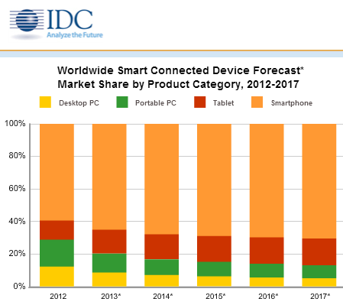

Figure 1 Worldwide smart connected device forecast (Forbes.com. 2018)

The mobile or the smartphone users are increasing rapidly all over the world. So, from the findings mobile device is very easy and convenient to use which is an important reason for developing the android mobile application for centralized scheduling system (‘MScheduling’).

**Consultation Hour Booking**

To get direct help from lecturer outside class, consultation hour is very important for the students. Net four-tier architecture to the appointment management handling in the university/college environment. A Web based appointment management system called WBAMS is designed and implemented so that students and lecturers can arrange meetings in an effective and efficient way (Ming Lu & Ab Hamid, 26 December 2007).

E-appointment is closely related to electronic booking, electronic reservation and other types of internet-mediated agreements on relations between time periods and resources in focus. Even though there is no clear-cut distinction, one could say that e-appointment emphasizes the agreement between two or more partners as social subjects while reservation and booking rather refers to physical resources (e.g. presentation room) or impersonal and/or highly standardized services (e.g. flight, secondary care treatment) (Klischewski, 2003). The system allows students and lecturers to simply gain access to the system by connecting to the Internet. It also enables students to drop any message which consists of the purpose and time of the appointment. This will enable an android application to be robust, cheap and capable of operating on various platforms. The system does not only fully automated, and perform excellently well, but also user-friendly, time effective and efficient (Ridwan, et al., 2016).

One common software that be used to achieve this is Microsoft Outlook. But still there are some drawbacks which include human involvement towards recording of appointment, cancellation, confirmation and reschedule etc. Of course, these systems possess one advantage which is the automatic reminder only. Though ICT has played a good role in appointment scheduling, still there is no automation in appointment scheduling system (Parchment1 & Sankaranarayanan , 2013)

Based on research an institution uses consultation hour booking system to get some benefits such as See upcoming consultations, book consultations, see the consultations that has already booked, cancel or make changes to the consultations hour etc. Shockingly, numerous issues happen while implementing the manual consultation system that causes the low number of students who go to their lecturers for consultation. It has been found that rarely students meet their lecturer due to face difficulties and no idea about how to set an appointment with lecturer. Only a few student use consultations booking system that is provided by the university because they do not know how to book lecturer’s consultation hour. As a new platform it is suggested by researcher to develop an android application system for lecturer’s consultation hour booking which is going to be replaced the current system with an advanced system that will contribute for developing a better educational environment and improving student-lecturer relationship.

**IT Lab Reservation System**

The lab booking system can be designed and implemented through the investigation and analysis on the need of the management of the laboratory in Xinzhou Teachers’ College. With the auxiliary of the website news model, the system has realized the operation of four functional models: registering, appointment of users, messages of users and backstage management. The realization of the system will be conducive to the modern management of laboratory (Li_min, et al., 2003)

A multilayer feed forward neural network is trained on speech examples with known reverberation times generated by a room simulator. The speech signals are preprocessed by calculating short-term rms values. A second decision-based neural network is added to improve the reliability of the predictions. In the retrieve phase, the trained neural networks extract room reverberation times from speech signals picked up in the rooms to an accuracy of 0.1 s. This provides an alternative to traditional measurement methods and facilitates the occupied measurement of room reverberation times (Darlington, et al., April 1, 2001).

From the findings, it aims to provide an efficient and convenient way of reserving rooms for all the individuals involved. By hosting the service online, the entire flow of the reservation system will not be greatly affected by the absence of important individuals.  online booking system should have at least one screen where we can see the availability very quickly and clearly.  By this proposed ‘MScheduling’ android application it will be an easy platform for the lecturer to book available computer lab from the system which would be helping to save time and reduce work.

**Live Chat**

According to, (Nam Kim, et al., 2010) recently live chats have received attention due to the growing popularity of chat services and the increasing body of applications. For example, large organizations are increasingly providing support or information services through live chat. Live chat between the lecturers and students will help them to address their short issues and quires outside the class timetable through ‘LiveHelp’ option that is going to be developed in proposed (MScheduling) application.

Online chat may refer to any kind of communication over the Internet which offers an instantaneous transmission of text-based messages from sender to receiver; hence the delay for visual access to the sent message shall not hamper the flow of communications in any of the directions. Several researchers have addressed the effectiveness of e-mail as a customer support tool (Millar 2001) and (Kannan 2011). Other has discussed online (not real-time) customer support such as filling out a form or browsing help menus. But very little research was found to discuss the effectiveness of “Live Support Chat” (Lindsay 2009), although it is an important new trend in online service because it solves users’ problems and concerns instantly on the spot. LiveHelp is an affordable live chat platform that delivers instant interactivity, information and support to the student.

LiveHelp will give a proper academic way to both the lecturer and student that they can message with each other in a simple, organized dashboard. Lecturers can easily transmit class materials or point students to an online knowledge resource. Even when the lecturer is not online, students can ask course questions and request a callback through Chat, email, or text. In APU It will improve the relationship and understanding between lecturer and student in a collaborative way which is an important thing for the better educational environment. LiveHelp will be used for administrative support, and to get lecturers help from students with questions.

**Client-Server Model**

In the recent computing world, Client-Server system becoming so popular all over the world because it is being used virtually every now and then for different applications. Some of the standardized protocols that client and servers use to communicate with themselves include: File Transfer Protocol (FTP), Simple Mail Transfer Protocol (SMTP) and Hypertext Transfer Protocol (HTTP). Thus, Client-server system can be defined as a software architecture made up of both the client and server, whereby the clients always send requests while the server responds to the requests sent. An inter-process communication has provided by the client server because it helps to exchange of data for both the client and server and each of them functions differently (Ridwan, et al., 2016). Nevertheless, the architecture of the Web is the Client-Server model, in which accordingly the correspondence between the customer and server is the principal thing we should be concerned about

For the proposed ‘MScheduling’ system client-server architecture has been used for user login and registration purpose. The user needs to enroll with their accreditation to login into the system. The user will be enlisted in the server. Afterward, the system will approve the user email and password from the server and approve or reject the user

## 2.3: Similar System/s

**“UniConnect” Application**

UniConnect is an android application that has been found through research and it has few similarities to the proposed system. This UniConnect android application is developed by Professor Dr. Syed Akhter Hossain who currently working as a professor in Daffodil International University.

**Application Functionalities**

Firstly, from the google play store the application needs to be download and installed in an android device. User need to be registered to get access to log into the system. There is a login interface that the user needs to type the user name and password to log into the system. After installation the application user can log into the system and see the functionalities. In this application the different functionality has been added based on user type.

It is a platform where lecturer can-

* Make their work schedule / Class routine
* Add reminder
* Contact with student
* Create groups of students
* Make Announcement
* Create Notifications
* Answer to students’ questions
* Give appointment

And student can-

* Make class routine
* Ask question to teacher
* Request for appointment
* See when his/her expected teacher is available
* Join in a group

**Additional Functionalities**

Students can upload their picture to the profile as identity that lecturer can easily identify the students.

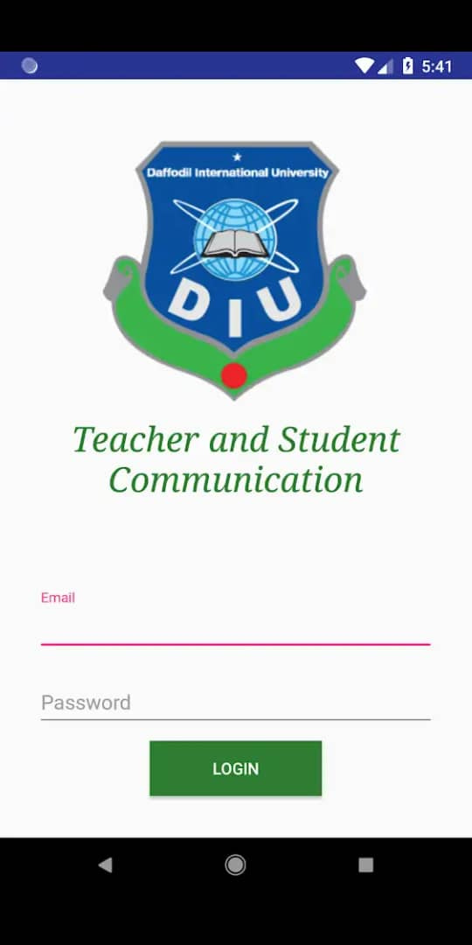 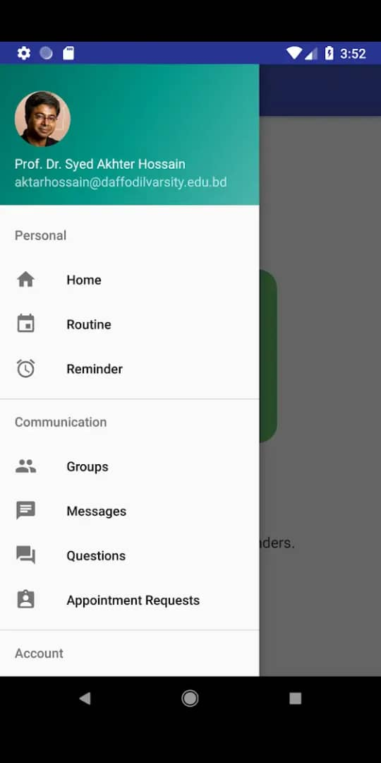

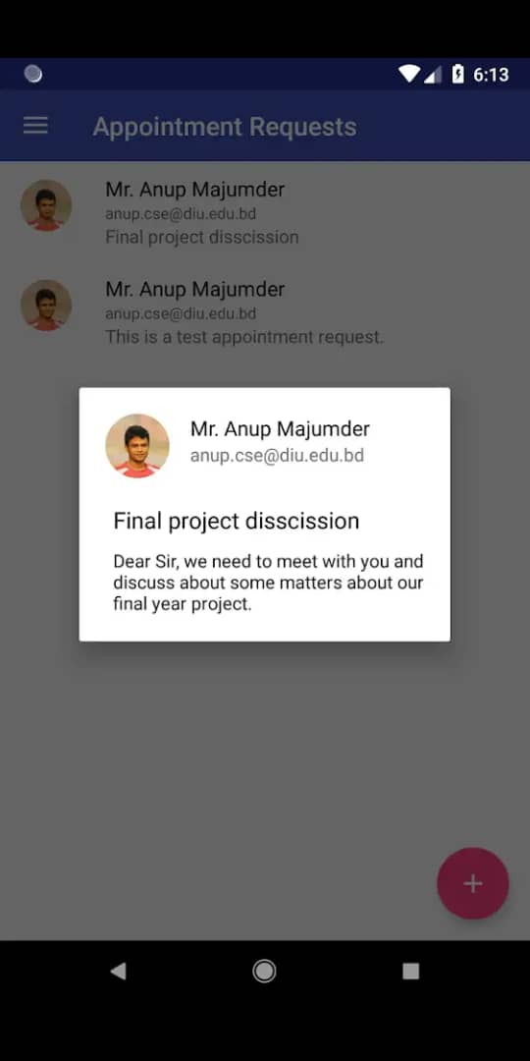 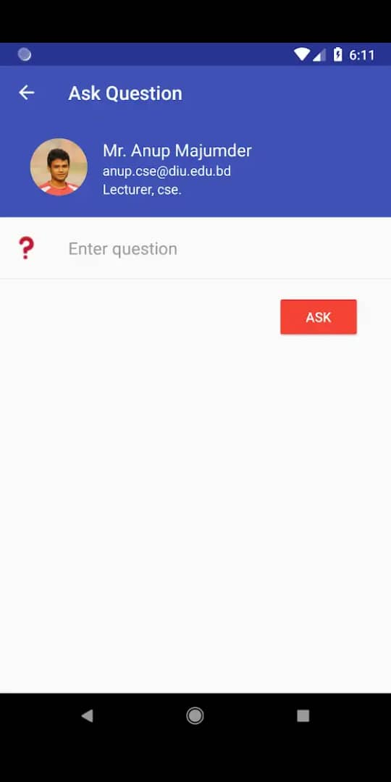

Figure 2 UniConnect application screenshot

**“UMM Appointment” Application**

UMM Appointment is an android application that has been found through research and it has few similarities to the proposed system. This UMM Appointment android application is found in google play store.

**Application Functionalities**

Appointment UMM is a mobile application that works on android platform. This application was created to facilitate the scheduling of Final guidance, or consultation with the faculty staff. This application can be used by faculty and students. With this application is expected lecturers can estimate the time and be able to estimate the density of the queue students who wish to undertake coaching or consultation. So that guidance can be carried out in accordance with the number of students who have already made an appointment and in accordance with the scheduled time.

**Additional Functionalities**

In this application students are allowed to provide feedback or give rating based on their consultation hour. Both the student and lecturer get a notification once the consultation hour booking has been made. In the user interface there is a login option based on the type of student.

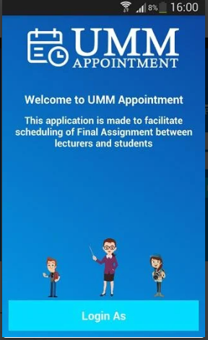 

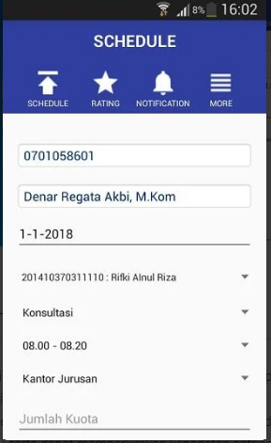 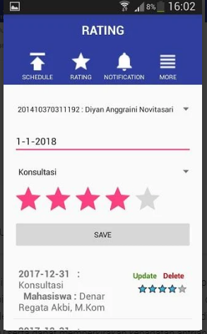

Figure 3 UMM Appointment application

**Differences between the proposed system and similar systems**

|  |  |  |  |
| --- | --- | --- | --- |
| Functionalities | UniConnect | UMM Appointment | MScheduling |
| Modify or cancel consultation hour | Not available | Not available | User can modify or cancel their consultation hour. |
| IT lab Reservation | Not available | Not available | Lecturer can book IT lab through this system. |
| Live chat | There is an option for chat between the user but not in real-time. | Not available | Lecturers and students can interact with each other in a real-time online live chat system. |
| Rating on consultation hour | Not available | Available | Student can give the feedback on their consultation with lecturer. |
| Email Notification | There is no email automatic notification service once the booking has been confirmed or cancelled. | There is no email automatic notification service once the booking has been confirmed or cancelled. | User will get notification in event of consultation hour booking or cancellation. |

Table 1 Differences between the proposed system and similar systems

## 2.4: Summary

In the domain research it is clear that the using of mobile devices are incising significantly all around the globe. The huge demand of android mobile phone is increasing massively in the market which is found by the researcher. The importance of live chat briefly discussed in the domain research and the advantage of choosing live chat into the proposed system can bring a revolutionary change in the educational environment. A Client-Server model correspondingly researched from different aspects through the domain research. In the proposed system there are many valid reasons of choosing client-server model. Throughout the domain research the reason has been clarified.

To determine the better functionalities and options for the proposed system different type of similar android application has been researched for Centralized Scheduling System for Lab Booking and Lecturer’s Consultation Hour. This is to ensure that all students who has no idea about how to book consultation hour, they can use this application without having any kind of trouble.

# CHAPTER 3: TECHNICAL RESEARCH

**Mobile Application Development**

## 3.1: Programming language chosen

In many respects, developing mobile applications is similar to software engineering for other embedded applications. Common issues include integration with device hardware, as well as traditional issues of security, performance, reliability, and storage limitations ( Wasserman , 2010). In the major mobile platform there are some comprehensive programming environment available. For example, Android Development Tools plug-in can be used by the developers for Eclipse programming environment.

There are two type of processes are available for mobile application development in view of the immense fracture of stages and devices. Native Applications are the projects that is based on a specific stage. It very well may be Android, Windows or iOS. As Native applications are worked for a single stage, it can take almost every advantage of the most recent operating system technologies and features that has been installed just for that stage, for example, camera resolutions and the GPS.

On the other hand, A cross-platform application is a mobile app which is compatible with multiple operating systems and can therefore run on any smartphone or tablet. Cross platform application can work in several types of operating environments. Cross-platform also known as multiplatform or platform independent it means the application can work in Android, windows and iOS.

“Centralized Scheduling System for Lab booking and lecture’s consultation hour (MScheduling)” is a native mobile application. “MScheduling” can be developed in many platforms such as iOS, Windows and android application. For developing the application each platform needs identified and specific programming language. Based on increasing numbers of user a native application and the platform of android has been chosen for developing the proposed system “MScheduling”. There are basically two kind of programming language are offered to develop an android application. Kotlin and Java are mainly focused and well known for developing android application.

The comparison between Kotlin and Java are given below:

|  |  |  |
| --- | --- | --- |
|  | Kotlin | Java |
| Developed By | Kotlin was developed by JetBrains. Andrey Breslav was team leader of project Kotlin. First version of Kotlin was released in 2016. | Java was developed by Sun Microsystems which was later acquired by Oracle Corporation. James Gosling was the lead developer of Java. First version of Java was released in 1995. |
| Operating System | Multi-platform | Multi-platform |
| Code Size | In Kotlin we have to write 30-40% less code as compared to java | In Java we have to write more code as compared to Kotlin. |
| Null Safety | Kotlin does not have null pointer exception problem. Various ways are provided to deal with this exception. | Null Pointer Exception is most common problem in java that is occurred when we try to access a member having null reference. |
| Features | Encapsulation, inheritance, data hiding, polymorphism | Distributed, Simple, interpreted, secure, portable, architecture neutral |
| Checked Exception | Kotlin doesn’t have the check exception feature. | Java have checked exception feature. |
| Use of semicolon | It is optional to write semicolon at the end of statements | In java each statement must be terminated by semicolon |
| Filename Extensions | .kts, .kt | .jar, .class, .java |

Table 2 The comparison between Kotlin and Java `

During the development of system every programming language has some advantages and disadvantages. For the Kotlin and Java programming languages the advantages and disadvantages are given below:

**Kotlin**

**Advantages**

* Increases team efficiency.
* It can be written in any command line or java IDE.
* Compiles with existing java code.
* Avoid the errors such as, null pointer exceptions.
* Easily Maintainable and less buggy.

**Disadvantages**

* Limited learning sources.
* Kotlin doesn’t have checked exception feature.
* Kotlin doesn’t have checked exception feature.
* Scarcely any Kotlin expert to hire.
* Kotlin compiles slower than java.
* It has very smaller developer society.

**Java**

**Advantages**

* Java is simple, free, distributed, object-oriented, supports multithreading and offers multimedia and network support.
* Being highly popular at embedder, networking level and enterprise, java has a large active community and support available.
* Java has powerful development tools like Eclipse SDK and NetBeans which have debagging capability and offer integrated development environment.
* Relatively seamless compatibility from one version to the next.
* Java has that function to store data and restore those data easily, which is known as stack allocation system.
* Increasing language diversity, evidence by combability with java with Scala, JRubby, Groovy and Clojure.

**Disadvantages**

* Java architecture code is insufficient
* Language limited latency critical tuning
* Performance is comparatively slower and takes more time
* The database is more complex
* Java takes more memory space

**Justification**

Java seems the most appropriate language after the analysis of disciplines, features, advantages and disadvantages of both Kotlin and Java languages. Without any doubt it can say java is more useful programing language to develop the proposed system (“MScheduling”). Java is a secured, portable and an object-oriented programing language which will be more suitable for the proposed system. Java is most usable language with the possible functionalities and features for developing any android application though it consumes more spaces than other languages.

## 3.2: IDE (Interactive Development Environment) chosen

An integrated development environment (IDE) is a software suite that combines the basic tools that developers need to write and test software. Characteristically, an IDE contains a code editor, an interpreter or compiler and debugger that the developer accesses over a single graphical user interface (GUI). An IDE may be including as part of one or more existing and compatible applications or may a standalone application. Over the past five decades, desktop IDEs have become mature and are now prevalent in modern software engineering. They provide tools for working with a wide range of languages, combined with facilities for version management, issue management, and so on (Kats, et al., 2012). IDE provide valuable services in the appropriate platform such as, content assist, graphical debugging, refactoring, semantic highlighting and so on. To access of Android’s features, one needs to develop app using tools such as Android studio, which is provided by Google as a full-fledged development environment for Android development, debugging, packaging and testing (A. Allison , 2016).

As “MScheduling” is an android app it would be better to develop the app with the help and support of Android Studio and Android SDK as the IDE. For developing an android application android studio has a lot of functionalities including more additional features and Android studio is built on JetBrain’ Intellij IDEA software.

Android studio has huge flexibility and suitable operating system for macOS, Linax, windows. The first commercial version of android studio was released on September 23, 2008. But the version history of mobile operation system started with the release of the Android beta on November 2007.

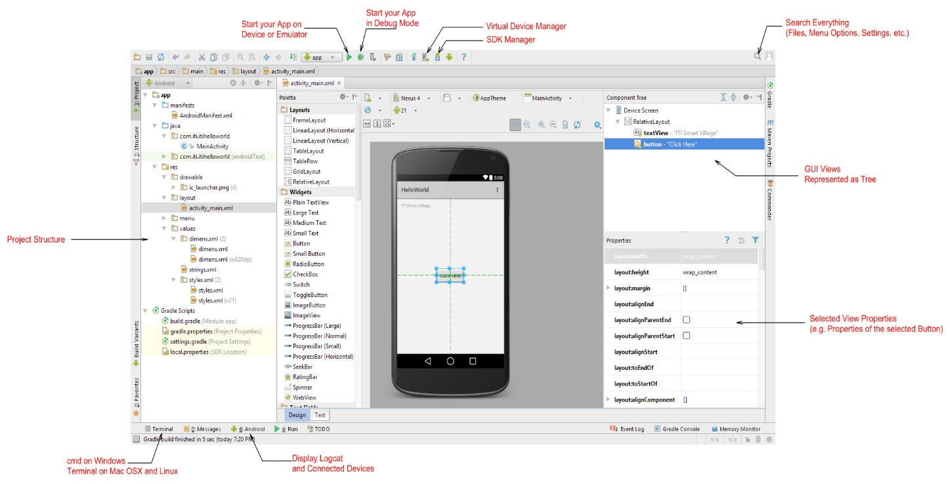

Figure 4 Interface of Android studio

**Advantages of Android Studio**

* In order to check the performances and combability developers can check one application in multiple devices with different specifications.
* Android studio support the flexible griddle-based build system.
* Free to download on multiple platform.
* Emulator allows developers to observe app behavior on simulated devices.
* Many code templates are available in android studio, which helps to build common features in application.
* Code writing for android become more easier, faster accurate and through android studio.

**Disadvantages of Android Studio**

* The interface has an old feel.
* Emulator can run very slow at time in windows rather than macOS and Ubuntu.
* Very little documentation and support.

Apart from these disadvantages, there are some huge advantages and more useful features in android studio that will help the developer to build and design a user-friendly application in an appropriate way. So, the developer has chosen Android studio as a platform of developing the proposed app “MScheduling”.

## 3.3: Database Management System chosen

To develop the proposed system “Centralized Scheduling System for Lab booking and lecturer’s consultation hour (MScheduling)” there are three types of database management system have been chosen. MySQL, SQLite and Firestore are the three chosen database management system for the proposed “MScheduling” app.

The comparison is given below among the database management systems:

|  |  |  |  |
| --- | --- | --- | --- |
|  | MySQL | SQLite | Cloud Firestore |
| Developer | Oracle Corporation | D. Richard Hipp | Andre Lee, James Tamplin |
| Database Size | Medium | Small | Large |
| Operating System | Cross-platform | Cross-platform | Cross-platform |
| APIs and other access methods | * ODBC * JDBC * ADO.NET | * DB-API | * IOS * Android * RESTful HTTP API * JavaScript API |
| Programing languages (for development of database) | C, C++ | C |  |
| Advantages | * Database is encrypting the password and secured * MySQL is very easy to install and use * MySQL cost effective for the developers because it is free to use | * System directly reads and writes * Before using SQLite, it doesn’t need any installation or setup process * Source codes are design to be accessible and readable to the developers | * Very faster and richer queries * More intuitive model than SQLite and MySQL * Automatically validates data * Automatically scales the data * Easy to organize the hierarchical and complex data * Scales batter than other real time |
| Disadvantages | * Development is not community driven and it has lags * There is a stability issue in MySQL * Database is not supportive for the application with large database | * Very small database size * Less features than MySQL and Firestore | * There are no disadvantages for Cloud   Firestore until now |

Table 3The comparison among the database management systems

## 3.4: Operating System Chosen

Operating system chosen is one of the most important tasks of this proposed system. There are many operating system already been developed in this modern era such as, iOS, Android, Windows, Blackberry etc. Android operating system is one of the most popular operating system developed by google. Android was initially released on 23rd September 2008. Android is an open source operating system, meaning its source code made available to the manufacturers with an Apache License 2.0 (Padhya, et al., August 2016).

The comparison between different operating system with the proposed Android operating system are given below:

|  |  |  |  |
| --- | --- | --- | --- |
| Parameter | Android | iOS | Windows |
| Vendor | Open Handset Alliance | Apple | Microsoft |
| Symbol |  |  |  |
| Developed in programming Language | C, C++, Java | C, C++, Objective-C, Swift | C#, VB.NET, F#, C++, Jscript |
| License | Open source | Proprietary | Proprietary |
| App Store | Google Play | App Store | Windows Phone Store |
| No. of App | 1.3 million | 1.2 million | 500,000 |
| Side loading | Available | Done by installing Xcode7 | Available with windows phone 10, not in earlier version |
| Battery Demand | Highest | Less | Least |
| Customizability | Highest | Provide few option (allows a few selected widgets to be applied on the notification panel) | Allow re-sizable live tiles, various color schemes can be chosen in addition to background images |
| Security | Softest to crack | Hard to crack | Hardest to crack |
| Advantages | * Android is more customizable can change almost anything * Android offers an open platform * Cost effective * Easy access to Android App market. | * Excellent UI and fluid responsive * Developers can design apps because a smaller number of models * Excellent for media entertainment * iOS is more “Intuitive” | * Windows phone battery saver. * Windows phone are comparatively cheaper than other phone. * Windows phone has personal control features. |
| Disadvantages | * Usually need more code on java than objective-C. * Complex layout and animation are harder to code in android * High device fragmentation | * Using iOS is costly Apps an no widget. * Battery performances is very poor on 3G. * Not flexible only support iOS devices | * Screen glasses of Windows phone are not good enough. * Windows phone OS sometimes unresponsive. * Windows phone gets slower quickly than other smartphones. |

Table 4 The comparison between different operating system

**Justification**

Every operating system has its own fractures. From the comparison it is clear to the developer that Android operating system is the best operating system for the proposed “MScheduling” application.

## 3.5: Summary

Centralized Scheduling System for Lab Booking and Lecturer’s Consultation Hour (MScheduling) is a mobile application which would be providing services to the student through mobile devices. Java has been chosen as programming language, Cloud Fire store would be using for database management, Android Studio would be using as a platform for developing the proposed system and Android operating system will operate the proposed “MScheduling” application.

# CHAPTER 4: SYSTEM DEVELOPMENT METHEDOLOGY

## 4.1 System Development Methodology chosen

Software development methodologies improving the management and control of software development process with the development quality and productivity. In this present world many system development methodologies are using commonly by the developers. For the proposed “MScheduling” system there are three common methodologies have been chosen for comparison and the best methodologies have been chosen to develop the proposed system.

Agile methodology, prototyping methodology and waterfall methodologies have been compared with the advantages and disadvantages of those methodologies are given below in the table.

|  |  |  |  |
| --- | --- | --- | --- |
|  | Agile  Methodology | Prototyping Methodology | Waterfall  Methodology |
| Model | 6 stages | 6 stages | 8 stages |
| Stages | * Planning * Requirements analysis * Design * Implementation, coding or design * Testing * Deployment | * Requirement design * Quick design * Building prototype * User evaluation * Refining prototype * Engineer product | * Conception * Initiation * Analysis * Design * Code * Testing * Implementation * Maintenance |
| Advantages | * Faster and high-quality delivery. * End goal can be unknown. * Strong team interaction. * Continuous improvement. * Face-to-face communication between customers and developers which improve connection. * Accommodate and accept changes. | * Errors are detected very earlier. * Give quick feedback for better solution. * Identifying missing functionality easily. * Identifies confusing and difficult function. * Users are properly involved in project. * User get a better understanding. | * Uses clear structure. * Determines the end goal early. * Transfers information well. * Easy to use and understand. * Appropriate for all small projects with clear requirements. * Procced to next phase after the full complementation of previous phase. |
| Disadvantages | * Planning can be less correct. * Team must be knowledgeable. * Active involvement and collaboration are required. * Need professional developer for taking sensitive decision. | * The client involvement is more. * It is a slow process. * Many changes can be disturbing the rhythm of developers. * Lack of analysis and incomplete application can’t be used. * Doesn’t give fully lead to the implementation. | * Makes changes difficult. * Excludes a client or end user. * Delays testing until after completion. * Not good for big project. * Very risky and uncertainty. * Inappropriate for object-oriented and complicated project. |

Table 5 Comparison between the methodologies

## 4.2 Justification

Developing mobile application is currently a very challenging task due to the specific demands and technical constraints of the mobile environment (Abrahamsson, et al., 2004). Agile methodology has been chosen for developing the “MScheduling” application after the research of software development models, advantages and disadvantages of three common methodologies. As “MScheduling” is mainly android application agile will be appropriate methodology for the proposed system.

The user requirements are not stable for mobile applications development until the software is fully developed. So, in mobile application development agile methodology makes a flexible process that the track of development process can be changed easily and quickly to any alternative way. The mobile software application has user interface modules which react immediately to user interactions, and since this is an environment with rapidly changing user demands, the development of such applications requires an agile approach. Among the available software development methods, agile methods are the most appropriate and potential solution for mobile application development (Kaleel & Harishankar, 2013).

## 4.3 Description of system development methodology chosen

Agile methodology has overwhelmed the software development world and quickly established its place as "the gold standard." It’s an iterative and incremental software development process. For any software development agile methodologies are commonly used by the developers. Agile methodologies are set of IS methodologies which share some of the agile principles. Some of the popular IS methodologies under adopting to agile principle are Extreme Programming (XP), Scrum Agile Modeling Adaptive Software Development (ASD), Dynamic System Development Method (DSDM), Feature Driven Development (FDD), Lean Software Development, Dialogue-Driven Development (aka d3) and Kanban Methods. But comparatively to other methodologies, Extreme Programming (XP) will be more suitable agile method for the proposed “MScheduling” application development.

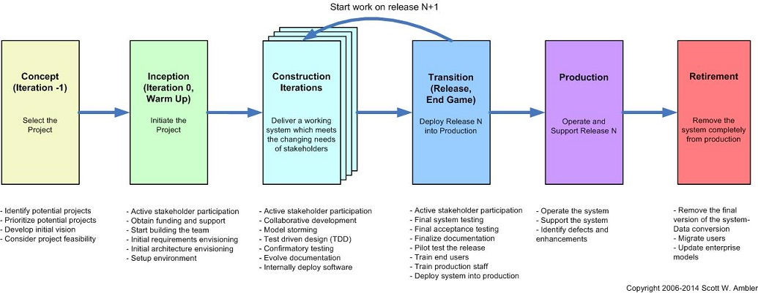

Figure 5 The agile SDLC (Ambler, 2014)

For all the Agile methodologies overall goal is to change and deliver all the software faster. Based on the definition there is an inconsequential difference between the Agile methodologies, but for all the methodologies the lifecycle is the same. According to the nature of software and situation developers select different methodologies.

The phases of Agile methodologies are briefly explained below:

**Phase1: Scope out and priorities projects**

The team scopes out and prioritizes projects during the first step of the agile software development life cycle. Depending on the department’s organization some team may work more than one project at the same time. Developers should define the business opportunity for each concept and determine the work it will take to complete the project and the time. In the feasibility analysis of the system developers normally give s very less effort. The amount of effort depends on the type of system in feasibility analysis.

**Phase2: Diagram requirements for the initial sprint**

Once the project has been identified then developers need to work with stakeholders to determine requirements. Developer might want to use high-level UML diagrams or User flow diagrams to demonstrate how the new feature should function and how it will fit into the existing system. From that point, selected team members to work on the project and allocate resources. Developers also create swim lane process map in the chart or a timeline to delineate responsibilities and clearly show when certain work need to be done for the duration of the sprint.

**Phase3: Construction Iteration**

Once the requirements have defined by the developer’s team for the initial sprint based on stakeholder feedback and requirements, the work brings. Developers and the UX designers bring work on their first iteration of the project, with the goal of having a working product to launch at the end of the sprint. The system will be testing by the user after each iteration of the project. For developer testing at the design level and for the requirements level there are many tastings involved in the project, which are agile requirements testing and confirmatory testing.

**Phase4: Release the iteration into production**

At this phase developer nearly release the product into the world. Finish up this software iteration with the following steps:

* Test the system

-The system should be tested by the quality assurance team based on functionality, detect bugs, and record wins and losses.

* Address any defect.
* Finalize system and user documentation

-Lucid chart can help to visualize the code through UML diagrams or provide user flows for everyone that they can understands how the system functions and they can build upon it further.

* Release the iteration into production

**Phase5: Production and ongoing support for the software release**

The focus of this phase keeps the system running among the user and productive after the deployment of the system. The production phase ends when support has ended or when the release is planned for retirement.

**Phase6: Retirement**

The last phase of agile method is retirement. During the retirement phase the system release will be fully removed from production when developer want to replace a system with new release when the system becomes obsolete, or contrary and redundant to the business model.

**Phase of Extreme Programming (XP) Methodology**

For the proposed system Extreme Programming (XP) has been chosen as it is one of the development methodologies of Agile methodology. The phases involve in Extreme Programming (XP) are given below:

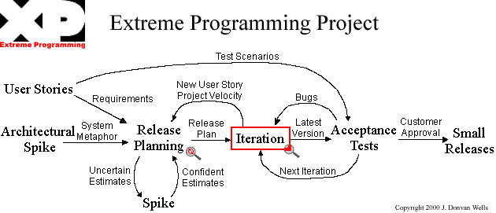

Figure 6 Extreme Programming (XP) Diagram (Wells, 2013)

**Phase1: Planning phase**

Planning phase is the first phase of Extreme programming (XP) life cycle. In this phase users meet the development team to create user requirement. The user stories have been converted into iterations by the development team that cover a small part of the functionality or featured required. A combination of iteration delivers the client with the concluding functional product. The development team prepares the time, plan and costs of carrying out the iteration, and separate developers sign up for the iteration.

**Phase2: Designing**

An iteration of XP programming begins with designing

The guidance principle of this steps are given below:

* Using systems metaphor or standards on names, methods and class name, and agreeing on uniform formats and style to ensure the compatibility among the work or different team members.
* Thrust on simplicity by stating an object only once and not addition of functionality in application.
* Creating spike solutions or simple programs that explore potential solution for a specific problem, ignoring all other concerns, to mitigate risk.
* Using software Class Responsibilities and Collaboration (CRC) Cards that allow for a departure from traditional procedural mindset and make possible object-oriented technology. Such cards allow all members of the project team to contribute ideas, and collate the best ideas into the design

**Phase3: Coding**

The customers availability is one of the requirements of extreme programming. Developers should include at least one or more customers in the project team. The customers will not only be a member of the team but also will help with the system requirements by communicating with the developers face-to-face on the site. User stories also written by these customers with the help of the developers. These customers should be expert in this field and make sure the future functionalities are covered by the user stories. the formation of the coding must be standard so that other developers can understand and easily refactor it if necessary (Wells, 2013).

Standard related to coding include:

* Pair of developing code by two programmers working together on a single machine, aimed at producing higher quality code at the same or less cost.
* Frequent integration of the code to the dedicated repository, with one pair integration at a time to prevent conflicts, and optimization at the end.
* Developing the code based on the agreed metaphors and standards and adopting a policy of collective ownership.

**Phase4: Testing**

Unit test must be created for all the codes of the system. During this phase, unit tests will be released with the codes. If it does not appear during testing, then the developers have to create the unit testing at that time and the codes must pass the unit tests before releasing. If any bug is found during testing in the system, then an acceptance test will be created to protect against it. Acceptance tests are created from user stories. These are the black box system tests and each test represents the expected results from the system. During the testing phase the acceptance tests are run, and the score is published (Wells, 2013).

**Phase5: Listening**

During the development phase the basic extreme programming is a continuous mechanism of customer involvement through feedback. Apart from the customer, the developers also receive feedback from the project manager. The basis of feedback is the customer acceptance test. If the customers are satisfied with the test results the iteration ends there, and the design for new iteration starts which again follows the design-coding-listening cycle.

# CHAPTER 5: RESEARCH METHODS

## 5.1: Introduction

Research methods is a comprehensive term. While methods of data collection and data analysis represent the core of research methods, you must address a range of extra elements within the scope of your investigation (Dudovskiy, 2018). The methodology may include any publication research, questionnaire, interviews, surveys, other investigation techniques and could contain both present and historical information. So, in this project, the developer has chosen questionnaire and interview techniques to collect data and information. This technique will allow the developer to get opinion and gather information straight from users for the system.

Questionnaire is another important technique of primary research method. It is a process of collecting data from the targeted respondents which consists of a series of questions. This method can be classified in both quantitative and qualitative approach based on the type of questions. The questionnaire method has been chosen for this project, because it is an easy way to collect data from a large group of students in a short period of time. The attitudes, priorities, perspectives, behaviors and the expectations of the students from a library management system can be found out by this process (Anon., n.d.).

One of the most important quantitative primary research methods for data gathering is interview. To collect data which is related to the research this is a method of a conversation between two people. To know the lack of current system developer can directly answer to the participants. For fixing the requirements by deliberating from both sides about the proposed system this technique will also help both the developers and the users.

## 5.2 Design

**Designing of questions for the interview**

Name of Interviewee: __________________________________________________

Position:_____________________________________________________________

Time from: ________________________________To:________________________

Name of University: ________________________Date of Interview: __/___/______

Type of Interview:_____________________________________________________

1. How Do you book Lecturer’s consultation Hour?

**Answer**: ___________________________________________________________________

1. How do you manage the IT lab reservation?

**Answer**: ___________________________________________________________________

1. Who controls the current lab reservation system?

**Answer**: ___________________________________________________________________

1. Is current system convenient to use? If ‘No’, then explain the reason.

**Answer**: ___________________________________________________________________

1. Did any student ask you before to help them by booking lecturer’s consultation hour? If ‘Yes’, Then how did you manage that?

**Answer**: ___________________________________________________________________

1. Have you found any student who asked you to show the lecturer’s consultation booking system and procedure? If ‘yes’, Then explain how did you do that?

**Answer**: ___________________________________________________________________

1. Do you think in the new android application there should be an option to modify and cancel the consultation hour? If ‘yes’, then explain the reason why?

**Answer**: ___________________________________________________________________

1. Is the current system convenient to use? If ‘No’, please explain the reason why?

**Answer**: ___________________________________________________________________

1. If there are any new system being developed for IT lab reservation and lecturer’s consultation booking will you try to use? If ‘yes’, please explain the reason why?

**Answer**: ___________________________________________________________________

1. Do you think a live chat option will help to improve communication between the lecturer and student? If ‘yes’ then How?

**Answer**: ____________________________________________________________________

## 5.2.1 Questionnaire

Survey Cover Letter



Dear Participants,

My name is Md Easir Arafat. I am a student in Asia pacific university of technology and innovation. I am doing a research for my final year project for the fulfillment of a degree of international business management. You are kindly invited to participate in this research entitled “Centralized Scheduling system for Lab Booking and lecturer’s Consultation Hour”. The purpose of this research is to develop an android application and enhance the features of existing lecturer scheduling system which is used in APU by integrating IT Lab reservation, and Consultation Hour Booking.

Your corporation to fill out the questions in an utmost honesty, truthfully and faithfully will be highly appreciated. The questionnaires will only take around 5-10 minutes of your time to be completed. Please be informed that there are no consequences or known risk in participating in this survey. Your participation is voluntary, and this research is only conducted for academic purpose and that your response will be strictly confidential. If you have problems or concerns regarding this research, please feel free to contact the researcher through the number or send an email as provided below.

Thank you for your corporation.

Sincerely,

Md Easir Arafat,

TP039768

[easirarafat07@gmail.com](mailto:easirarafat07@gmail.com)

**Questionnaires**

**Section A**

In this section the question is prepared to collect general information of the participant

1. What is your Occupation?

* Lecturer
* Admin Staff
* Student
* Other (please specify)

(**Objective**: To verify the user type, who will use this application)

1. What is your gender?

* Male
* Female

(**Objective**: To identify and measuring the activities of the user based on their gender)

1. What is your study level?

* Foundation
* Diploma
* Degree
* Master’s degree
* Doctorate degree

(**Objective**: To identify the user based on their education level)

**Section B**

In this section the question is prepared for collecting the information regarding the final year project

1. What operating system are you using in your smart phone?

* Android
* iOS
* Other

(**Objective**: To identify the type of smart phone user and operating system that is mostly used)

1. How often do you use your mobile phone in a week to play online games, browsing and others?

* 1-3 times in a week
* 4-6 times in a week
* 7-9 times in a week
* More than 9 times in a week

(**Objectives**: To identify user’s availability and spending time on mobile phone that will help to find out possible user)

1. Have you ever booked lecturer’s consultation hour?

* YES
* NO

(**Objective**: To find out the user who would be using this application)

1. How do you book lecturer’s consultation hour?

* From website
* Sending Email
* Both of above
* Other

(**Objective**: To identify the current system user and their response about using the system)

1. Have you faced anyone who asked you to help them for booking lecturer’s consultation hours?

* Yes
* No

(**Objective**: To identify the user who faced difficulties while booking lecturer’s consultation hour)

1. How often do you book lecturer’s consultation hour?

* 1-5 times in a semester
* 6-10 times in a semester
* 11-15 times in a semester
* More than 15 times

(**Objective**: To verify the average time of lecturer’s consultation booking)

1. Do you think android mobile application will help you to do IT lab reservation?

* Yes
* No

(**Objective**: To identify lecturer’s necessity of having mobile application which would be helping them to save their valuable time and book IT lab class)

1. Do you think mobile application would be an easier platform to book lecturer’s consultation hour?

* YES
* NO
* Maybe

(**Objective**: To identify student’s necessity of this project that would be heling them for booking lecturer’s consultation hour easily)

1. Do you prepare live chat system in proposed lecturer’s scheduling system application?

* Yes
* No

(**Objective**: To find out the importance of communication system among users that will help them keep in touch with each other outside class time)

1. Do you prepare to be notified in event of any changes on consultation timing from the system?

* YES
* NO

(**Objective**: To determine the importance of notification system that should be facilitate user to get the update in real time)

1. How would you rate your current lecturer’s scheduling and consultation booking system?

1 2 3 4 5

Very Poor Very Good

(**Objective**: To identify the user’s satisfaction for the current lecturer’s scheduling and consultation booking system)

1. Do you agree an android application will help you to book lecturer’s consultation hour?

1 2 3 4 5

Strongly Disagree Strongly Agree

(**Objective**: To find out the importance of developing this centralized scheduling system for lab booking and lecturer’s consultation hour in an android application)

## 5.3 Summary

This interview and questionnaire are part of the method that would be helping the developer to gather exact information regarding the proposed system and to identify user’s knowledge with proposed system. and, to know user’s involvement for example, to identify whether the user like the system or not? So, this method benefits the developer a lot for the proposed android application. From this section, the developer also gathers data for example, what are the things that should be applied in this system, how to progress the system, etc.

# CHAPTER 6: REQUIREMENTS VALIDATION

## 6.1 Analysis of Data

Analysis of data collected through questionnaire

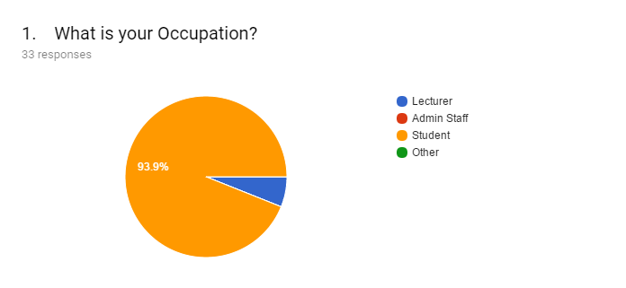

**Result**

Result shows that there are a huge number of responses from student. From the diagram it can see 93.9% of students have attended and rest of the number are lecturers among 33 participants.

**Analysis:**

Result shows that the question has been answered by the students and lecturers.

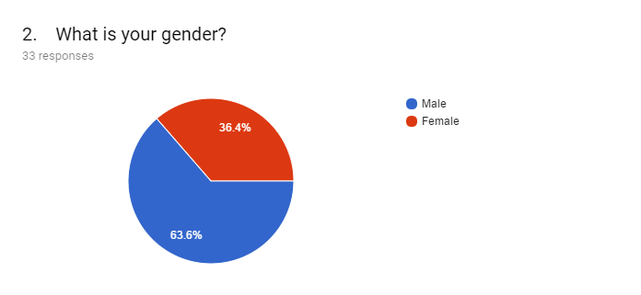

**Result**

There are total 33 participants responded to this question, 63.6% male and 36.4% female.

**Analysis**

The diagram shows that the question has been answer by both the male and female participant.

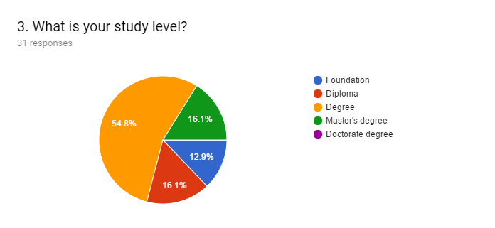

**Results**

There are 31 participant total and 54.8% students are currently studying in degree level, 16.1% are studying in both diploma and master’s degree and rest of 12.9% are studying foundation.

**Analysis**

The diagram shows that the height number of participants are from degree level so that they knowledge about the technology and mobile application.

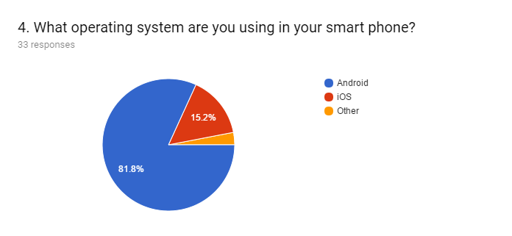

**Result:**

The results showing that among 33 participants there are 81.8% people are using android mobile phone, 15.2% are using iOS mobile phone and only a few numbers of people are using other phone.

**Analysis**

The demand of android mobile phone is higher than any other operating system phone. So, the demand and popularity of android operating system is higher than other operating systems.

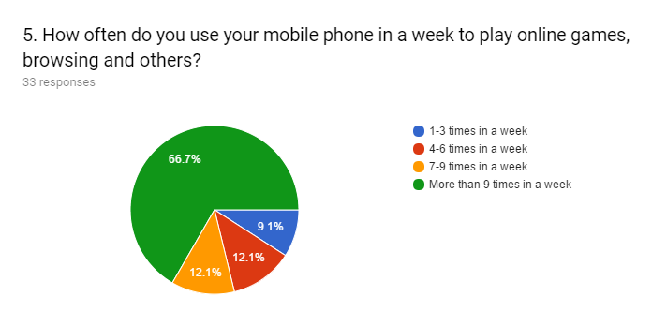

**Result**

33 participants involved to this question. The height number of participants 66.7% spend on playing online game more than 9 hours. 9.9% spend 1-3 times in a week, 12.1% spend 4-6 times in a week and 12.15 spend 7-9 times in a week.

**Analysis**

From Result it is clear that, the height number of people are engaging with mobile phone for playing online games is more than 9 times in a week. So, the result explains the high usage of mobile phone among the users.

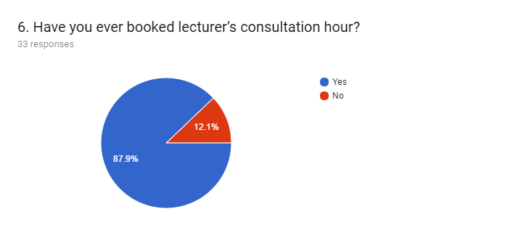

**Results**

Among 33 participants 87.9% answered yes and 12.1% answered no. So, the height number of people are booking lecturer’s consultation hour.

**Analysis**

The result show that height number of participants are booking lecturer’s consultation hour. There is a huge importance of lecturer’s consultation hour currently.

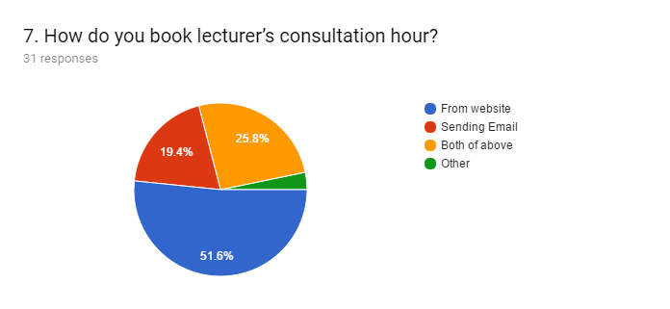

**Result**

The number of participants in this question are 31. Among them 51.6% participants book consultation hour by using university website, 25.8% book lecturer’s consultation through email. 25.8% people use both website and the email for booking the consultation hour. Only a few using other.

**Analysis**

From the chart it is clear that the greatest number of participants are suing university website for booking lecturer’s consultation hour.

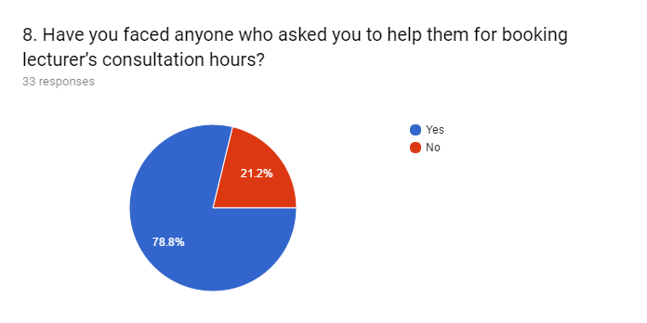

**Result**

In this question 33 participants have involved and among them 78.8% people are facing the problem of booking lecturer’s consultation hour. Only 21.2% participants can do it by themselves.

**Analysis**

From the chart it can see a frustrating number of participants have no idea how to book lecturer’s consultation hour.

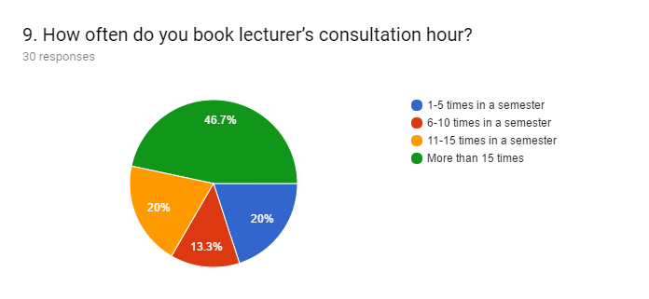

**Result**

In this question 30 participant have involved and 46.7% people are booking lecturer’s consultation hour very often. More than 15 times the consultation hour is booking by the height number of participants in a semester where the other 20% are booking 11-15 times in a semester, 13.3% are booking 6-10 times in and rest of 20% are booking 1-5 times in a semester.

**Analysis**

From the diagram it has been found that the height number of participants are booking lecturer’s consultation hour more than 15 times in a semester.

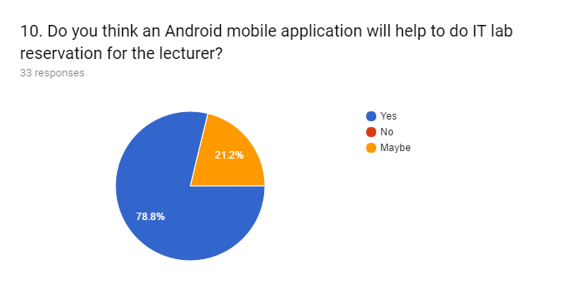

**Results**

78.8% participants think among all 33 participants that, an android application will help lecturers to book the available computer lab. On the other hand, only 21.2% think It can be helpful for the lectures.

**Analysis**

A height number of participants think the lecturers can get the benefit from the proposed application regarding their available IT lab reservation.

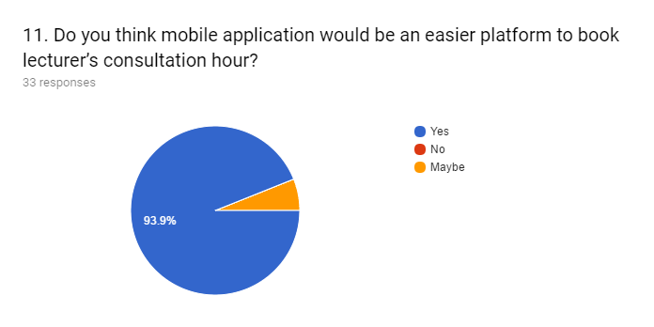

**Result**

Total number of participants of this question are 33. Among all the participants 93.9% answered “YES” and only a very smaller number of participants answered “NO”.

**Analysis**

In this diagram it can easily say that the height number of participants prefer android application for booking lecturer’s consultation hour.

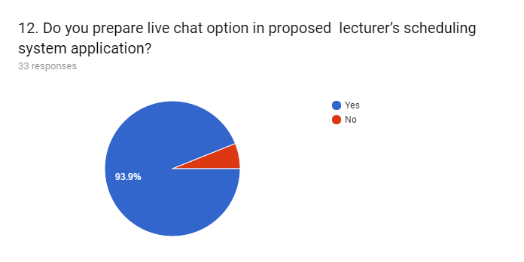

**Result**

93.9% participants prefer live chat option among all the participants where only rest of 6.1% answered “NO” among 33 participants.

**Analysis**

From the diagram it can see that the height number of participants want live chat option the proposed “MScheduling” application.

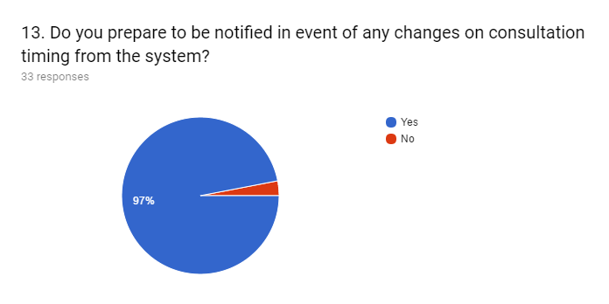

**Results**

In this question there are 33 participants have involved and among the 97% answered “YES” and only 3% answered “NO.

**Analysis**

So, this is clear from the diagram that the height number of participants prefer to be notified in event of any changes on consultation timing where only 3% participants do want that feature among all the participants.

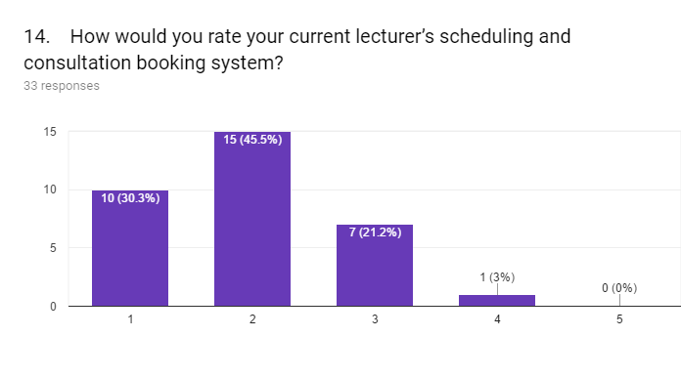

**Result**

From this bar chart it is easy to predict the current consultation booking system’ s performances among the 33 participants. 10 participants only giving 1 as their rating on current system, 15 participants given 2, and very few 7 participants given 3 rating on the current system.

**Analysis**

From the above diagram this is clear that people don’t like the current system as the height number of participants given very low rating on the current system.

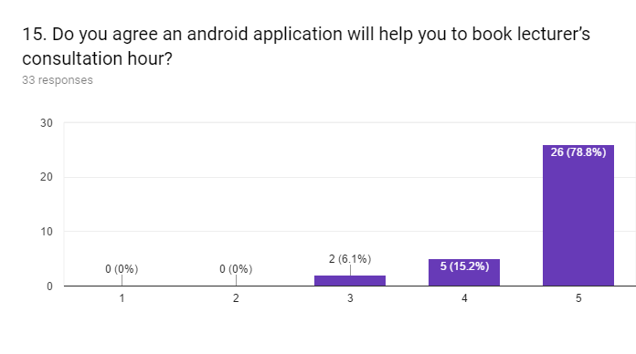

**Result**

From the above stated bar chart total participant were 33 for this question and 78.8% people strongly agreed that android application will help them to book the lecturer’s consultation hour. 15.2% agreed and 6.1% moderately agreed among all the participants.

**Analysis**

Among 33 participants the height number of participants strongly agreed that an android application will help them to book the lecturer’s consultation hour.

## 6.2 Analysis of data collected through interview

Name of Interviewee: _________________Md Showmik Rahman_____________ __

Position:____________________Student___________________________________

Time from: ___________2 pm________________To: _____________3 pm_______

Name of University: __Asia Pacific University___ Date of Interview: _25_/08_/2018

Type of Interview: ____Face-to-Face______________________________________

1. How Do you book Lecturer’s consultation Hour?

**Answer**: I usually visit university website and book my lecturer’s consultation, Once or twice I did it through directly sending email to the lecturer.

1. How do you manage the IT lab reservation? (Lecturer)

**Answer**: N/A (Not applicable for the student only lecturer can answer this specific question)

1. Who controls the current lab reservation system?

**Answer**: N/A (Not applicable for the student only lecturer can answer this specific question)

1. Is current system convenient to use? If ‘No’, then explain the reason.

**Answer**: No. because in the current system I need to visit the university website which is a bit more difficult. It’s time effective and if I need a consultation hour urgently I can’t book it in a faster way.

1. Did any student ask you before to help them by booking lecturer’s consultation hour? If ‘Yes’, Then how did you manage that?

**Answer**: Yes, every now and then I am facing this type of problem. Even few my classmates don’t know how to book lecturer’s consultation hour. I guided them to visit through university website when they asked me how to do it.

1. Have you found any student who asked you to show the lecturer’s consultation booking system and procedure? If ‘yes’, Then explain how did you do that?

**Answer**: I usually face this type of problem. I met a junior who is currently studying in diploma. He asked me the procedure of booking lecturer’s consultation hour. I thought him how to do it from university website.

1. Do you think in the new android application there should be an option to modify and cancel the consultation hour? If ‘yes’, then explain the reason why?

**Answer**: Yes, in case of emergency or sickness students are unable to go and meet their lecturers and if there will be any option to modify or cancel it before a certain time then both can plan accordingly.

1. Is the current system convenient to use? If ‘No’, please explain the reason why?

**Answer**: No, the current system is not convenient to use because it’s time effective and interface is not user-friendly.

1. If there are any new android system being developed for IT lab reservation and lecturer’s consultation booking will you try to use? If ‘yes’, please explain the reason why?

**Answer**: Yes, because it’s easy to understand and I can track my appointment with lecturer’s any time I need. I don’t need to visit the university web site which is bit difficult.

1. Do you think a live chat option will help to improve communication between the lecturer and student? If ‘yes’ then How?

**Answer**: Yes, if there will be any chat option in your proposed system it will help a lot to both lecturers and students. Sometimes a student can face any little problem regarding to their lessons, if they want to address those little issues, they need to book consultation hour that is complicated for both the lecturer and students.

## 6.2 Summary

The interview was done successfully with an APU student. From the interview information it is clear that the current system is not effective for the student. Most of the student are using the university for booking the lecturer’s consultation hour. They are demanding a user friendly and portable application from where can easily book the lecturer’s consultation hour.

Therefor the proposed “MScheduling application will help them to book the lecturer’s consultation hour in a convenient way.

# CHAPTER 7: SYSTEM ARCHITECHTURE

## 7.1 Introduction

System architecture is the conceptual model that defines the structure, behavior, and more views of a system. The designs help in delivering and fulfilling the requirements of the users and system. It presents the overview of the systems. “MScheduling” also have the diagrams specifying the overall design of the system which have been used for the development of system. The modules, interfaces, data and also other components are defined in system designs. There are use case diagram, class diagram, sequence diagram, system architecture diagram, entity relationship diagram which are included in the proposed system design.

## 7.2 Abstract Architecture

### 7.2.1 System Design

**Use Case Diagram**

Use case is a list of actions or event steps, typically defining the interactions between a role ( an actor) and a system, to achieve a goal. The actor can be a human, an external system, or time. It represents the missions or stakeholder goals. It represents the actions which the system can perform according to the users. the current system “MScheduling” has three different types of users, such as, the students, lecturers and the admin. The diagram for the system has given below:

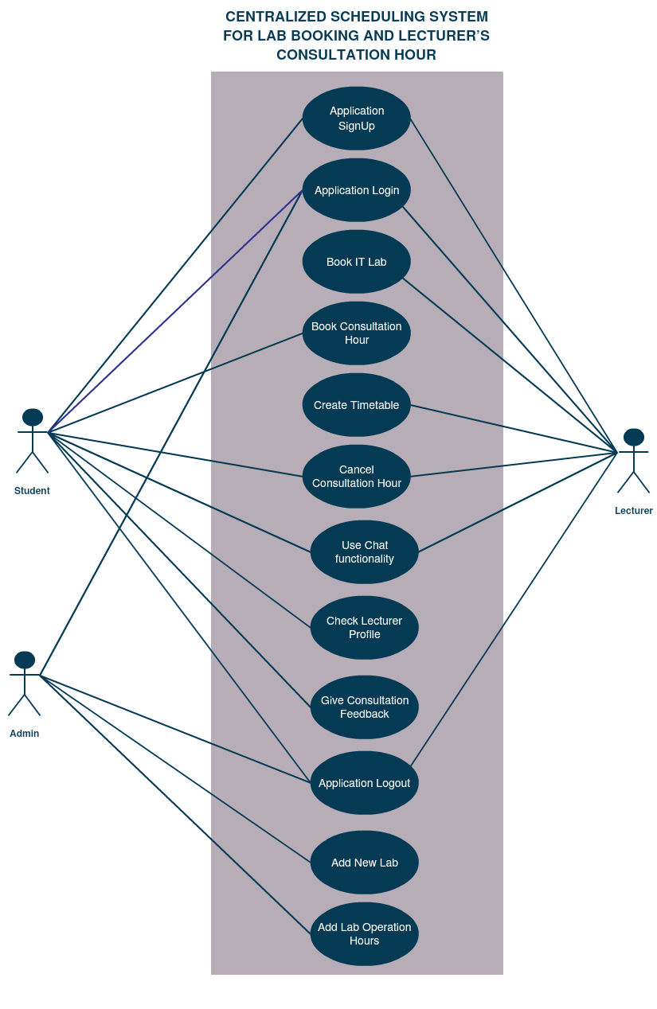

Figure 7 Use Case Diagram

**Actor Specification**

|  |  |
| --- | --- |
| **Actors** | **Details** |
| Students | Students are one of the main actors of “MScheduling” application. |
| Lecturers | Lecturers are one of the main actors of “MScheduling” application. |
| Admin | Admin adds the new labs to the list of labs available for classes. |

Table 6 Actors Specification

**Use Case Specification**

**SIGN UP**

|  |  |
| --- | --- |
| **Use Case Name** | Sign Up |
| Summary | Users must sign up the application before using it. After the sign up, the system validates the credentials and saves it into the database. |
| Actors | Students , Lecturers |
| Precondition | Users must open the application downloaded from play store and must have internet access in the device. |
| Use Case Flow | 1. Sign Up   1. Users enter their valid name, password and email address. 2. Then, user chooses whether it is student or lecturer. 3. Users clicks the “SIGN UP” button. 4. Application validate the name, email address and password. 5. Application saves the information in the database. |
| Post Condition | Application creates new account and give access to the account after the successful verification process. |

Table 7Users Specification (Sign Up)

**View Lecturer List**

|  |  |
| --- | --- |
| **View Lecturer List (Student) Use Case Name** | View Lecturer |
| Summary | System shows the list of available lecturers along with their email. When a particular lecturer is clicked, application moves to the page that shows his/her consultation hours. |
| Actors | Students |
| Precondition | Users have to open and login to the application. |
| Use Case Flow | 1. View Lecturer List   1. Users click the “Lecturer List” option in the side bar. 2. System shows the available lecturers in a list. |
| Post Condition | System displays the lecturer consultation hour. |

Table 8 Users Specification (View Lecturer List)

**View Lecturer Time-table**

|  |  |
| --- | --- |
| **View Lecturer Time Table (Lecturer) Use Case Name** | View Lecturer Timetable |
| Summary | System shows the timetable to the lecturer where he can decide which timeslot is free for him to put available for consultation. |
| Actors | Lecturers |
| Precondition | Users have to open and login to the application. |
| Use Case Flow | 1. View Lecturer Timetable   1. In the homepage, user can select “Timetable”. 2. System shows the lecturer timetable and lecturer can choose slots for consultation and click “save” button to save |
| Post Condition | System displays those free slot hours when student books the consultation. |

Table 9Users Specification (View Lecturer Timetable)

**Book Lab**

|  |  |
| --- | --- |
| **Book Lab (Lecturer) Use Case Name** | Book Lab |
| Summary | System shows the list of available labs that can be booked by lecturer. From where user select the particular lab, which redirects it to the page that shows the dates and available hours on a specific date. |
| Actors | Lecturers |
| Precondition | Users have to open and login to the application. |
| Use Case Flow | 1. View List Of Labs   1. In the homepage, user can select “Lab List option”. 2. System redirects to the page that shows the list of labs available. 3. User selects the particular lab and system directs it to the lab booking page.   2.Book lab   1. System provides the month calendar with highlighted dates, when lab is available. 2. User click on a particular date and the available timing is displayed. 3. User click on the timing and clicks “Book” button. 4. Then, it moves to the page that shows the booked lab details and has a “Cancel” button that can be used to cancel booking |
| Post Condition | The lab is booked under the particular lecturer. |

Table 10Users Specification (Book Lab)

**Book Consultation Time**

|  |  |
| --- | --- |
| **Book Consultation Time(Student) Use Case Name** | View Lecturer Timetable |
| Summary | System shows the list of available lecturers for consultation. From where user selects lecturer, which redirects it to the page that shows the dates and available consultation hours on a specific date. |
| Actors | Lecturers |
| Precondition | Users must open and login to the application. |
| Use Case Flow | 1. View Lecturer List   1. Users click the “Lecturer List” option in the side bar. 2. System shows the available lecturers in a list. After clicking the lecturer, application redirects it to the page to book consultation under a particular lecturer.   2. Book Consultation Time   1. System provides the month calendar with highlighted dates, when consultation is available. 2. User click on a particular date and the available timing is displayed. 3. User click on the timing and clicks “Book” button. |
| Post Condition | System books the consultation timing of student in the lecturer. |

Table 11Users Specification (Book Consultation Time)

**Add New Lab**

|  |  |
| --- | --- |
| **Add New Lab (Admin) Use Case Name** | Add new lab |
| Summary | System provides the option to add new lab for admin user. The admin enters the name and assign the time slot for when the lab will be available for booking. |
| Actors | admin |
| Precondition | Users have to open and login to the application. |
| Use Case Flow | 1. Add New Lab   1. User chooses the “Add New Lab” option from the side bar menu. 2. Then , it is redirected to the page where user enter the name of lab and assigns the timeslots to it, when it is going to be available. 3. The user clicks the “Submit” button. |
| Post Condition | System saves the new lab to the list of labs. |

Table 12 Users Specification (Add New Lab)

**Live Chat Functionality**

|  |  |
| --- | --- |
| **Use Case Name** | Add new lab |
| Summary | System provides the option to chat among the users. |
| Actors | Admin, Students, Lecturers |
| Precondition | Users have to open and login to the application. |
| Use Case Flow | 1. Chat Functionality   1. User select the “Message” option. 2. System open the chat functionality. 3. User type the messages and click the send button. |
| Post Condition | System send the messages to the particular user. |

Table 13 Users Specification (Live Chat Functionality)

**Class Diagram**

Class diagram represents a static structure diagram by defining the classes, methods and attributes of the “MScheduling” system. the class diagram also defines the relationship among the objects of the classes. The class diagram of the current system is given below:

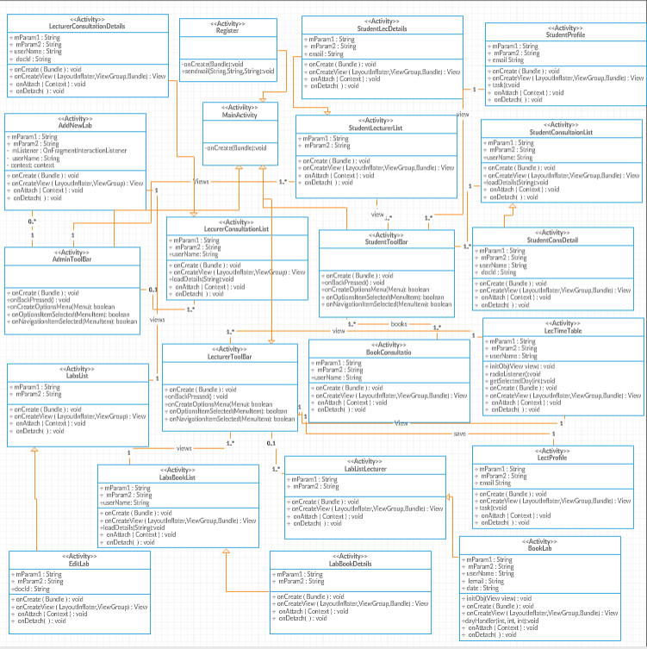

Figure 8 Class Diagram

**Sequence Diagram**

The sequence diagram is also a part of Unified Modelling Language (UML). It identifies the logics, functions and interactions between the objects and the external actors of a selected scenario from the use case diagram in a sequence.

**Register**

Users have to register themselves before using the “MScheduling” system. They have to input the valid email address and password for successful registration. Users will be accessed in the system after the registration.

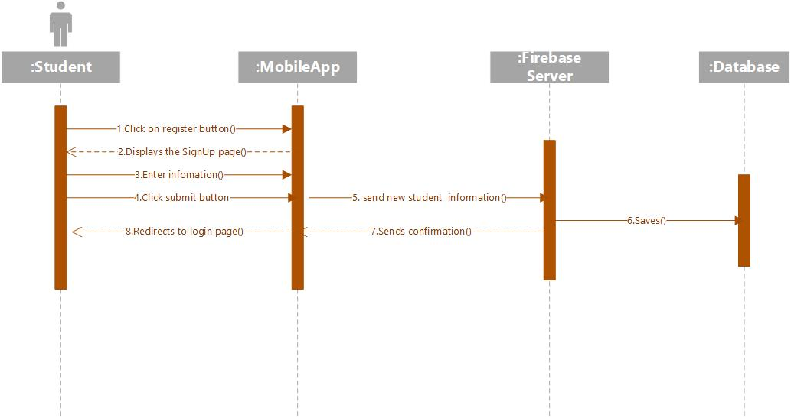

Figure 9 Sequence diagram(student register)

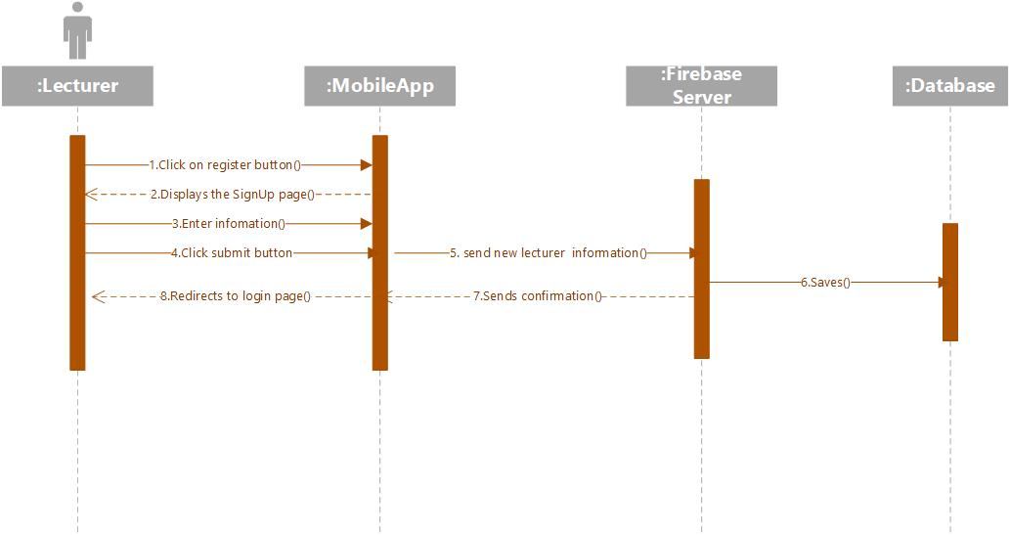

Figure 10 Sequence diagram(lecturer register)

**Login**

Users have to login with the registered email address and password. They have to login for once after registration. Later, the system will redirect to the home page directly after the first login until the users log out their account from the system.

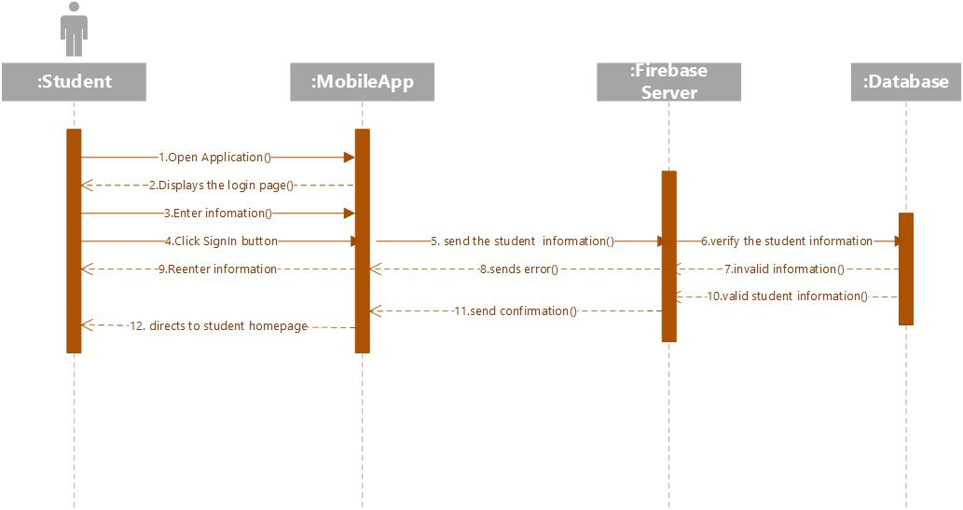

Figure 11 Sequence diagram (student login)

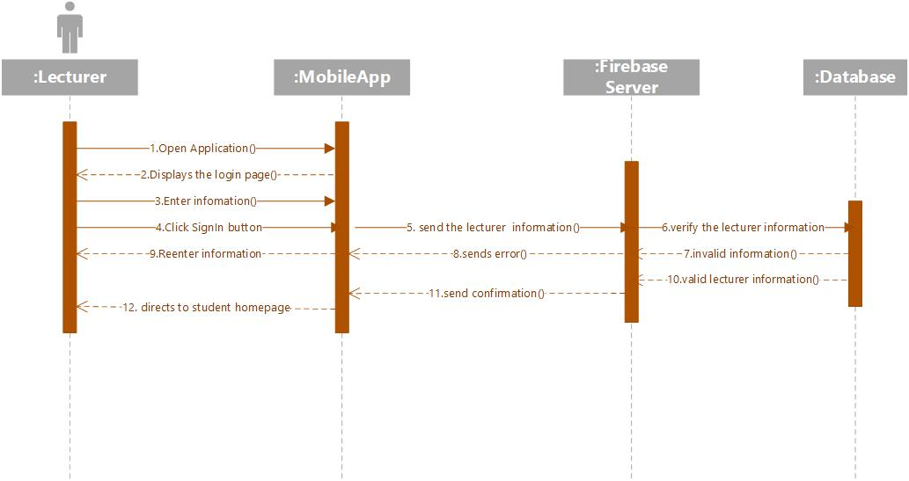

Figure 12 Sequence diagram(lecturer login)

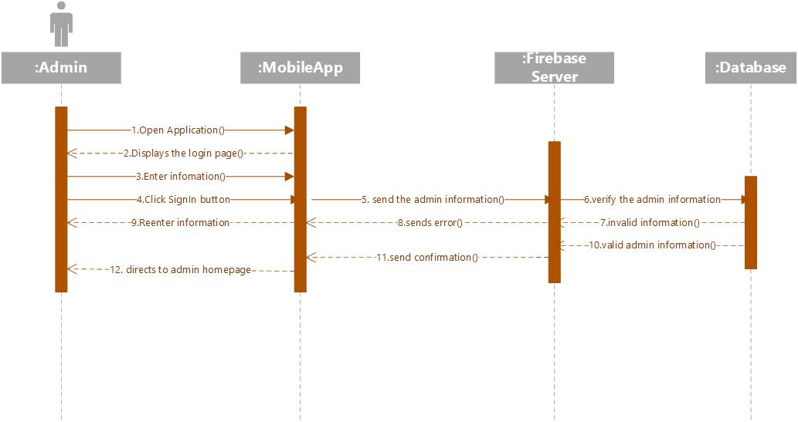Figure 13 Sequence diagram(Admin login)

**Add New Lab**

When admin logs in, he can add a new lab to the list of labs available for booking by clicking on “Add New Lab” option in navigation menu, then is directed to the page where user can put lab information and click “submit” button, the new lab will be added to the list of labs.

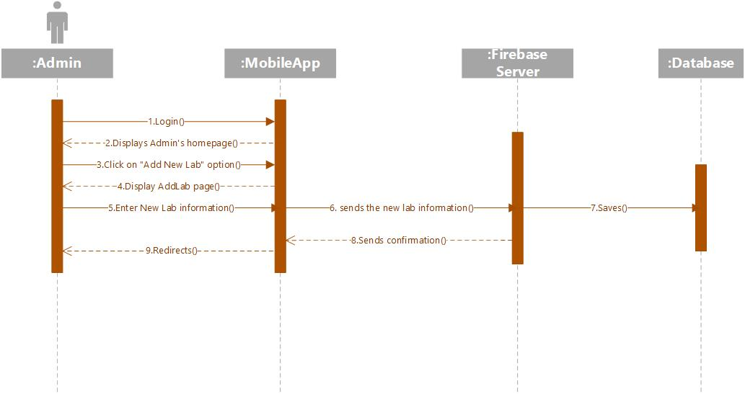

Figure 14 Sequence diagram(Add New Lab)

**Lecturer Timetable**

When lecturer logs in, he can set his timetable to put time slots for consultation by clicking on “consultation timetable” option in navigation menu, then is directed to the page where timetable is displayed, and the lecturer chooses the timeslots and click “save” button.

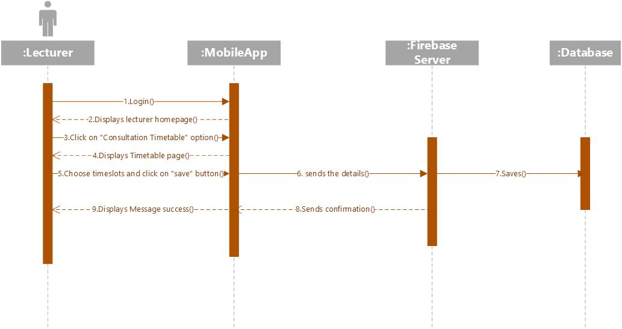

Figure 15 Sequence diagram(Lecturer Timetable)

**Book Lab**

When lecturer logs in, he can book lab by clicking on “Lab Reservation” option in navigation menu, then is directed to the page where list of labs is displayed. The lecturer clicks on any of the lab, “book lab” page is displayed, then the lecturer can select booking information and click “Book” button. The lab will be booked.

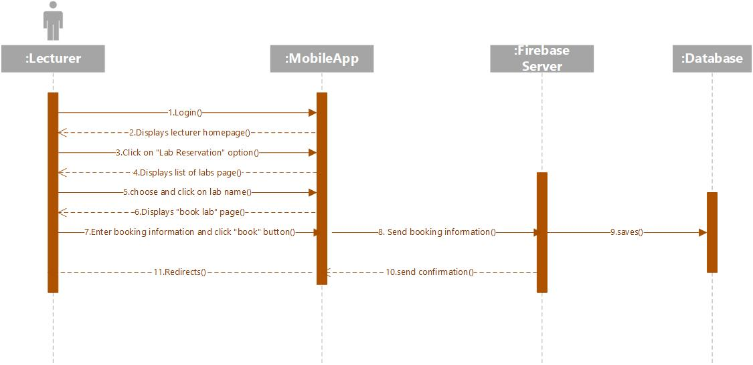

Figure 16 Sequence diagram(Book Lab)

**Lecturer List and Information(student)**

When student logs in, he can check lecturer details by clicking on “Lecturers List” option in navigation menu, then is directed to the page where list of lecturers is displayed. The student clicks on any lecturer in the list, then the app is directed to the page where lecturer details are displayed.

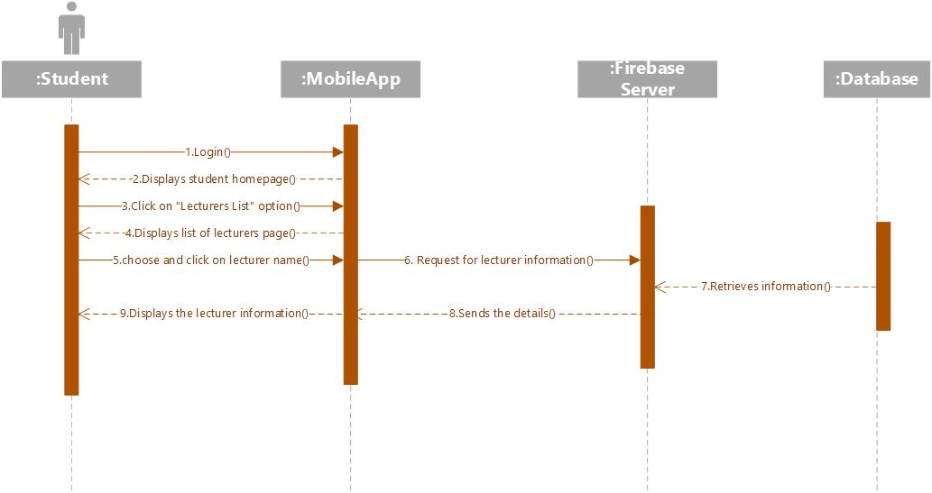

Figure 17 Sequence diagram(Lecturer details)

**Book Consultation**

When student logs in, he can book consultation by clicking on “Book Consultation” option in navigation menu, then is directed to the page where list of lecturers is displayed. The student clicks on any of the lecturer name, “book consultation” page is displayed, then the lecturer can select booking information and click “Book” button. The consultation will be booked.

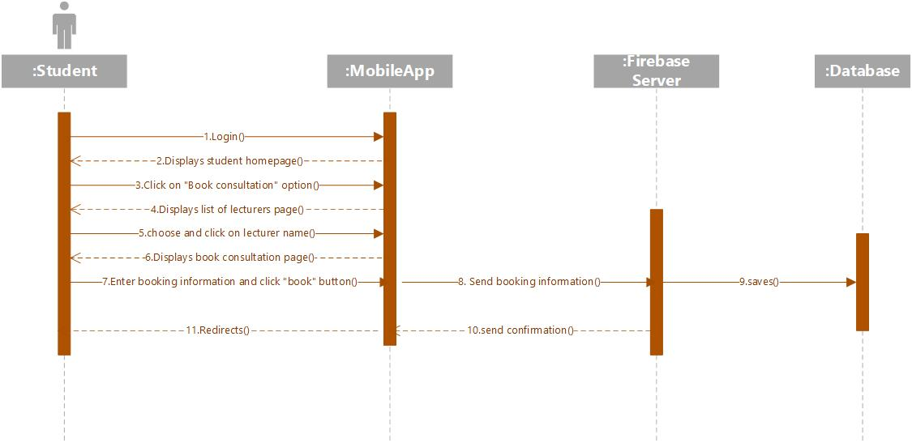

Figure 18 Sequence diagram(Book consultation)

**Consultation Feedback**

When the user logs in, he can view consultation details and provide feedback by clicking on “Consultations” option in navigation menu, then is directed to the page where list of consultations is displayed .The user clicks on any of the consultation, “consultation details” page is displayed, then the user can check details and provide feedback and click “save” button to save the details.

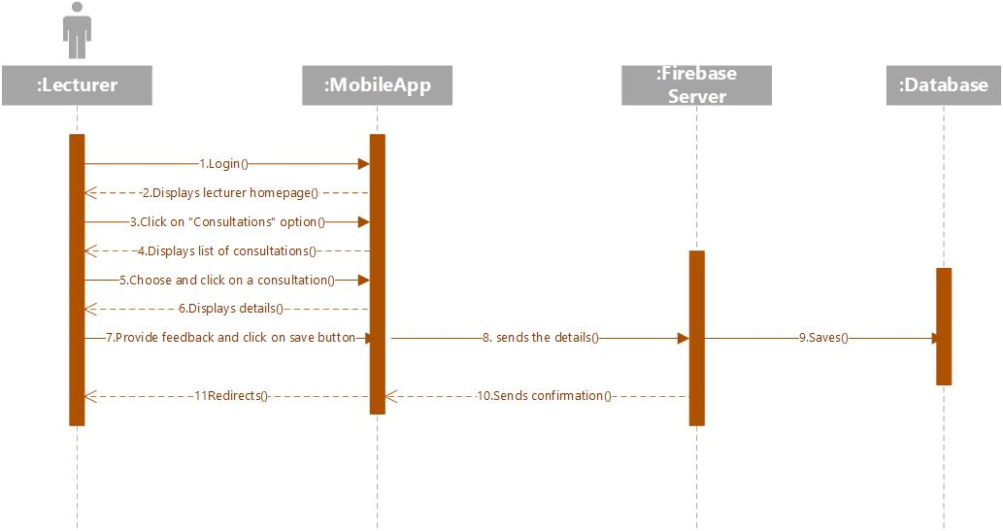

Figure 19 Sequence diagram (lecturer feedback)

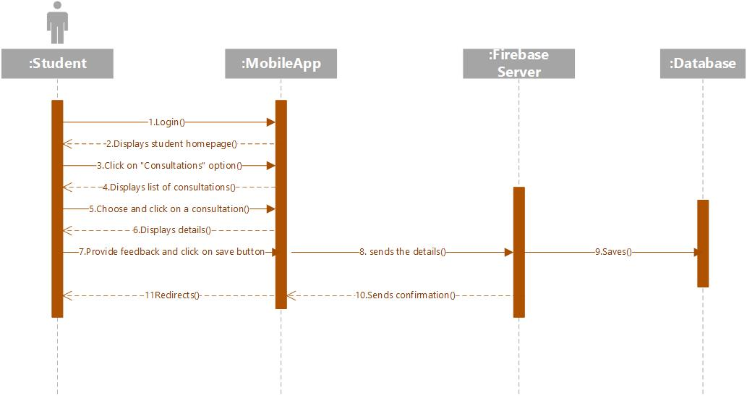

Figure 20 Sequence diagram(student feedback)

**System Architecture Diagram**

For system developers, they need system architecture diagrams to understand, clarify, and communicate ideas about the system structure and the user requirements that the system must support. It's a basic framework can be used at the system planning phase helping partners understand the architecture, discuss changes, and communicate intentions clearly. This diagram mainly extends and separates the system or application into multiple functional layers. The architecture diagram for the current system “MScheduling” has been separated into 5 layers, which are – Data Storage Layer, Functional Layer, Communication Layer, Internet Layer and User Interface Layer. The system architecture diagram is given below:

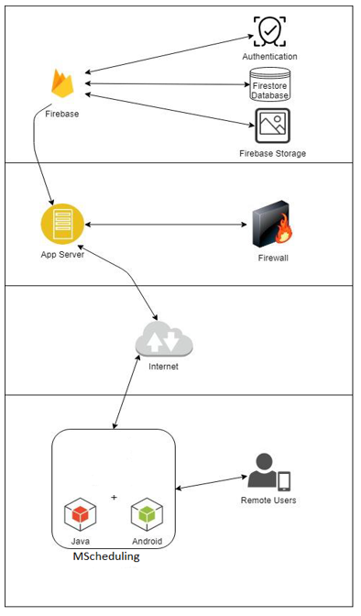

Figure 21 system architecture design

### 7.2.2 Database Design

#### 7.2.2.1 Entity Relationship Diagram

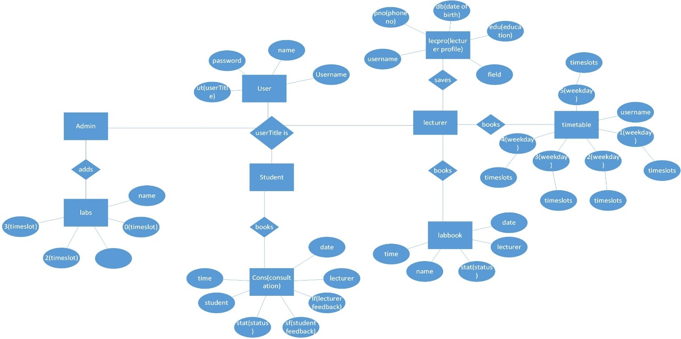

Figure 22 Entity Relationship Diagram

#### 7.2.2.2 Database Table Structure

**User Database:**

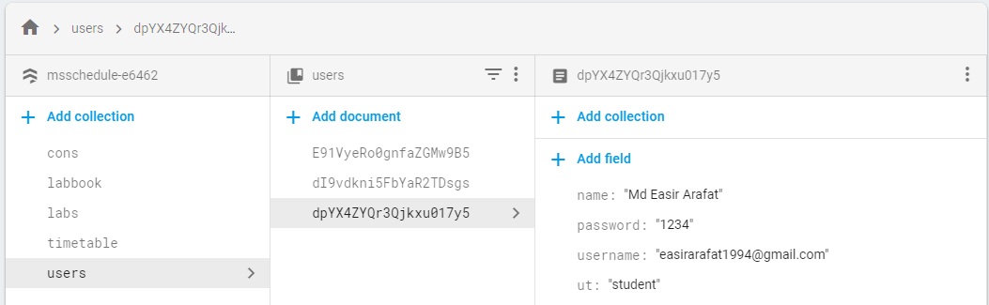

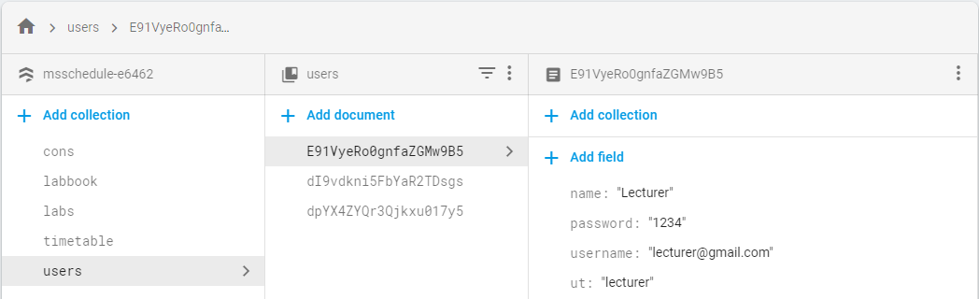

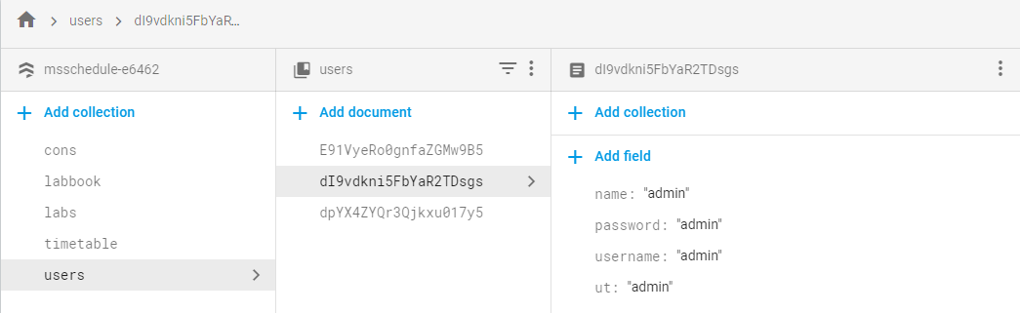

Table 14 User database

**Lecturer Timetable Database:**

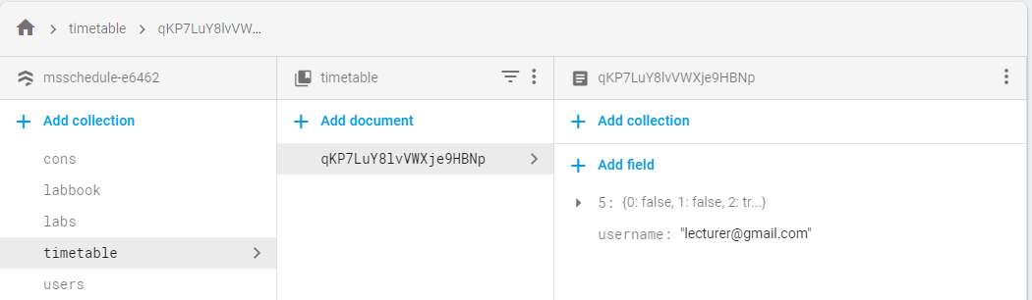

Table 15 Lecturer timetable database

**Lab Booking Database:**

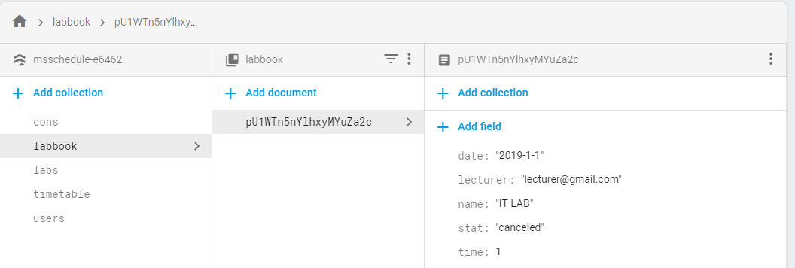

Table 16 Lab booking database

**Lab List Database:**

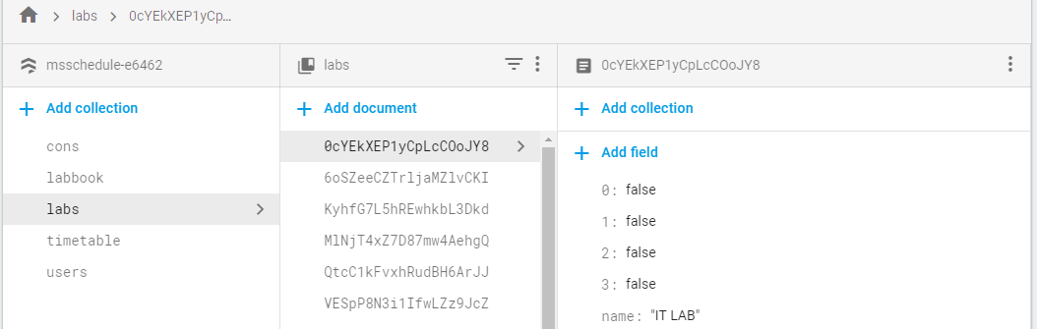

Table 17 Lab list database

**Lecturer Profile Database:**

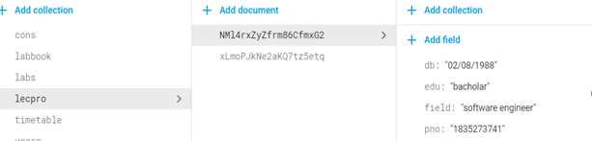

Table 18 Lecturer profile database

**Consultation Booking Database:**

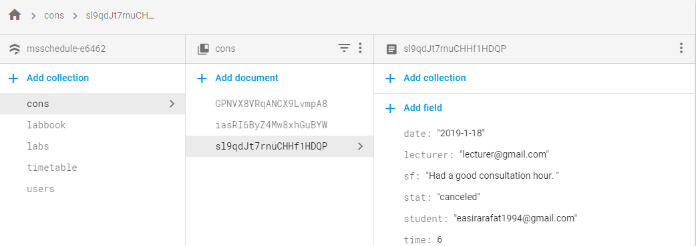

Table 19 consultation booking database

### 7.2.3 Interface Design

**Sign Up**

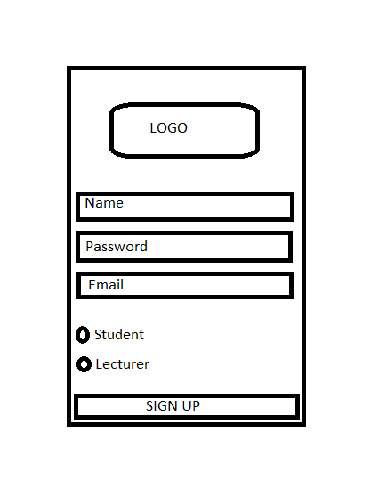

Figure 23 sign up (interface)

**Sign In**

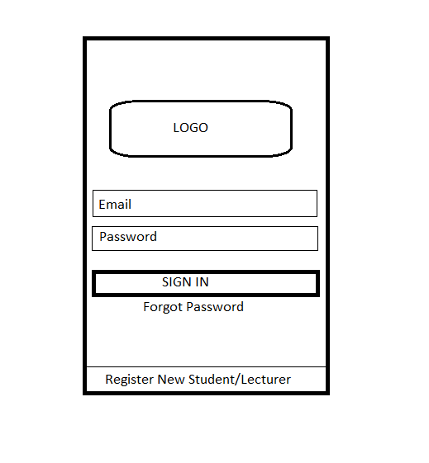

Figure 24 sign in (interface)

**Admin Sign-in**

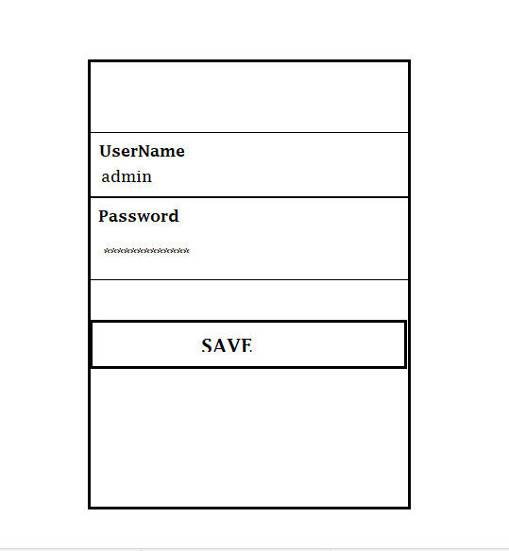

Figure 25 Admin sign in (interface)

**Menu (Admin)**

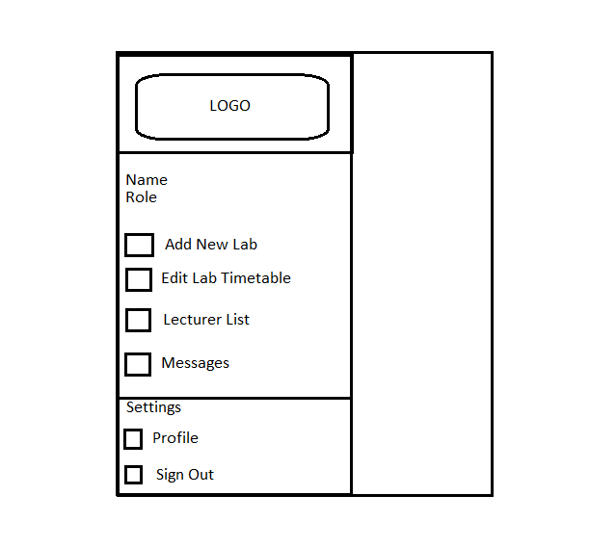

Figure 26 Main menu (interface)

**Add New Lab (Admin)**

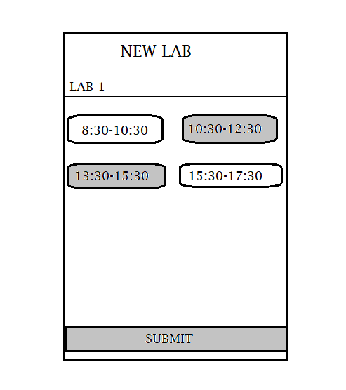

Figure 27 Add new lab (interface)

**Lecturer List(student)**

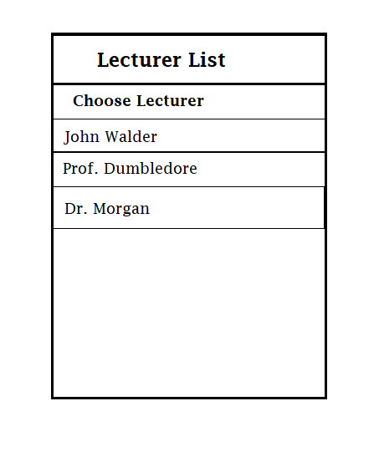

Figure 28 Lecturer list (interface)

**Lecturer Profile (student)**

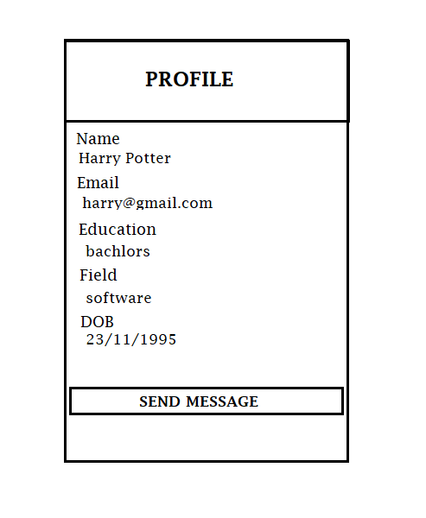

Figure 29 Lecturer profile (interface)

**Lecturer chat (student)**

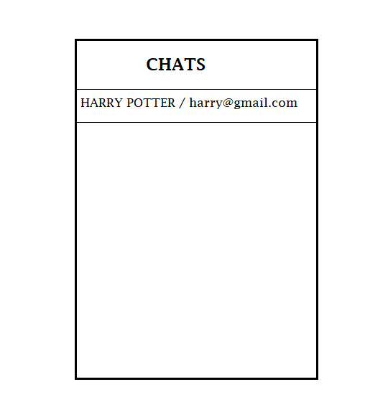

Figure 30 Lecturer chat (interface)

**View Lab List (Lecturer)**

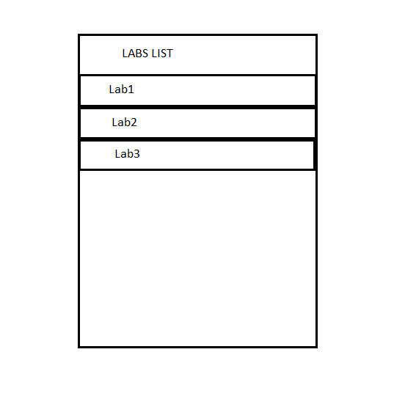

Figure 31 Lab list (interface)

**Book Lab (lecturer)**

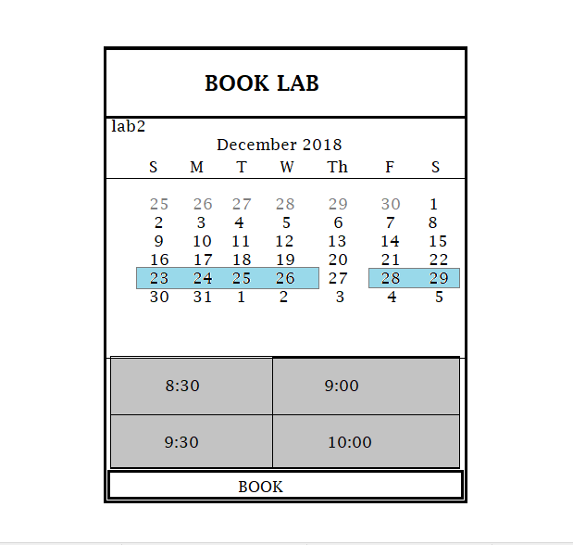

Figure 32 Book Lab (interface)

**View Timetable (Lecturer)**

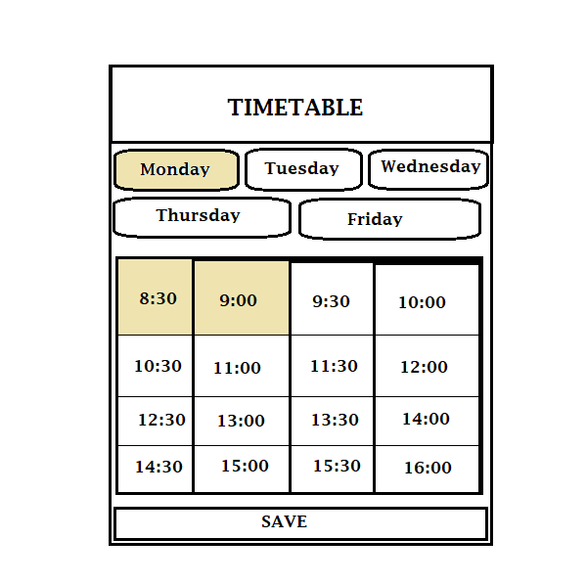

Figure 33 Timetable(interface)

**Lecturer Profile (Lecturer)**

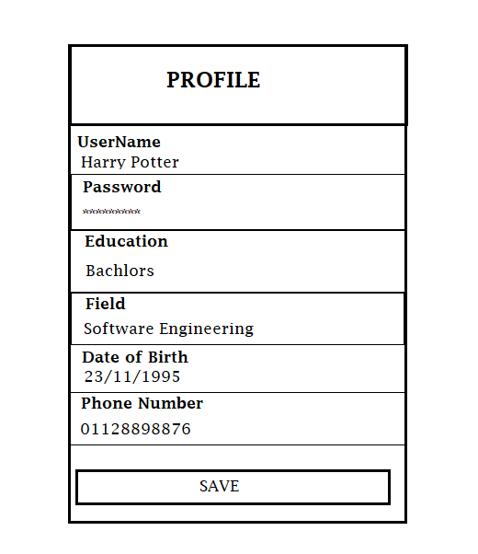

Figure 34 Lecturer Profile(interface)

**Book Consultation (Student)**

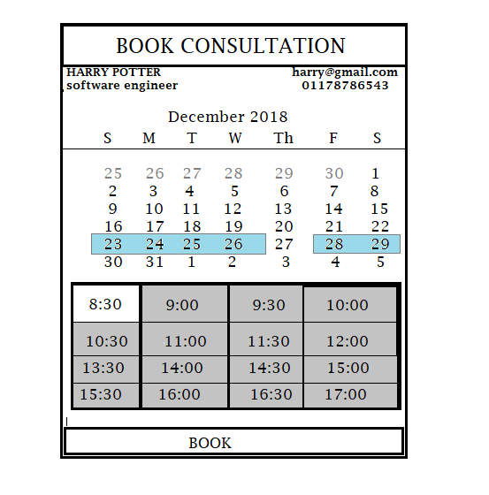

Figure 35 Book consultation (interface)

**Consultation Feedback(Lecturer/student)**

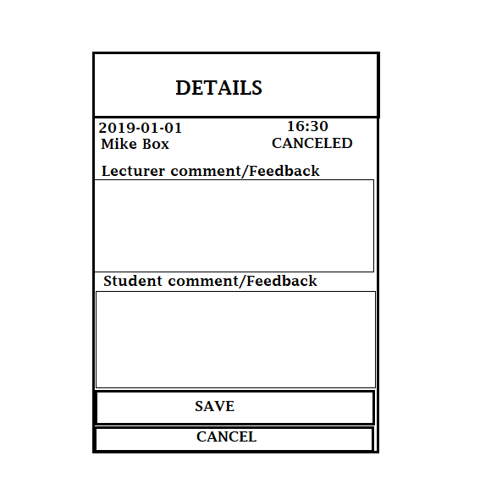

Figure 36 Consultation feedback (interface)

**Consultation details (student/lecturer)**

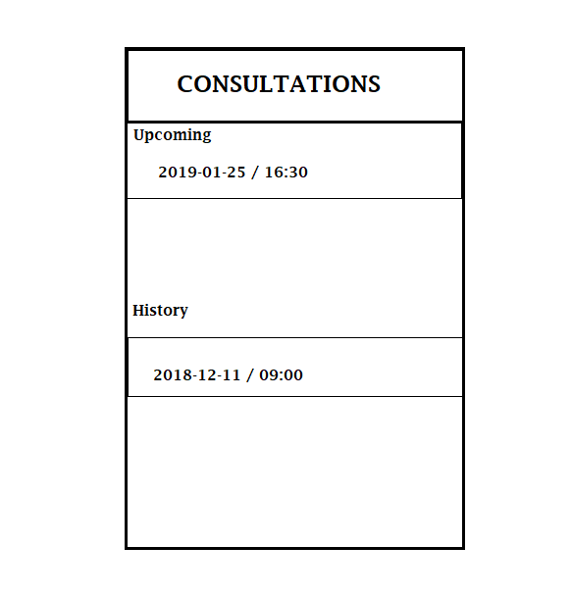

Figure 37 Consultation details(interface)

# CHAPTER 8: PROJECT PLAN

## 8.1 Features for “MScheduling” Application

|  |  |  |
| --- | --- | --- |
| **Feature ID** | **Feature** | **Description** |
| **1** | Register Students /Lecturers | System validates the email address and password and then store the information in the database(firebase). |
| **2** | Login (Students/lecturers) | System retrieves the students’/lecturers’ information from the database to check whether it is registered or not. |
| **3** | Login (Admin) | System allows admin to login with the admin credentials. |
| **4** | Add new Lab | System allows admin to add new lab to the list of labs available to lecturers. |
| **5** | Show lecturer list | Shows the list of lecturers available for consultation. |
| **6** | Show lab list | Shows the list of labs to lecturers for them to book. |
| **7** | View Timetable | Shows the lecturer timetable to lecturer, making easy for him to manage timetable and assign consultations. |
| **8** | Book lab | System lets lecturer book lab by choosing the available time slot of lab. |
| **9** | Book consultation | System lets student book the consultation by choosing the time slots made available by the lecturer. |
| **10** | View Lecturer profile | System lets the student view the profile details of the lecturer. |
| **11** | Edit profile details | System lets the lecturer edit his profile details |
| **12** | chat | System lets the student chat with lecturer |
| **13** | Consultation check | System lets the user know of the upcoming consultations and history of the past consultations. |
| **14** | Consultation feedback | System lets the students and lecturer both provide the feedback of the attended consultation. |

Table 20 Features for "MScheduling" Application

## 8.2 Release Plan for “MScheduling” Application

|  |  |  |
| --- | --- | --- |
| **Version Number** | **Version Content(s)** | **Release Week** |
| **1.0** | The version 1.0 consists of the function for the student, lecturer and admin to log in. This function allows to login with specific username and password. | The version 1.0 will be released on 1st week of January |
| **2.0** | The version consists of the development of interface and implementation of firebase for backend. | The version 2.0 will be released on 3rd week of February |
| **2.1** | The version consists of the development chat functionality with all other features. | The version 2.1 will be released on 4th week of March |

Table 21 Release Plan for "MScheduling" Application

## 8.3 Test Plan

### 8.3.1 Test Plan for Unit Testing

Unit testing is a level of software testing where individual units/ components of a software are tested. The purpose is to validate that each unit of the software performs as designed. A unit is the smallest testable part of any software. It usually has one or a few inputs and usually a single output. Unit testing is the first phase of software testing. The smallest parts of the system are called the units. These units are tested to check whether these are working as planned or not. As example, a unit may have one or few inputs and only one output. The test plan for unit testing for the “MScheduling” system has given below in a table:

**Test Unit: Sign Up**

|  |  |  |  |  |  |
| --- | --- | --- | --- | --- | --- |
| **No.** | **Test Case** | **Expected Result** | **Actual Result** | **Pass** | **Fail** |
| **1** | Email Format | Validation must show when the email address will not have the correct format. |  |  |  |
| **2** | Password must have at least 6 characters | Validation must show when the password has less than 6 characters |  |  |  |
| **3** | Empty Field | Validation will show when any field will be empty |  |  |  |
| **4** | Trigger Sign-up Button | User credentials should be saved |  |  |  |

Table 22 Unit Testing Plan (Sign Up)

**Test Unit: Login(Students/lecturers)**

|  |  |  |  |  |  |
| --- | --- | --- | --- | --- | --- |
| **No.** | **Test Case** | **Expected Result** | **Actual Result** | **Pass** | **Fail** |
| **1** | Incorrect email address and password | Validation must show when the email address or password is not correct. |  |  |  |
| **2** | Validate correct Email Address and password from the database. | Prompt user to the home activity if the email address and password is correct. |  |  |  |
| **3** | Empty Field | Validation will show when any field will be empty |  |  |  |
| **4** | Trigger Sign In Button | Prompt user to the home activity and shows “Logged in Successfully” |  |  |  |
| **5** | Trigger Register Button | Prompt user to the register activity. |  |  |  |

Table 23 Unit Testing Plan for Login (Student, Lecturer)

**Test Unit: Login(Admin)**

|  |  |  |  |  |  |
| --- | --- | --- | --- | --- | --- |
| **No.** | **Test Case** | **Expected Result** | **Actual Result** | **Pass** | **Fail** |
| **1** | Incorrect email address and password | Validation must show when the email address or password is not correct. |  |  |  |
| **2** | Validate correct Email Address and password from the database. | Prompt user to the home activity if the email address and password is correct. |  |  |  |
| **3** | Empty Field | Validation will show when any field will be empty |  |  |  |
| **4** | Trigger Sign In Button | Prompt user to the home activity and shows “Logged in Successfully” |  |  |  |

Table 24 Unit Testing Plan for Login (Admin)

**Test Unit: Add New Lab**

|  |  |  |  |  |  |
| --- | --- | --- | --- | --- | --- |
| **No.** | **Test Case** | **Expected Result** | **Actual Result** | **Pass** | **Fail** |
| **1** | Empty Field | Validation will show when any field will be empty |  |  |  |
| **2** | Trigger Submit Button | The information of the new lab must be stored in database, after clicking the “Submit” button. |  |  |  |
| **3** | Trigger navigation drawer menu Button | Must prompt navigation drawer menu |  |  |  |

Table 25 Unit Testing Plan (Add New Lab)

**Test Unit: Lecturers List**

|  |  |  |  |  |  |
| --- | --- | --- | --- | --- | --- |
| **No.** | **Test Case** | **Expected Result** | **Actual Result** | **Pass** | **Fail** |
| **1** | Show all the lecturers in a list | All of the lecturers must be able to retrieve from the database, show it in a list in the system. |  |  |  |
| **2** | Search lecturers | Those lecturers according to the similarity between their name and entered name based on the alphabets must be shown in a list. |  |  |  |
| **3** | Trigger lecturer name. | Prompt user to the lecturer profile |  |  |  |
| **4** | Trigger navigation drawer menu Button | Must prompt navigation drawer menu |  |  |  |

Table 26 Unit Testing Plan (Lecturers List)

**Test Unit: Lecturer Profile**

|  |  |  |  |  |  |
| --- | --- | --- | --- | --- | --- |
| **No.** | **Test Case** | **Expected Result** | **Actual Result** | **Pass** | **Fail** |
| **1** | Trigger “Send Message” Button | Should prompt user to the chat thread between lecturer and user(student). |  |  |  |

Table 27 Unit Testing Plan (Lecturer profile)

**Test Unit: Book Consultation Timetable**

|  |  |  |  |  |  |
| --- | --- | --- | --- | --- | --- |
| **No.** | **Test Case** | **Expected Result** | **Actual Result** | **Pass** | **Fail** |
| **1** | Show all the week days and timing under it | All the weekdays should be displayed along with time slots |  |  |  |
| **2** | Trigger weekday | Prompts the user to choose desired timeslots under it |  |  |  |
| **3** | Trigger Save Button | The information of the consultation must be stored in database with confirmation message. |  |  |  |
| **4** | Trigger navigation drawer menu Button | Must prompt navigation drawer menu |  |  |  |

Table 28 Unit Testing Plan (Book Consultation Timetable)

**Test Unit: Lab list**

|  |  |  |  |  |  |
| --- | --- | --- | --- | --- | --- |
| **No.** | **Test Case** | **Expected Result** | **Actual Result** | **Pass** | **Fail** |
| **1** | Show all the labs available in a list | All of the available labs must be retrieving from the database show it in a list in the system. |  |  |  |
| **2** | Trigger any of the lab name | Redirects the user to the Book lab page. |  |  |  |
| **3** | Trigger navigation drawer menu Button | Must prompt navigation drawer menu |  |  |  |

Table 29 Unit Testing Plan (Lab List)

**Test Unit: Book Lab**

|  |  |  |  |  |  |
| --- | --- | --- | --- | --- | --- |
| **No.** | **Test Case** | **Expected Result** | **Actual Result** | **Pass** | **Fail** |
| **1** | Show all the dates and available time slots under it | A month date calendar should be displayed and timeslots. |  |  |  |
| **2** | Trigger any date | Displays the time slots under it |  |  |  |
| **3** | Trigger “Book” Button | The information of the booking must be stored in database with confirmation message. |  |  |  |
| **4** | Trigger navigation drawer menu Button | Must prompt navigation drawer menu |  |  |  |

Table 30 Unit Testing Plan (Book Lab)

**Test Unit: Book Consultation**

|  |  |  |  |  |  |
| --- | --- | --- | --- | --- | --- |
| **No.** | **Test Case** | **Expected Result** | **Actual Result** | **Pass** | **Fail** |
| **1** | Show all the dates and available time slots under it | A month date calendar should be displayed and timeslots. |  |  |  |
| **2** | Trigger any date | Displays the time slots under it |  |  |  |
| **3** | Trigger “Book” Button | The information of the booking must be stored in database with confirmation message. |  |  |  |
| **4** | Trigger navigation drawer menu Button | Must prompt navigation drawer menu |  |  |  |

Table 31 Unit Testing Plan (Book Consultation)

**Test Unit: Edit lecturer profile**

|  |  |  |  |  |  |
| --- | --- | --- | --- | --- | --- |
| **No.** | **Test Case** | **Expected Result** | **Actual Result** | **Pass** | **Fail** |
| **1** | Empty Field | Validation will show when any field will be empty |  |  |  |
| **2** | Trigger Save Button | The information of the consultation must be stored in database with confirmation message. |  |  |  |
| **3** | Trigger navigation drawer menu Button | Must prompt navigation drawer menu |  |  |  |

Table 32 Unit Testing Plan (Edit Lecturer Profile)

**Test Unit: Consultation details**

|  |  |  |  |  |  |
| --- | --- | --- | --- | --- | --- |
| **No.** | **Test Case** | **Expected Result** | **Actual Result** | **Pass** | **Fail** |
| **1** | Empty Field | Validation will show when any field will be empty |  |  |  |
| **2** | Trigger Save Button | The information of the consultation must be stored in database with confirmation message. |  |  |  |
| **3** | Trigger “cancel” Button | Should return to the home page. |  |  |  |
| **3** | Trigger navigation drawer menu Button | Must prompt navigation drawer menu |  |  |  |

Table 33Unit Testing Plan (Consultation Details)

### 8.3.2 Test Plan for Integration Testing

Integration testing is the second part of software testing. All the units of the system are combined for testing in a group. The integration testing is mainly used for check and expose the defects in the connection between the integrated components of the system.

The test plan for integration testing for the “MScheduling” system has given below in a table:

|  |  |  |  |  |
| --- | --- | --- | --- | --- |
| **Testing Function** | **Test Description** | **Test Case** | **Expected Result** | **Actual Result** |
| Register | Store the email address and password in the database. | Input email address and password and click “Sign-up” button. |  |  |
| Login(student/lecturer) | Validates email address and password from the database. | Input email address and password and click “Sign In” button |  |  |
| Login (Admin) | Checks the username and password from the system. | Input username and password and click “Sign In” button |  |  |
| Add New Lab | Store the information of new lab in the database | Input all the information of the new lab and click the “Submit” button |  |  |
| Lecturers List | Retrieve all the list of lecturers available from the database. | Click on a selected lecturer from the list. |  |  |
| Lecturer Profile | Store the information of the lecturer profile in the database | Input all the lecturer information as a lecturer and click the “Save” button |  |  |
| Book Consultation Timetable | Store the information of the lecturer consultation in the database. | Select all the information for consultation timing and click the “Save” button. |  |  |
| Lab list | Retrieve all the list of labs available from the database. | Click on a selected lab from the list. |  |  |
| Book Lab | Store the information of the lab booking in the database. | Select all the information for lab booking and click the “Book” button |  |  |
| Book Consultation(student) | Store the information of student consultation booking in the database. | Select all the information for consultation booking and click the “Book” button |  |  |
| Edit lecturer profile | Store the information of the lecturer profile in the database | Input all the lecturer information as a lecturer and click the “Save” button |  |  |
| Consultation details | Store the information of lecturer and student feedback in database | Input the feedback and click the “Save” button. |  |  |

Table 34 The test plan for integration testing for the “MScheduling”

### 8.3.3 Test Plan for User Acceptance Testing

User acceptance testing is actually the testing of the overall and fully functional system in the real world. The current system “MScheduling” will be performed by three types of users. They are the students, lecturers and admin. Basically, four users will be performed the testing. One of them will be the admin, one will be lecturer and other two others will be students of Asia Pacific University. The fully functional system of “MScheduling” will be given to the users. The admin will test the admin functionality of the system, lecturer will test the lecturer functionality of the system and the students will test the student functionality of the system. After they finish their testing, they will be given a feedback form each person which consists of 4 questions. There are 3 yes/no questions and one optional feedback question. The yes/no questions have been chosen rather than normal questions because the students might not provide the accurate answer.

The questions are given below:

1. Do you think the application makes students life easier?

* 1. o Yes
  2. o No

2. Do you think the interface for the “MScheduling” application is user-friendly?

* 1. o Yes
  2. o No

3. Do you think the functions of the system will be enough to fulfil the requirements of the users?

o Yes

o No

4. Do you think the developed system is better than the current web-based system?

* 1. o Yes
  2. o No

5. Any suggestions or opinions for improving the current system will be highly appreciated.

# CHAPTER 9: IMPLEMENTATION

## 9.1 Screenshots

### 9.1.1 Screenshots for Register Activity

#### 9.1.1.1 Description

The users have to register with their valid email address, name and password to get access through the system “MScheduling”. After entering the required information, they must click the “Sign-up” button.

#### 9.1.1.2 Screenshot

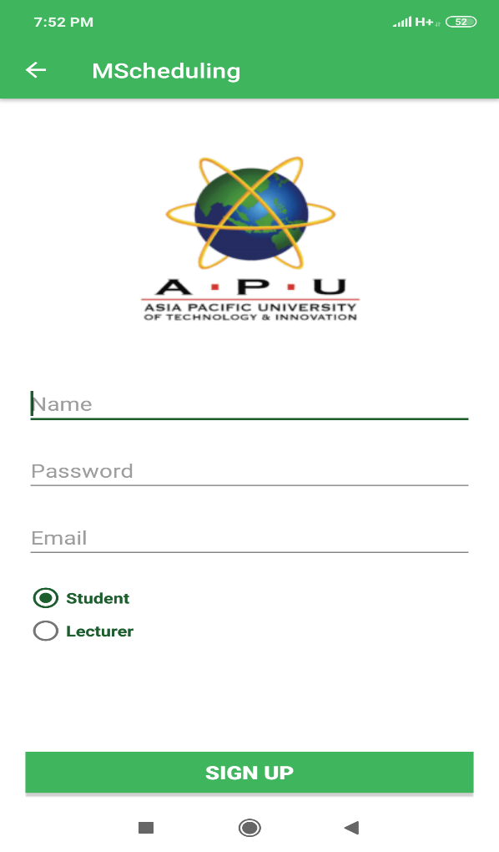

Figure 38 Sign-Up Activity

### 9.1.2 Screenshots for Login Activity

#### 9.1.2.1 Description

The user must enter the valid username and password and then has to click the “Sign In Button” to get access. The “Forgot Password” text when click moves to reset password page and “Register New Student/Lecturer account” redirects to register page.

#### 9.1.2.2 Screenshot

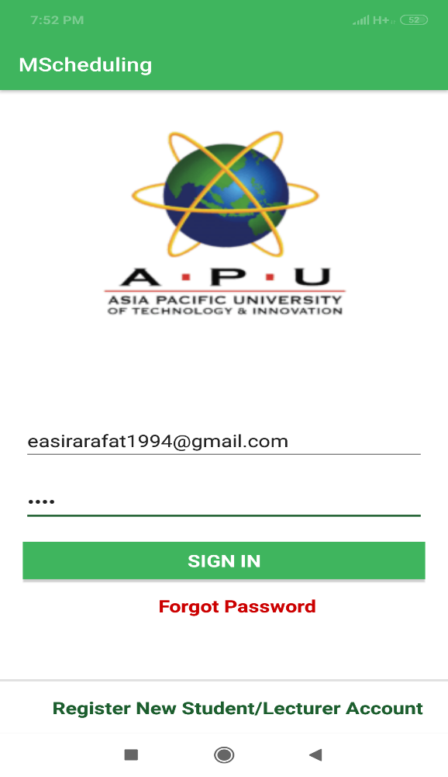

Figure 39 Login (Students) Activity

### 9.1.3 Screenshots for Main Menu Activity (Admin)

#### 9.1.3.1 Description

This main menu displays the user name, timetable, lecturer list, add new lab for admin, messaging the lecturer, profile and sign-out functionality. Admin and lecturers both can chat between them.

#### 9.1.3.2 Screenshot

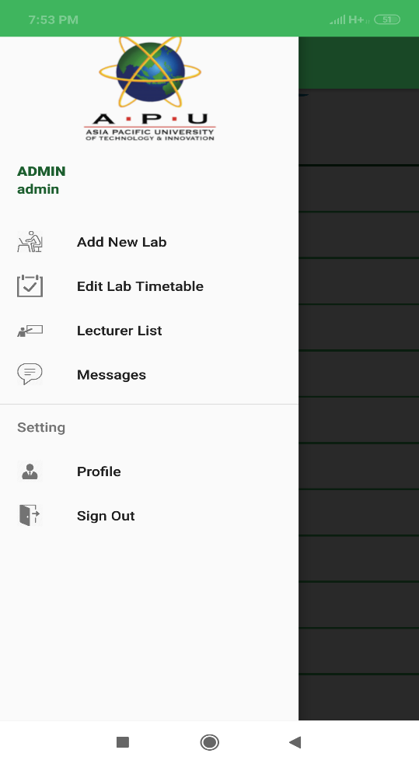

Figure 40 Login (Admin) Activity

### 9.1.4 Screenshots for Main Menu Activity (Student)

#### 9.1.4.1 Description

In the student account the navigation drawer menu displays the user name, consultations, book consultations, lecturers list, messages, profile and Sign Out.

#### 9.1.4.2 Screenshot

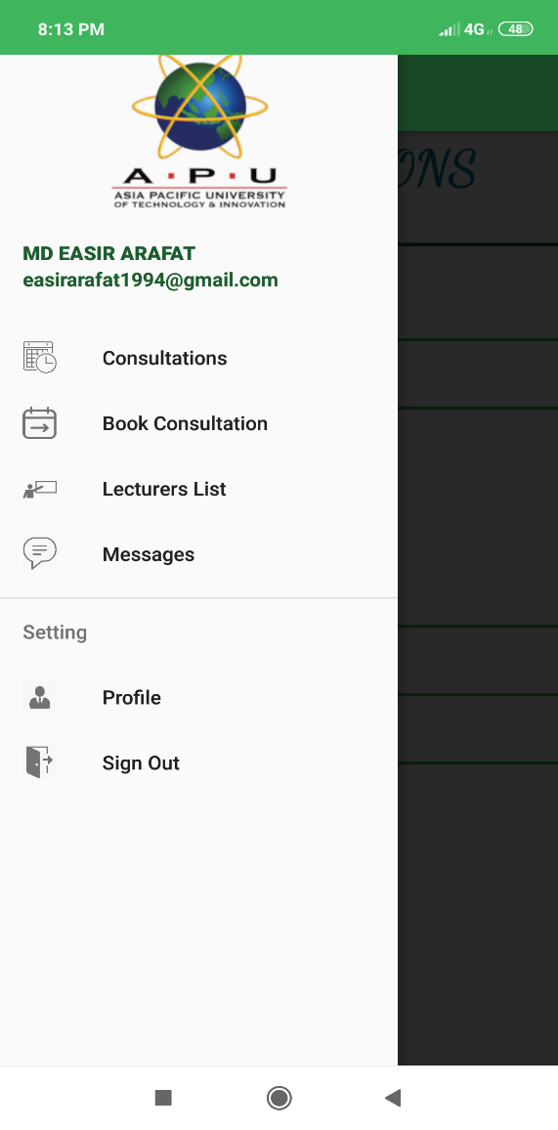

Figure 41 Login (Student) Activity

### 9.1.5 Screenshots for Main Menu Activity (Lecturer)

#### 9.1.5.1 Description

In the Lecturer account the navigation drawer menu displays the user name, upcoming consultations, consultation timetable, lab reservation, messages, profile and Sign Out.

#### 9.1.5.2 Screenshot

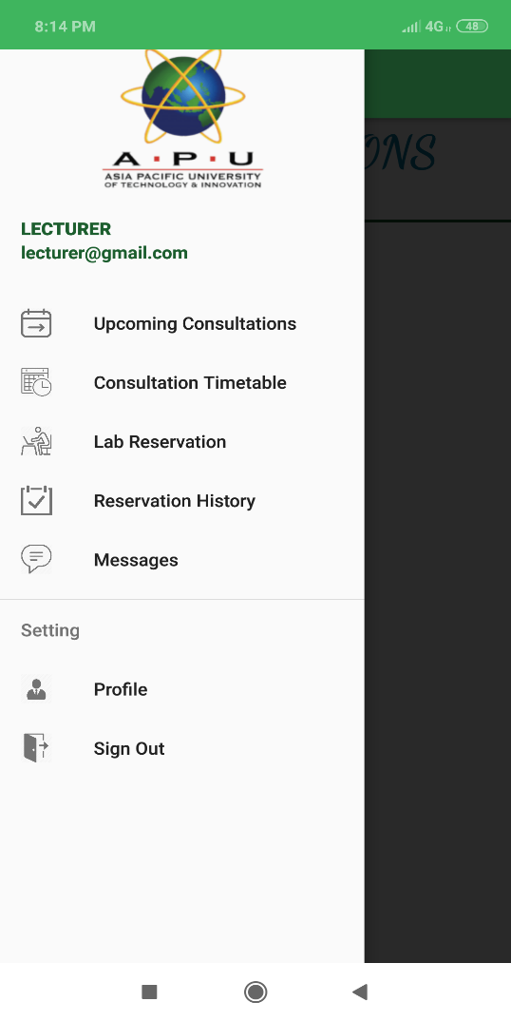

Figure 42 Login (Lecturer) Activity

### 9.1.6 Screenshots for Add New Lab

#### 9.1.6.1 Description

This is the layout for adding new lab by providing the lab name, choosing the timeslots and clicking “submit” button.

#### 9.1.6.2 Screenshot

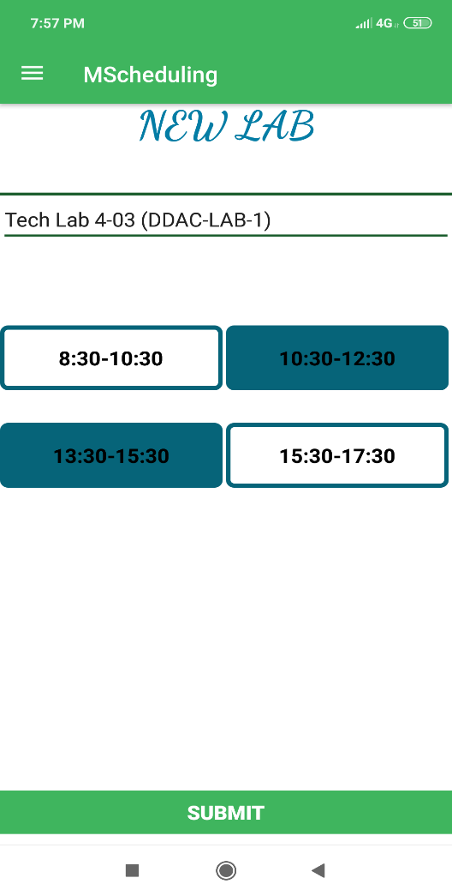

Figure 43 Add New Lab (Admin) Activity

### 9.1.7 Screenshots for Labs list Activity

#### 9.1.7.1 Description

The “Labslist” activity is available in the panel of lecturers and admin. The user can view the available labs in the list and by clicking on any of the name, it takes it to the page for booking the lab

#### 9.1.7.2 Screenshot

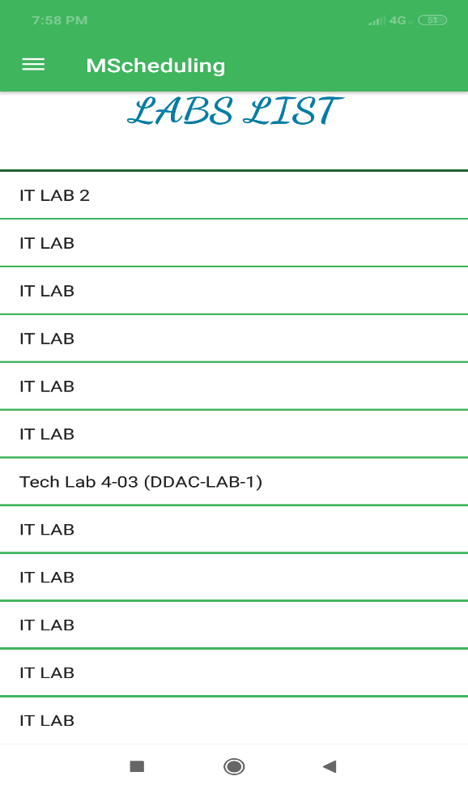

Figure 44 Labs List (Admin) Activity

### 9.1.8 Screenshots for Book lab Activity

#### 9.1.8.1 Description

In this activity, lecturer can book the lab by choosing the dates and timeslots provided under it and then clicking the book button.

#### 9.1.8.2 Screenshot

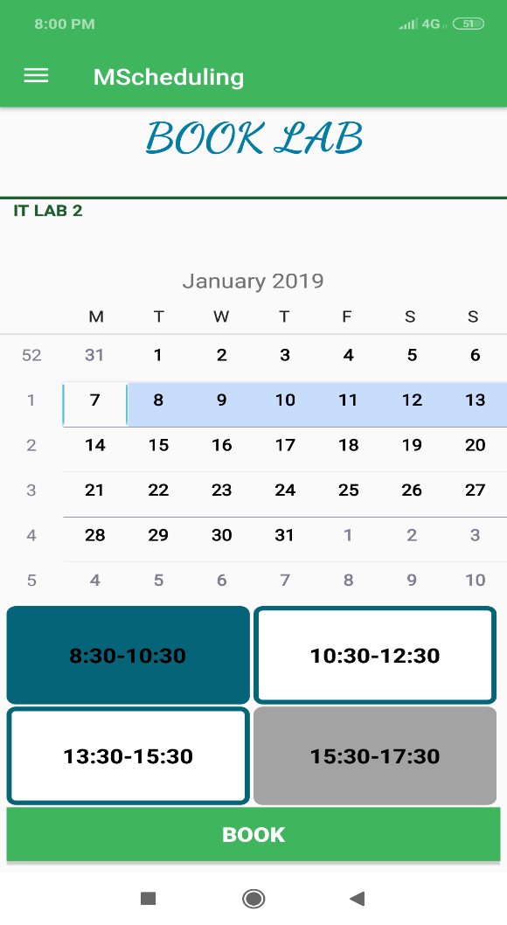

Figure 45 Book Lab (Lecturer) Activity

### 9.1.9 Screenshots for LecTimetable Activity

#### 9.1.9.1 Description

In this activity, lecturer saves the timetable and puts up timeslots for consultation.

#### 9.1.9.2 Screenshot

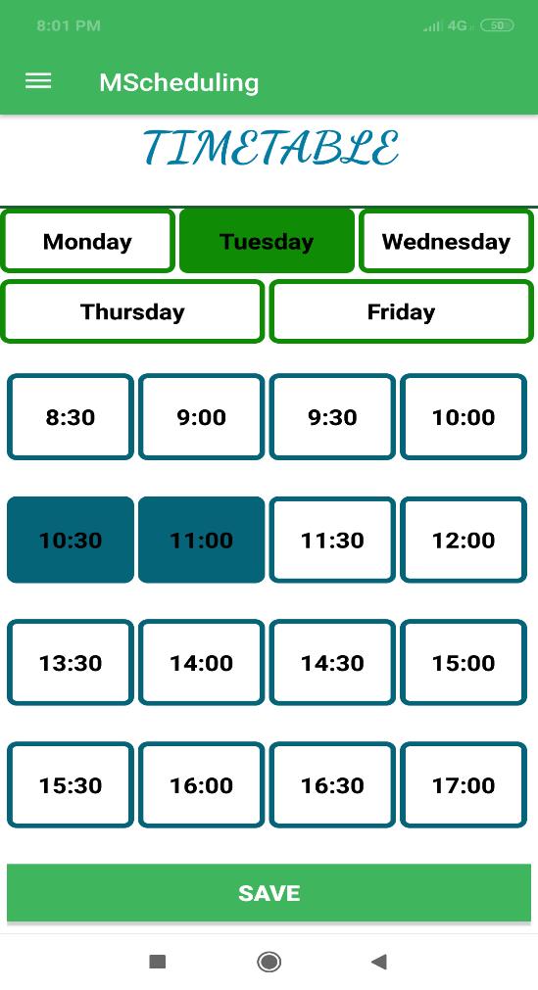

Figure 46 Lecturer Consultation Timetable (Lecturer) Activity

### 9.1.10 Screenshots for LecProfile Activity

#### 9.1.10.1 Description

In this activity, lecturer saves the profile details by filling in the information and clicking “save” button.

#### 9.1.10.2 Screenshot

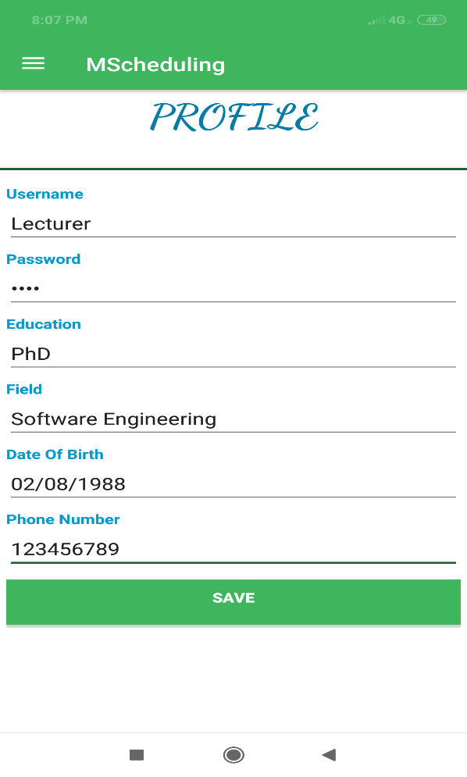

Figure 47 Lecturer’s Profile (Lecturer) Activity

### 9.1.11 Screenshots for LabBookDetails Activity

#### 9.1.11.1 Description

In this activity, details of the lab booking are displayed for lecturer and can click the “cancel” button to cancel booking.

#### 9.1.11.2 Screenshot

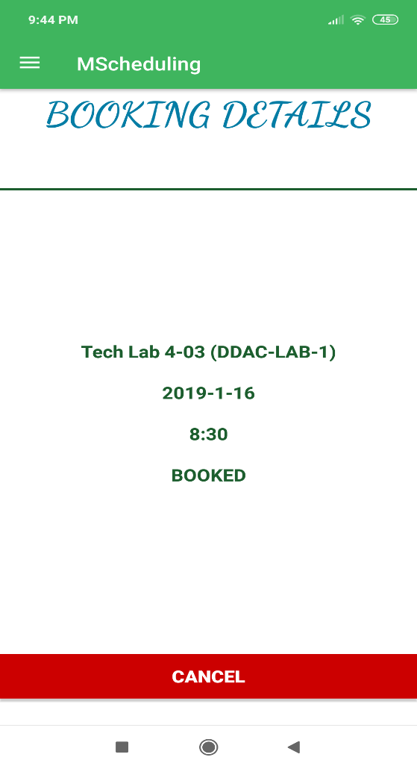

Figure 48 Lab Booking Details (Lecturer) Activity

### 9.1.12 Screenshots for Consultation List

#### 9.1.12.1 Description

In this activity, details of the upcoming and already attended consultations are displayed.

#### 9.1.12.2 Screenshot

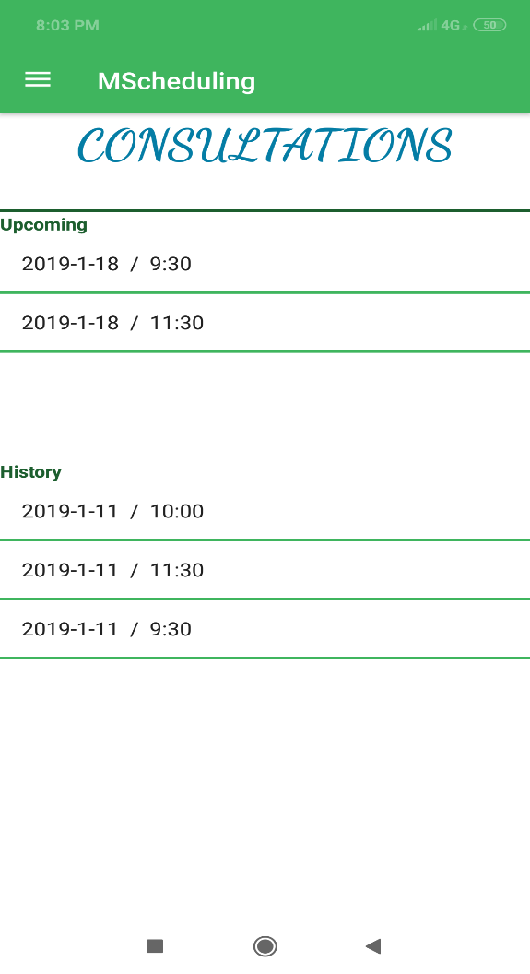

Figure 49 Consultation List (Lecturer/Student) Activity

### 9.1.13 Screenshots for Consultation details

#### 9.1.13.1 Description

In this activity, details of the consultation are displayed, and both lecturer and student can provide feedback and save it using “save” button and cancel the appointment using “cancel” button.

#### 9.1.13.2 Screenshot

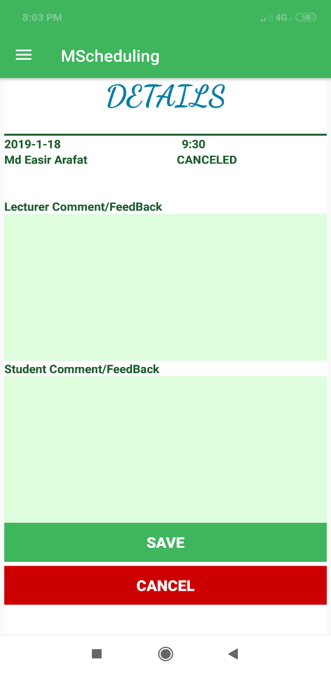

Figure 50 Consultation Details (Lecturer/Student) Activity

### 9.1.14 Screenshots for Consultation Booking

#### 9.1.14.1 Description

In this activity, dates and timing of the consultation are shown for student and student can choose the date and timeslots under it and click “Book” button for booking.

#### 9.1.14.2 Screenshot

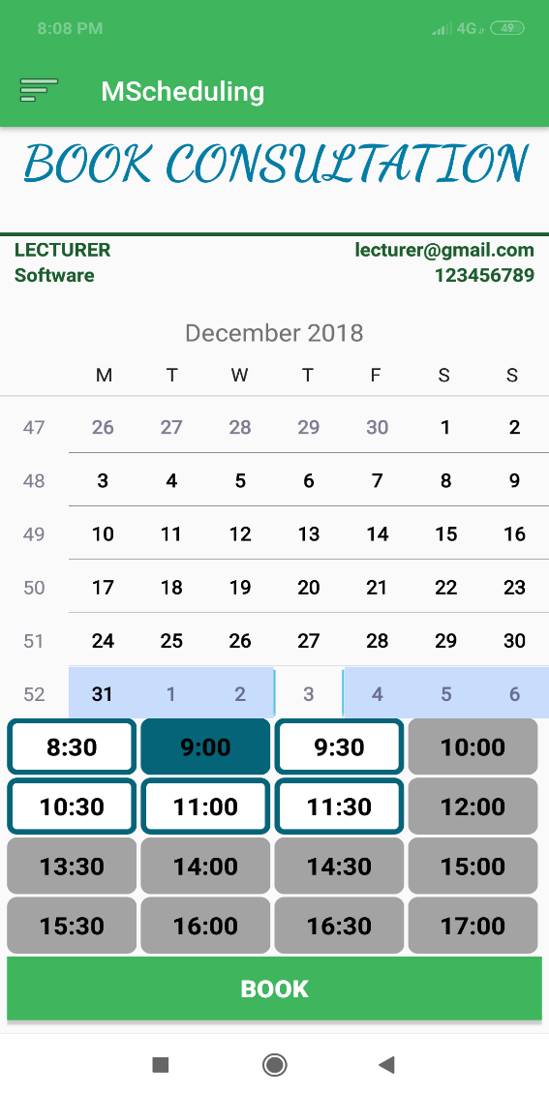

Figure 51 Book Consultation (Student) Activity

### 9.1.15 Screenshots for Lecturer List

#### 9.1.15.1 Description

In this activity, lecturer list is displayed. Student can search in the search bar with the name alphabet also.

#### 9.1.15.2 Screenshot

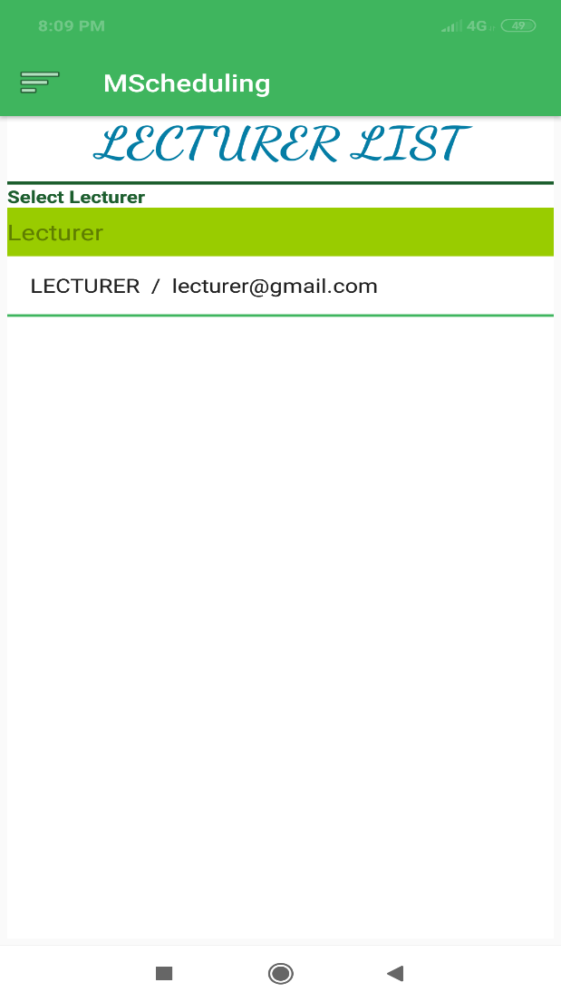

Figure 52 Lecturer’s List (Student) Activity

### 9.1.16 Screenshots for Lecturer Profile details(student)

#### 9.1.16.1 Description

In this activity, the selected lecturer details are displayed, and the student can click on the “Send Message” button to send message to the lecturer.

#### 9.1.16.2 Screenshot

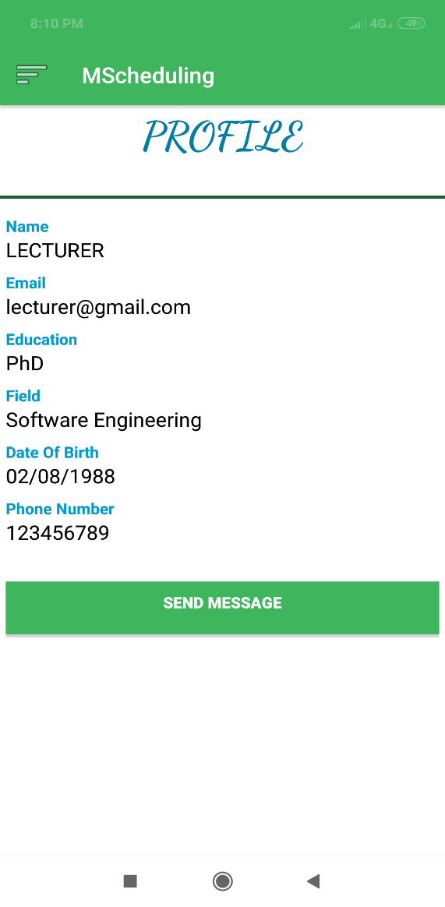

Figure 53 Lecturer’s Profile Details (Student) Activity

### 9.1.17 Screenshots for Lecturer chat list (student)

#### 9.1.17.1 Description

In this activity, the lecturer chat list is displayed.

#### 9.1.17.2 Screenshot

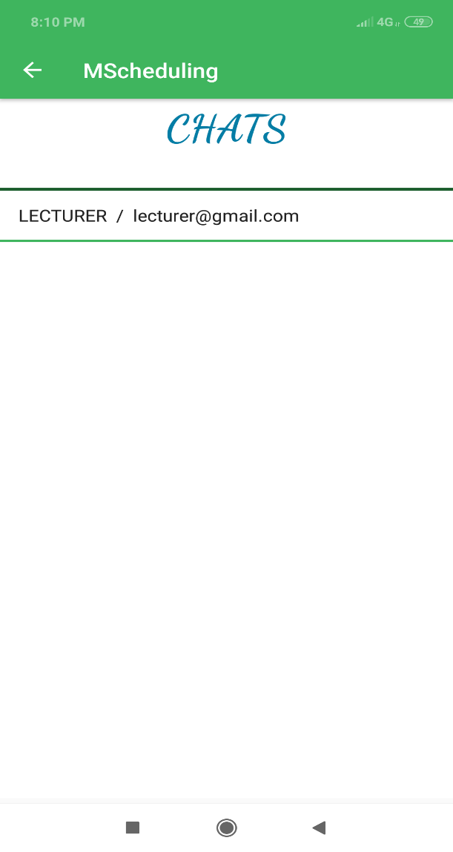

Figure 54 Lecturer’s Chat List (Student) Activity

### 9.1.18 Screenshots for Lecturer and student chat (student)

#### 9.1.18.1 Description

In this activity, lecturer student chat thread is displayed and can chat in this interface by entering message in the bottom and sending.

#### 9.1.18.2 Screenshot

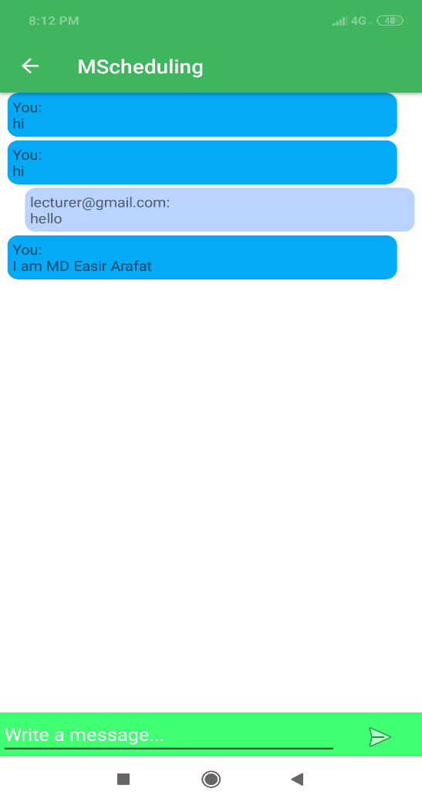

Figure 55 Lecturer and student Chat (Student) Activity

## 9.2 Sample Codes

The current system “MScheduling” is implemented mainly for the mobile devices. In this section, the main functionalities of the current system have been explained with the screenshots of the sample codes.

The developer did not make the interface design that much high because the size also matters in terms of usability and flexibility of the system. Simpler design makes it easier for the users to use and also takes less memory in the phone storage.

As the system is mainly developed for the android devices, so Java programming language has been used for developing the functionalities and the XML has been used for making the interface design. The firebase database has been also used by the developer to store all the information of the users and the bookings in the system. Some of the main functions have been explained below with sample codes:

### 9.2.1 Register and Login

In order to register and store the information of the users, the system needs to be connected to the Firebase database. The dependencies for connecting the database and the system are given below:

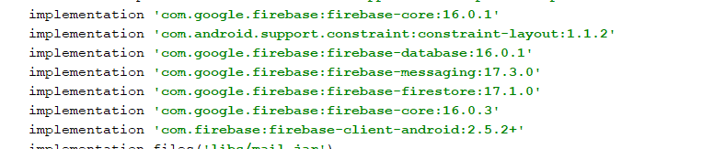

The code for registering the users is given below:

bSignUp.setOnClickListener(**new** View.OnClickListener() {  
@Override  
**public void** onClick(View v) {  
 **final** FirebaseFirestore db = FirebaseFirestore.*getInstance*();  
 **final** String Email=fEmail.getText().toString();  
 **final** String password=fPassword.getText().toString();  
 **final** String Name=fName.getText().toString();  
 String userType=**"student"**;  
 **final boolean**[] check = {**false**};  
 **if**(rLecturer.isChecked())  
 userType=**"lecturer"**;

**if**(Name.length()<1 || Email.length()<1 || password.length()<1)  
 {  
**new** AlertDialog.Builder(**activity**)  
 .setTitle(**"Failed!"**)  
 .setMessage(**"Please fill all the field."**)  
 .setPositiveButton(**"OK"**, **null**).show();  
 **return**;  
 }

**final** String finalUserType = userType;  
 db.collection(**"users"**)  
 .get()  
 .addOnCompleteListener(**new** OnCompleteListener<QuerySnapshot>() {  
@Override  
**public void** onComplete(@NonNull Task<QuerySnapshot> task) {  
**if** (task.isSuccessful()) {  
check[0]=**false**;  
**for** (QueryDocumentSnapshot document : task.getResult()) {  
 **if**(document.getString(**"username"**).toString().equals(Email))

check[0]=**true**;

**break**;  
}  
 }  
**if**(check[0]==**true**)

{  
**new** AlertDialog.Builder(**activity**)

.setTitle(**"Failed!"**)  
.setMessage(**"The email is already exists."**)  
.setPositiveButton(**"OK"**, **null**).show();  
 }  
 **else** {  
 Map<String, Object> docData = **new** HashMap<>();  
 docData.put(**"name"**,Name);  
 docData.put(**"username"**,Email);  
 docData.put(**"password"**,password);  
 docData.put(**"ut"**, finalUserType);  
 db.collection(**"users"**).add(docData)  
 .addOnSuccessListener(**new** OnSuccessListener<DocumentReference>() {  
 @Override  
 **public void** onSuccess(DocumentReference documentReference) {  
 **new** AlertDialog.Builder(**activity**)  
 .setTitle(**"Success!"**)  
 .setMessage(**"The new account has been created successfully."**)  
 .setPositiveButton(**"OK"**, **null**).show();  
 Thread thread = **new** Thread(**new** Runnable(){  
 **public void** run() {  
 **try** {  
 sendmail(Email,password,Name);  
 **activity**.finish();  
}

**catch** (Exception e) e.printStackTrace();  
}  
 }  
 });  
thread.start();  
 }  
 });  
}  
}

**else** {

Log.*w*(**"aba"**, **"Error getting documents."**, task.getException()

}  
}  
 });  
 }  
});

The users have to register with their valid email address, name and password. After entering the necessary information, they must click the “SignUp” button.

The sample code for login is given below:

bSignIn.setOnClickListener(**new** View.OnClickListener() {  
 **public void** onClick(View v) {  
 *// your handler code here* **final** String userName=fUserName.getText().toString();  
 **final** String password=fPassword.getText().toString();  
 **final boolean**[] check = {**false**};  
 FirebaseFirestore db = FirebaseFirestore.*getInstance*();  
 db.collection(**"users"**)  
 .get()  
 .addOnCompleteListener(**new** OnCompleteListener<QuerySnapshot>() {  
@Override  
**public void** onComplete(@NonNull Task<QuerySnapshot> task) {  
**if** (task.isSuccessful()) {  
 check[0] =**true**;  
**int** userType=0;

**for** (QueryDocumentSnapshot document : task.getResult()) {  
 **if**(document.getString(**"username"**).toString().equals(userName) &&  
 document.getString(**"password"**).toString().equals(password))

**if** (document.getString(**"ut"**).toString().equals(**"admin"**)) {  
 userType = 1;

Intent adIntent = **new** Intent(**activity**, AdminToolBar.**class**);  
prefs.edit().putString(**"username"**, userName).apply();  
**activity**.startActivity(adIntent);  
}

**else if** (document.getString(**"ut"**).toString().equals(**"student"**)) {  
userType = 2;

Intent adIntent = **new** Intent(**activity**, StudentToolBar.**class**);  
prefs.edit().putString(**"username"**, userName).apply(); prefs.edit().putString(**"name"**, document.getString(**"name"**)).apply();  
**activity**.startActivity(adIntent);  
}  
**else if** (document.getString(**"ut"**).toString().equals(**"lecturer"**)) {

Intent adIntent = **new** Intent(**activity**, LecturerToolBar.**class**);

prefs.edit().putString(**"username"**, userName).apply();  
prefs.edit().putString(**"name"**, document.getString(**"name"**)).apply();  
**activity**.startActivity(adIntent);  
userType = 3;  
}  
**break**;  
}  
**if**(userType==0)  
{  
**new** AlertDialog.Builder(**activity**)

.setTitle(**"Failed!"**)  
.setMessage(**"Wrong username or password."**)  
.setPositiveButton(**"OK"**, **null**).show();  
}  
  
} **else** {  
Log.*w*(**"aba"**, **"Error getting documents."**, task.getException());

}  
 });  
 }  
});

When the students click the login button, the system read the information from the database to search for the given email address and password. If the email address and password are correct, then redirects to the menu activity otherwise the system shows “Login Failed”.

### 9.2.2 Add New Lab

The sample code for Adding new lab by admin is given below:

**bSubmit**.setOnClickListener(**new** View.OnClickListener() {  
 @Override  
 **public void** onClick(View v) {  
 **final boolean**[] check = {**false**};  
 **final** String name=**tName**.getText().toString();  
 **final** Boolean T0=**c83**.isChecked();  
 **final** Boolean T1=**c83**.isChecked();  
 **final** Boolean T2=**c83**.isChecked();  
 **final** Boolean T3=**c83**.isChecked();  
 **if**(name.length()<2)  
 {  
 **new** AlertDialog.Builder(**context**)  
 .setTitle(**"Failed!"**)  
 .setMessage(**"Please enter the lab name."**)  
 .setPositiveButton(**"OK"**, **null**).show();  
 **return**;  
 }  
  
**db**.collection(**"labs"**)  
 .get()  
 .addOnCompleteListener(**new** OnCompleteListener<QuerySnapshot>()

@Override  
**public void** onComplete(@NonNull Task<QuerySnapshot> task) {  
**if** (task.isSuccessful()) {  
  
 check[0]=**false**;  
**for** (QueryDocumentSnapshot document : task.getResult()) {  
 **if**(document.getString(**"name"**).toString().equals(name)) {  
check[0]=**true**;  
 **break**;  
 }  
 }  
**if**(check[0]==**true**)  
{  
**new** AlertDialog.Builder(**context**)

.setTitle(**"Failed!"**)  
.setMessage(**"The lab is already exists."**)  
.setPositiveButton(**"OK"**, **null**).show();  
 }  
**else** {  
Map<String, Object> docData = **new** HashMap<>();  
 docData.put(**"name"**,name);  
 docData.put(**"0"**,T0);  
 docData.put(**"1"**,T1);  
 docData.put(**"2"**,T2);  
 docData.put(**"3"**,T3);

**db**.collection(**"labs"**).add(docData)

.addOnSuccessListener(**new** OnSuccessListener<DocumentReference>() {  
@Override  
**public void** onSuccess(DocumentReference documentReference) {  
**new** AlertDialog.Builder(**context**) .setTitle(**"Success!"**)  
.setMessage(**"The new account has been created successfully."**)  
 .setPositiveButton(**"OK"**, **null**).show();  
}  
});  
  
}  
  
} **else** {  
Log.*w*(**"aba"**, **"Error getting documents."**, task.getException());  
}  
 }

});  
 }  
});

The admin adds new lab by providing the lab name, choosing the timeslots and clicking “submit” button.

### 9.2.3 Book Lab

The sample code for Booking lab by lecturer is given below:

**bSubmit**.setOnClickListener(**new** View.OnClickListener() {  
 @Override  
 **public void** onClick(View v) {  
 **int** selectedTime=-1;  
 **if**(**c83**.isChecked()) selectedTime=0;  
 **if**(**c103**.isChecked()) selectedTime=1;  
 **if**(**c133**.isChecked()) selectedTime=2;  
 **if**(**c153**.isChecked()) selectedTime=3;  
 **if**(selectedTime==-1)  
 {  
 **new** AlertDialog.Builder(**context**)  
 .setTitle(**"Success!"**)  
 .setMessage(**"Please Select Date."**)  
 .setPositiveButton(**"OK"**, **null**).show();  
 **return**;  
 }  
 String stat=**"booked"**;  
 Map<String, Object> data = **new** HashMap<>();  
 data.put(**"name"**,**lab**);  
 data.put(**"lecturer"**,**userName**);  
 data.put(**"date"**,**date**);  
 data.put(**"time"**,selectedTime);  
 data.put(**"stat"**,stat);  
 **db**.collection(**"labbook"**).add(data)  
.addOnSuccessListener(**new** OnSuccessListener<DocumentReference>() {  
@Override

**public void** onSuccess(DocumentReference documentReference) {  
**new** AlertDialog.Builder(**context**)  
 .setTitle(**"Success!"**)  
 .setMessage(**"The lab has been booked."**)  
 .setPositiveButton(**"OK"**, **null**).show();  
  
 }  
 });

Class fragmentClass = LabListLecturer.**class**;  
android.support.v4.app.Fragment fragment = **null**;  
**try** {  
fragment = (android.support.v4.app.Fragment)

fragmentClass.newInstance();  
 }

**catch** (Exception e) {  
e.printStackTrace();  
}  
FragmentManager fragmentManager = getActivity()

.getSupportFragmentManager();  
**final int** commit = fragmentManager.beginTransaction()

.replace(R.id.***navmain***, fragment).commit();  
  
 }  
});

The lecturer can book the lab by choosing the dates and timeslots provided under it and then clicking the book button.

### 9.2.4 Lecturer Timetable

The sample code for lecturer timetable setup is given below:

**bSubmit**.setOnClickListener(**new** View.OnClickListener() {  
@Override  
**public void** onClick(View v) {  
 **int** day=1;  
 **if**(**rTue**.isChecked()) day=2;  
 **if**(**rWed**.isChecked()) day=3;  
 **if**(**rThu**.isChecked()) day=4;  
 **if**(**rFri**.isChecked()) day=5;  
  
**final boolean**[] array = **new boolean**[16];  
  
 array[0]=**c83**.isChecked();  
 array[1]=**c90**.isChecked();  
 array[2]=**c93**.isChecked();  
 array[3]=**c10**.isChecked();  
 array[4]=**c103**.isChecked();  
 array[5]=**c11**.isChecked();  
 array[6]=**c113**.isChecked();  
 array[7]=**c12**.isChecked();  
 array[8]=**c133**.isChecked();  
 array[9]=**c14**.isChecked();  
 array[10]=**c143**.isChecked();  
 array[11]=**c15**.isChecked();  
 array[12]=**c153**.isChecked();  
 array[13]=**c16**.isChecked();  
 array[14]=**c163**.isChecked();  
 array[15]=**c17**.isChecked();  
  
 Map<String, Object> data = **new** HashMap<>();  
 data.put(**"username"**,**userName**);  
 Map<String,Object> dTime=**new** HashMap<>();  
 **for**(**int** i=0;i<16;i++)  
 {  
 dTime.put(String.*valueOf*(i),array[i]);  
 }  
 data.put(String.*valueOf*(day),dTime);  
 **if**(**docId**[0].length()>2)  
**db**.collection(**"timetable"**).document(**docId**[0]).set(data, SetOptions.*merge*())  
addOnSuccessListener(**new** OnSuccessListener<Void>() {  
@Override  
**public void** onSuccess(Void aVoid) {  
**new** AlertDialog.Builder(**context**)  
 .setTitle(**"Success!"**)  
 .setMessage(**"The timetable has been updated."**)  
 .setPositiveButton(**"OK"**, **null**).show();  
 }  
 });  
 }  
 **else** {  
 **db**.collection(**"timetable"**).add(data)  
.addOnSuccessListener(**new** OnSuccessListener<DocumentReference>() {

@Override

**public void** onSuccess(DocumentReference documentReference) {  
**new** AlertDialog.Builder(**context**)  
.setTitle(**"Success!"**)  
.setMessage(**"The timetable has been updated."**)  
.setPositiveButton(**"OK"**, **null**).show();  
  
 }  
 });  
 }  
  
 }  
});

The lecturer saves the timetable and puts up timeslots for consultation using “submit button.

### 9.2.5 Consultation Booking

The sample code for Booking consultation is given below:

**bSubmit**.setOnClickListener(**new** View.OnClickListener() {  
 @Override  
 **public void** onClick(View v) {  
 **int** selectedTime=-1;  
 **if**(**c83**.isChecked()) selectedTime=0;  
 **if**(**c90**.isChecked()) selectedTime=1;  
 **if**(**c93**.isChecked()) selectedTime=2;  
 **if**(**c10**.isChecked()) selectedTime=3;  
 **if**(**c103**.isChecked()) selectedTime=4;  
 **if**(**c11**.isChecked()) selectedTime=5;  
 **if**(**c113**.isChecked()) selectedTime=6;  
 **if**(**c12**.isChecked()) selectedTime=7;  
 **if**(**c133**.isChecked()) selectedTime=8;  
 **if**(**c14**.isChecked()) selectedTime=9;  
 **if**(**c143**.isChecked()) selectedTime=10;  
 **if**(**c15**.isChecked()) selectedTime=11;  
 **if**(**c153**.isChecked()) selectedTime=12;  
 **if**(**c16**.isChecked()) selectedTime=13;  
 **if**(**c163**.isChecked()) selectedTime=14;  
 **if**(**c17**.isChecked()) selectedTime=15;  
 **if**(selectedTime==-1)  
 {

**new** AlertDialog.Builder(**context**)

.setTitle(**"Success!"**)  
 .setMessage(**"Please Select Consultation Date."**)  
 .setPositiveButton(**"OK"**, **null**).show();  
**return**;  
 }  
 String stat=**"booked"**;  
 Map<String, Object> data = **new** HashMap<>();  
 data.put(**"student"**,**userName**);  
 data.put(**"lecturer"**,**lemail**);  
 data.put(**"date"**,**date**);  
 data.put(**"time"**,selectedTime);  
 data.put(**"stat"**,stat);  
 **db**.collection(**"cons"**).add(data)  
 .addOnSuccessListener(**new** OnSuccessListener<DocumentReference>() {  
@Override  
**public void** onSuccess(DocumentReference documentReference) {  
**new** AlertDialog.Builder(**context**)  
 .setTitle(**"Success!"**)  
 .setMessage(**"The consultation has been booked."**)  
 .setPositiveButton(**"OK"**, **null**).show();  
  
 }  
 });  
  
 Class fragmentClass = BookConsultatio.**class**;  
 android.support.v4.app.Fragment fragment = **null**;  
 **try** {

fragment = (android.support.v4.app.Fragment) fragmentClass.newInstance();  
 }

**catch** (Exception e) {  
e.printStackTrace();  
 }

FragmentManager fragmentManager = getActivity()

.getSupportFragmentManager();  
**final int** commit = fragmentManager.beginTransaction()

.replace(R.id.***navmain***, fragment).commit();  
  
 }  
});

Thedates and timing of the consultation are shown for student and student can choose the date and timeslots under it and click “Book”button for booking.

### 9.2.6 Lecturer List for students

The sample code for lecturer list is given below:

**db** = FirebaseFirestore.*getInstance*();  
**db**.collection(**"users"**)  
 .get()  
 .addOnCompleteListener(**new** OnCompleteListener<QuerySnapshot>() {  
@Override  
**public void** onComplete(@NonNull Task<QuerySnapshot> task) {  
**if** (task.isSuccessful()) {  
**int** userType=0;  
List<String> lecturer_list = **new** ArrayList<String>();  
  
**for** (QueryDocumentSnapshot document : task.getResult()) {  
**if**(document.getString(**"ut"**).equals(**"lecturer"**)) {  
 lecturer_list.add(document.getString(**"name"**).toString().toUpperCase()+ **" / "**+document.getString(**"username"**).toString());  
 }  
 }  
**final** ArrayAdapter<String> arrayAdapter = **new** ArrayAdapter<String>

(**context**, android.R.layout.***simple_list_item_1***, lecturer_list);

**lv**.setAdapter(arrayAdapter);  
**eSearch**.addTextChangedListener(**new** TextWatcher() {  
 @Override

**public void** beforeTextChanged(CharSequence s, **int** start, **int** count, **int** after) {  
  
 }  
@Override

**public void** onTextChanged(CharSequence s, **int** start, **int** before, **int** count) {  
  
   
@Override

**public void** afterTextChanged(Editable s) {  
String sText=**eSearch**.getText().toString();

arrayAdapter.getFilter().filter(sText);  
}  
});  
  
  
} **else** {

Log.*w*(**"aba"**, **"Error getting documents."**, task.getException());  
}  
}  
});  
**lv**.setOnItemClickListener(**new** AdapterView.OnItemClickListener() {  
@Override  
**public void** onItemClick(AdapterView<?> parent, View view, **int** position, **long** id) {  
 **int** p = **lv**.getCheckedItemPosition();  
 **if**(p!=ListView.***INVALID_POSITION***) {  
 **int** tindex=**lv**.getFirstVisiblePosition();  
 TextView textView = (TextView) **lv**.getAdapter().getView(p, **null**, **lv**);  
 **final** String text=textView.getText().toString();  
 **final** String userName=text.substring(text.indexOf(**" / "**)+4).trim();  
 **final** SharedPreferences prefs = **context**.getSharedPreferences(  
 **"pref"**, Context.***MODE_PRIVATE***);  
 prefs.edit().putString(**"lec"**, userName).apply();  
 prefs.edit().putString(**"lecname"**, text.substring(0,text.indexOf(**" / "**)).trim()).apply();  
  
  
 Class fragmentClass = StudentLecDetails.**class**;  
 android.support.v4.app.Fragment fragment = **null**;  
**try** {  
fragment = (android.support.v4.app.Fragment) fragmentClass.newInstance();  
 }

**catch** (Exception e) {  
 e.printStackTrace();  
 }  
FragmentManager fragmentManager = getActivity().getSupportFragmentManager();  
**final int** commit = fragmentManager.beginTransaction()

.replace(R.id.***navmain***, fragment).commit();  
}

**else**{

Toast.*makeText*(**context**, **"Nothing Selected.."**, Toast.***LENGTH_LONG***).show();  
}  
 }  
});

All the list of lecturers is retrieved from the database and displayed in the list view.

# CHAPTER 10: SYSTEM VALIDATION

## 10.1 Unit Testing

Unit testing is the first phase of software testing. The smallest parts of the system are called the units. These units are tested to check whether these are working as planned or not. As example, a unit may have one or few inputs and only one output. The test plan for unit testing for the “MScheduling” system has given below in a table:

### 10.1.1 Sign Up

|  |  |  |  |  |  |
| --- | --- | --- | --- | --- | --- |
| **No** | **Test Case** | **Expected Result** | **Actual Result** | **Pass** | **Fail** |
| **1** | Email Format | Validation must show when the email address will not have the correct format. | Validation shows after clicking the “SignUp” button with the email address which does not have the correct format. | **C:\Users\YUSSAIRI-LAPTOP\Desktop\eschedule\one.PNG** |  |
| **2** | Password must have at least 6 characters | Validation must show when the password has less than 6 characters | Validation shows after clicking the “SignUp button” with the password which has less than 6 characters. | **C:\Users\YUSSAIRI-LAPTOP\Desktop\eschedule\one.PNG** |  |
| **3** | Empty Field | Validation will show when any field will be empty | Validation shows after clicking the “SignUp” button with empty fields. | **C:\Users\YUSSAIRI-LAPTOP\Desktop\eschedule\one.PNG** |  |
| **4** | Trigger SignUp Button | User credentials should be saved | User information are stored in the database successfully. | **C:\Users\YUSSAIRI-LAPTOP\Desktop\eschedule\one.PNG** |  |

Table 35 Unit Testing Result (Sign Up)

### 10.1.2 Login (Students/Lecturers)

|  |  |  |  |  |  |
| --- | --- | --- | --- | --- | --- |
| **No.** | **Test Case** | **Expected Result** | **Actual Result** | **Pass** | **Fail** |
| **1** | Incorrect email address and password | Validation must show when the email address or password is not correct. | Validation shows when the email and password or any of them is incorrect after clicking the “SignIn” button. | **C:\Users\YUSSAIRI-LAPTOP\Desktop\eschedule\one.PNG** |  |
| **2** | Validate correct Email Address and password from the database. | Prompt user to the home activity if the email address and password is correct. | System redirects to home activity. | **C:\Users\YUSSAIRI-LAPTOP\Desktop\eschedule\one.PNG** |  |
| **3** | Empty Field | Validation will show when any field will be empty | Validation shows after clicking the “SignIn” button with empty fields. | **C:\Users\YUSSAIRI-LAPTOP\Desktop\eschedule\one.PNG** |  |
| **4** | Trigger Sign In Button | Prompt user to the home activity and shows “Logged in Successfully” | User is prompted to the home activity and shows “Logged in Successfully” | **C:\Users\YUSSAIRI-LAPTOP\Desktop\eschedule\one.PNG** |  |
| **5** | Trigger Register Button | Prompt user to the register activity. | User is prompted to the register activity. | **C:\Users\YUSSAIRI-LAPTOP\Desktop\eschedule\one.PNG** |  |

Table 36 Unit Testing Result (Login (Students/Lecturers))

### 10.1.2 Login(Admin)

|  |  |  |  |  |  |
| --- | --- | --- | --- | --- | --- |
| **No.** | **Test Case** | **Expected Result** | **Actual Result** | **Pass** | **Fail** |
| **1** | Incorrect email address and password | Validation must show when the email address or password is not correct. | Validation shows when the email and password or any of them is incorrect after clicking the “SignIn” button. | **C:\Users\YUSSAIRI-LAPTOP\Desktop\eschedule\one.PNG** |  |
| **2** | Validate correct Email Address and password from the database. | Prompt user to the home activity if the email address and password is correct. | System redirects to home activity. | **C:\Users\YUSSAIRI-LAPTOP\Desktop\eschedule\one.PNG** |  |
| **3** | Empty Field | Validation will show when any field will be empty | Validation shows after clicking the “SignIn” button with empty fields. | **C:\Users\YUSSAIRI-LAPTOP\Desktop\eschedule\one.PNG** |  |
| **4** | Trigger Sign In Button | Prompt user to the home activity and shows “Logged in Successfully” | User is prompted to the home activity and shows “Logged in Successfully” | **C:\Users\YUSSAIRI-LAPTOP\Desktop\eschedule\one.PNG** |  |

Table 37 Unit Testing Result (Login (Admin))

### 10.1.3 Add New Lab(Admin)

|  |  |  |  |  |  |
| --- | --- | --- | --- | --- | --- |
| **No.** | **Test Case** | **Expected Result** | **Actual Result** | **Pass** | **Fail** |
| **1** | Empty Field | Validation will show when any field will be empty | Validation shows after clicking the “Submit” button with empty fields. | **C:\Users\YUSSAIRI-LAPTOP\Desktop\eschedule\one.PNG** |  |
| **2** | Trigger Submit Button | The information of the new lab must be stored in db, after clicking the “Submit” button. | User information are stored in the database successfully. | **C:\Users\YUSSAIRI-LAPTOP\Desktop\eschedule\one.PNG** |  |
| **3** | Trigger navigation drawer menu Button | Must prompt navigation drawer menu | The navigation drawer menu is displayed. | **C:\Users\YUSSAIRI-LAPTOP\Desktop\eschedule\one.PNG** |  |

Table 38 Unit Testing Result (Add New Lab(Admin))

### 10.1.4 Lecturers List(Student)

|  |  |  |  |  |  |
| --- | --- | --- | --- | --- | --- |
| **No.** | **Test Case** | **Expected Result** | **Actual Result** | **Pass** | **Fail** |
| **1** | Show all the lecturers in a list | All of the lecturers must be retrieved from the database show it in a list in the system. | All the lecturers are displayed in the list in the system. | **C:\Users\YUSSAIRI-LAPTOP\Desktop\eschedule\one.PNG** |  |
| **2** | Search lecturers | Those lecturers according to the similarity between their name and entered name based on the alphabets must be shown in a list. | When start entering the lecturer name in the search bar, the lecturer names start appearing in the list. | **C:\Users\YUSSAIRI-LAPTOP\Desktop\eschedule\one.PNG** |  |
| **3** | Trigger lecturer name. | Should prompt user to the lecturer profile | The user is redirected to the lecturer profile | **C:\Users\YUSSAIRI-LAPTOP\Desktop\eschedule\one.PNG** |  |
| **4** | Trigger navigation drawer menu Button | Must prompt navigation drawer menu | The navigation drawer menu is displayed. | **C:\Users\YUSSAIRI-LAPTOP\Desktop\eschedule\one.PNG** |  |

Table 39 Unit Testing Result (Lecturers List(Student))

### 10.1.5 Lecturer Profile(Student)

|  |  |  |  |  |  |
| --- | --- | --- | --- | --- | --- |
| **No.** | **Test Case** | **Expected Result** | **Actual Result** | **Pass** | **Fail** |
| **1** | Trigger “Send Message” Button | Should prompt user to the chat thread between lecturer and user(student). | The chat thread is opened. | **C:\Users\YUSSAIRI-LAPTOP\Desktop\eschedule\one.PNG** |  |

Table 40 Unit Testing Result (Lecturer Profile(Student))

### 10.1.6 Book Consultation Timetable(Lecturer)

|  |  |  |  |  |  |
| --- | --- | --- | --- | --- | --- |
| **No** | **Test Case** | **Expected Result** | **Actual Result** | **Pass** | **Fail** |
| **1** | Show all the week days and timing under it | All the weekdays should be displayed along with time slots | All the weekdays are displayed along with time slots | **C:\Users\YUSSAIRI-LAPTOP\Desktop\eschedule\one.PNG** |  |
| **2** | Trigger weekday | Prompts the user to choose desired timeslots under it | The user is able to choose desired the timeslots under it. | **C:\Users\YUSSAIRI-LAPTOP\Desktop\eschedule\one.PNG** |  |
| **3** | Trigger Save Button | The information of the consultation must be stored in database with confirmation message. | The information of the consultation is stored in database and confirmation message is displayed. | **C:\Users\YUSSAIRI-LAPTOP\Desktop\eschedule\one.PNG** |  |
| **4** | Trigger navigation drawer menu Button | Must prompt navigation drawer menu | The navigation drawer menu is displayed. | **C:\Users\YUSSAIRI-LAPTOP\Desktop\eschedule\one.PNG** |  |

Table 41Unit Testing Result (Book Consultation Timetable(Lecturer))

### 10.1.7 Lab List(Lecturer)

|  |  |  |  |  |  |
| --- | --- | --- | --- | --- | --- |
| **No.** | **Test Case** | **Expected Result** | **Actual Result** | **Pass** | **Fail** |
| **1** | Show all the labs available in a list | All of the available labs must be retrieving from the database show it in a list in the system. | All the available labs are shown in the list in the system. | **C:\Users\YUSSAIRI-LAPTOP\Desktop\eschedule\one.PNG** |  |
| **2** | Trigger any of the lab name | Redirects the user to the Book lab page. | The user is redirected to the Book lab page. | **C:\Users\YUSSAIRI-LAPTOP\Desktop\eschedule\one.PNG** |  |
| **3** | Trigger navigation drawer menu Button | Must prompt navigation drawer menu | The navigation drawer menu is displayed. | **C:\Users\YUSSAIRI-LAPTOP\Desktop\eschedule\one.PNG** |  |

Table 42 Unit Testing Result (Lab List(Lecturer))

### 10.1.8 Book Lab(Lecturer)

|  |  |  |  |  |  |
| --- | --- | --- | --- | --- | --- |
| **No.** | **Test Case** | **Expected Result** | **Actual Result** | **Pass** | **Fail** |
| **1** | Show all the dates and available time slots under it | A month date calendar should be displayed and timeslots. | A month date calendar is displayed along with timeslots. | **C:\Users\YUSSAIRI-LAPTOP\Desktop\eschedule\one.PNG** |  |
| **2** | Trigger any date | Should display the time slots under it | Displays the time slots under it | **C:\Users\YUSSAIRI-LAPTOP\Desktop\eschedule\one.PNG** |  |
| **3** | Trigger “Book” Button | The information of the booking must be stored in database with confirmation message. | The information of the booking is stored in database and confirmation message is prompted. | **C:\Users\YUSSAIRI-LAPTOP\Desktop\eschedule\one.PNG** |  |
| **4** | Trigger navigation drawer menu Button | Must prompt navigation drawer menu | The navigation drawer menu is displayed. | **C:\Users\YUSSAIRI-LAPTOP\Desktop\eschedule\one.PNG** |  |

Table 43 Unit Testing Result (Book Lab(Lecturer))

### 10.1.9 Book Consultation(Student)

|  |  |  |  |  |  |
| --- | --- | --- | --- | --- | --- |
| **No.** | **Test Case** | **Expected Result** | **Actual Result** | **Pass** | **Fail** |
| **1** | Show all the dates and available time slots under it | A month date calendar should be displayed and timeslots. | A month date calendar is displayed along with timeslots. | **C:\Users\YUSSAIRI-LAPTOP\Desktop\eschedule\one.PNG** |  |
| **2** | Trigger any date | Should display the time slots under it | Displays the time slots under it | **C:\Users\YUSSAIRI-LAPTOP\Desktop\eschedule\one.PNG** |  |
| **3** | Trigger “Book” Button | The information of the booking must be stored in database with confirmation message. | The information of the booking is stored in database and confirmation message is prompted. | **C:\Users\YUSSAIRI-LAPTOP\Desktop\eschedule\one.PNG** |  |
| **4** | Trigger navigation drawer menu Button | Must prompt navigation drawer menu | The navigation drawer menu is displayed. | **C:\Users\YUSSAIRI-LAPTOP\Desktop\eschedule\one.PNG** |  |

Table 44 Unit Testing Result (Book Consultation(Student))

### 10.1.10 Edit Lecturer Profile(Lecturer)

|  |  |  |  |  |  |
| --- | --- | --- | --- | --- | --- |
| **No.** | **Test Case** | **Expected Result** | **Actual Result** | **Pass** | **Fail** |
| **1** | Empty Field | Validation will show when any field will be empty | Validation shows after clicking the “Save” button with empty fields. | **C:\Users\YUSSAIRI-LAPTOP\Desktop\eschedule\one.PNG** |  |
| **2** | Trigger Save Button | The information of the lecturer must be stored in database with confirmation message. | The information of the lecturer is stored in database and confirmation message is prompted. | **C:\Users\YUSSAIRI-LAPTOP\Desktop\eschedule\one.PNG** |  |
| **3** | Trigger navigation drawer menu Button | Must prompt navigation drawer menu | The navigation drawer menu is displayed. | **C:\Users\YUSSAIRI-LAPTOP\Desktop\eschedule\one.PNG** |  |

Table 45 Unit Testing Result (Edit Lecturer Profile(Lecturer))

### 10.1.11 Consultation details(Lecturer/student)

|  |  |  |  |  |  |
| --- | --- | --- | --- | --- | --- |
| **No.** | **Test Case** | **Expected Result** | **Actual Result** | **Pass** | **Fail** |
| **1** | Empty Field | Validation will show when any field will be empty | Validation shows after clicking the “Save” button with empty fields. | **C:\Users\YUSSAIRI-LAPTOP\Desktop\eschedule\one.PNG** |  |
| **2** | Trigger Save Button | The information of the consultation must be stored in database with confirmation message. | The information of the consultation is stored in database and confirmation message is prompted. | **C:\Users\YUSSAIRI-LAPTOP\Desktop\eschedule\one.PNG** |  |
| **3** | Trigger “cancel” Button | Should return to the home page. | The user is returned to the home page. | **C:\Users\YUSSAIRI-LAPTOP\Desktop\eschedule\one.PNG** |  |
| **4** | Trigger navigation drawer menu Button | Must prompt navigation drawer menu | The navigation drawer menu is displayed. | **C:\Users\YUSSAIRI-LAPTOP\Desktop\eschedule\one.PNG** |  |

Table 46 Unit Testing Result ( Consultation details(Lecturer/student))

## 10.2 Integration Testing

The result for integration testing for the “MScheduling” system has given below in a table:

|  |  |  |  |  |
| --- | --- | --- | --- | --- |
| **Testing Function** | **Test Description** | **Test Case** | **Expected Result** | **Actual Result** |
| Register | Store the email address and password in the database. | Input email address and password and click “SignUp” button. | System will validate and check the pattern of the email address and the password and it will save the information in the database. | System validates the email address and password and store the information in the database. |
| Login(student/lecturer) | Validates email address and password from the database. | Input email address and password and click “Sign In” button | System will process and validate the entered email address and password from the database to check whether this email address is registered or not. | System validates the entered email address and password and if it is registered, then redirects to the next page. |
| Login (Admin) | Checks the username and password from the system. | Input username and password and click “Sign-In” button | System will check the username and password whether it matches with the operated username  and password or not. If it does not match, then system will show “Login Failed”. | System checks the username and password and when it matches with the  operated email address and password then redirects to the next page. |
| Add New Lab | Store the information of new lab in the database | Input all the information of the new lab and click the “Submit” button | The information of the new lab must be stored in database, after clicking the “Submit” button. | User information are stored in the database successfully. |
| Lecturers List | Retrieve all the list of lecturers available from the database. | Click on a selected lecturer from the list. | The user should be redirected to the lecturer profile | The user is redirected to the lecturer profile |
| Lecturer Profile | Retrieves the lecturer information and displays in the profile | Click on the “ Send message” button to chat with the lecturer | The chat thread should open between user and lecturer when click “Send message” button | The chat thread is opened. |
| Book Consultation Timetable | Store the information of the lecturer consultation in the database. | Select all the information for consultation timing and click the “Save” button. | The information of the consultation must be stored in database with confirmation message. | The information of the consultation is stored in database. |
| Lab list | Retrieve all the list of labs available from the database. | Click on a selected lab from the list. | Redirects the user to the “Book lab” page. | The user is redirected to “Book lab” page. |
| Book Lab | Store the information of the lab booking in the database. | Select all the information for lab booking and click the “Book” button | The information of the booking must be stored in database with confirmation message. | The information of the booking is stored in database. |
| Book Consultation(student) | Store the information of student consultation booking in the database. | Select all the information for consultation booking and click the “Book” button | The information of the consultation must be stored in database with confirmation message. | The information of the consultation is stored in database. |
| Edit lecturer profile | Store the information of the lecturer profile in the database | Input all the lecturer information as a lecturer and click the “Save” button | The information of the lecturer must be updated in database with confirmation message. | The information of the lecturer is updated in database. |
| Consultation details | Store the information of lecturer and student feedback in database | Input the feedback and click the “Save” button. | The information of lecturer and student feedback must be stored in database | The information of lecturer and student feedback are stored in the database. |

Table 47 Integration Testing

## 10.3 User Acceptance Testing

### User Acceptance Analysis

In the questionnaire for user acceptance testing, there are overall four questions. First three questions are bound with yes and no answer and the last question is free to answer, and it is optional so that the admin, lecturer and the students can answer openly and can give opinions and suggestions in order to improve the system.

First question is whether the application makes the life of lecturers and students easier. This question will help to put more focus on improving the features. As a feedback, all two students and a lecturer answered yes which means that the application has given them the platform they were looking for.

Second question is about the interface of the system whether it is user-friendly or not. The two students and a lecturer answered yes for this question. So, the students’ panel is user-friendly. But the admin who another tester for the system is answered no for this question. This feedback of the tester will encourage the developers to overcome the lacks and to improve the interface of the system.

The third question is about the functionalities of the system. The admin and one student answered no for this question. So, it can be said that the system does not have enough functionalities which will allow the system fulfils all the requirements of all the users.

The fourth question is about the comparison between the current system and the previous system whether the current system fulfils all the requirements or not. All the four testers answered yes and agreed with this question.

The last question is free and optional for the testers. This question will help the developers to gather the requirements and the expectations of the users from the system. Among four testers, the admin and two students answered the fourth question.

## 10.4 Summary

Software testing is obvious process for all the fully functional system whether it can be web, windows, mobile or any type of application. Because the software testing is such a process which is performed though a system to find out any faults or bugs. The testing process also finds out whether the system or application is meeting all the requirements and demands of the users or not. If any of them is found out by the testers, then it will be returned to the developers with notifying the faults so that the developers can fix those before sending the system to the actual users.

The current system “MScheduling” has three types of users, such as – the admin, lecturers and the students. So, for the user acceptance testing, all of users has been performed properly and has gone through a questionnaire process. According to the result, the current system has some lacks which needs to be solved before delivering it to the actual users

The system will be a great companion for the lecturers and students. The result of the user acceptance testing helps to find out the hidden lacks and mistakes which the developer must remove, develop and also encourages to develop more features and functionalities for the current system in order to make it more user-friendly and to increase the usability.

During the unit testing, every unit of all the functions in the system have been tested properly and the actual results were similar with the expected results. The results for all core functionalities in the integration testing works and gives the actual result as similar with the expected result. So, it can be said that the overall system is working properly and will support all types of users in every phase.

The current system has passed all the testing process and the users are also happy with the system. So, the system can be handed over to the actual users in order to use it.

# CHAPTER 11: CONCLUSION AND REFLECTION

## 11.1 Critical Evaluation

The critical evaluation of the current system will be done by the developer. This section will be done by evaluating the degree of success, limitations and future enhancement of the system and the problems which have been faced by the developers during the development of the system.

### 11.1.1 Degree of Success

The degree of success mainly represents the output of the system and the feedback of the users for the system. The potential benefits which are the tangible and intangible benefits have been explained by the developers are also included in this section. It also includes the result of the objectives and deliverables which have been documented before, whether these are fulfilled by the system or not. One of the main objectives of this current system was providing live chat functionality to its users.

The system provides the platform for the students and lecturers to coordinate and communicate very easily. The current web-based scheduling system doesn’t provide lecturer timetable and available consultation hour in a single web-based system. It doesn’t synchronize with the system. So, lecturer need to open multiple tab for setting their available consultation timetable for the student where they need more time to do it. This helps the lecturer to check very easily the available time and put it up for consultation. It also helps them to book the labs very easily.

For the students, they can easily log into the system, check the available consultation timing and book in no time, otherwise earlier, they had to chase the lecturer and most of the time would find difficult to catch the lecturer and which could sometimes have serious consequences.

It saves the energy of all the users. This application saves a lot time for students and can focus on more productive work instead of wasting time chasing the lecturers.

In the testing section, the result of user acceptance testing which is inside the testing section will allow the developer to know how much convincing the current system to the developers will be. Overall, “MScheduling” system fulfils all the requirements of the users including the chat functionalities which successfully completes the objectives which was documented by the developer in the early stage.

### 11.1.2 System Limitations

There are no applications or systems that can be develop without any bugs or faults in the system. It is an obvious matter that any application which have been developed must have some bugs at the first time. Some faults can be fixed after a short period of testing. But it needs a long period of time to make a proper application which will be gone through a long and proper software testing. “MScheduling” system also has some limitations because of the lack of developing time resources. The limitations are given below:

1. a. The admin’s panel also needs to be developed as a web application. According to the admin’s feedback in the user acceptance testing, the system would be more flexible and easier to use in a web application. But to implement this function, the developer needs more time as their will be two different applications to be developed and tested for a long time. Because of the lack of enough time, the developer did not develop the web application for the librarian.
2. b. When the admin will add new lab in the system or lab timing is updated. The lecturer must be notified by the system. This lets him know he has more flexibility in choosing the labs and adjust his timetable. But because of the shortage of time, the developer could not develop it.
3. c. The students should have the functionality to select the lecturers, they want to get notification from when they publish their consultation timings. This will help students to know earlier and book as soon as possible.

Though, there are some limitations in the developed system, but it completed every objective and is fulfilling all the requirements of the users. The developer implemented all the core functions in the system. So, the system is fully ready to deliver to its actual users. Later, the system can be updated with the functions and features which are left.

### 11.1.3 Future Enhancement

The developer could implement and apply a lot of sub-functions and features in the system. But for the lack of time the developer could not do it. The future enhancement for the current system is given below:

1. a. Develop web-based panel for admin.
2. b. Include push notification for the students’ panel to notify them about new consolation timings published by lecturer
3. c. Include push notification for the lecturers’ panel to notify them about new lab added and the new timings of the availability of labs.

### 11.1.4 Problems Faced

The first problem which has been faced by the developer is the Firebase database. Cloud firebase database is a NoSQL database which supports IOS, android and web applications. But the developer could not find enough documentation for this database so that connect and implement it in the system. So, the developer had to give a lot of time and effort to learn the implementation of this database. The developer also took suggestions for more documentation from the other developers. After a lot of research and effort, the developer finally able to develop the system with the cloud firebase as database.

The second problem was the integration of the chat functionality in the system. The developer didn’t know how to add chat functionality to the system, so he had to do a lot of research but finally he managed to do it.

The developer also faced some other minor problems during the development of the system. one of them is the confliction of the version between firebase database and Android Studio. The version of the android IDE constantly being updated. And then the firebase version gets conflicted with the new version of the IDE. The developers still stuck in many parts of the development which is normal most of the developers. But he managed to cover those problems by his own.

### 11.1.5 Challenges

The first and main challenge for the developer was the programming languages for developing the system. As the developer was new to android development, first he had to learn the java and the functionalities of IDE properly before starting the implementation of the system. But still as a developer of a new programming language, he had to face many challenges during the development in terms of implementing new functionalities.

The interface design was another challenge for the developer. Since, the developed system is a mobile application, it has lesser resources for designing the features. So, the developer had to analyse and find new ways to design the interface in a way.

### 11.1.6 Learning Outcomes

The developer has learnt a lot of new things during the development of the system. Problems, bugs, faults may be being the negative words. But for a software developer it is considered as both negative and positive words. Because, the developer can experience and learn from different types of problems. Without facing and solving any error in a system means that the developer didn’t learn anything during that development. So, the developer took those errors as a chance of learning and solving his mistakes.

Moreover, the developer also had to learn java language and the functionalities of Android studio as well as the Firestore Database. The developer also learnt the core function of the system which is the development chat functionality and successfully incorporated in the system.

## 11.2 Conclusion

The main purpose of developing the system “MScheduling” is to lessen the problems and sufferings of the students as well as the lecturers. The previous system was a web application and the lecturers had to go through many links and pages just to see their timetable. The admin office also had to suffer by helping lecturers manage the labs for consultation.

“MScheduling” allows the students to chat directly with the lecturers. Students can view the lecturer details. They can also choose or cancel the consultations as per preferences. So, now they do not have to go to the lecturer office for seeing him or chasing him. It will save time for the lecturers, students as well as admin office. The developer also did the research and analysed the problems and made the idea for the new application for the users. The potential benefits, problems, objectives, domain and technical research and other valuable sections of the research had been done by the developer in order to make the system to fulfil all the users’ requirements and to solve the problems of them.

After the development of the system, it had been tested by the tester so that the users do not face any difficulties, bugs and errors in the system. The system passed all the tests successfully and the users are also happy with the system according to the result of user acceptance testing. So finally, the system is fully ready to deliver to the students and lecturers.

# References

A. Allison , L., 2016. Inter-App Communication between Android Apps. *ACM International Conferance,* pp. 17-18.

Abrahamsson, P. et al., 2004. Mobile-D: An Agile Approach for Mobile Application. *ACM DIGITAL LIBRARY,* pp. 174-175.

Ambler, S. W., 2014. *Agile Modeling.* [Online]   
Available at: http://agilemodeling.com/essays/agileDesign.htm  
[Accessed 4 September 2018].

Andreia Santos, I. C., 2015. Mobile Testing in Software Industry using Agile: Challenges and Opportunities. 8th ed. Manaus, Brazil: ICST.

Anon., n.d. *Android Developers.* [Online]   
Available at: https://developer.android.com/training/basics/firstapp/creating-project

Anon., n.d. *reywenderlich.com.* [Online]   
Available at: https://www.raywenderlich.com/

Burton, M. (2015). *Android Application Development for Dummies*. [online] Doc.lagout.org. Available at: https://doc.lagout.org/programmation/Android/Android%20App%20Development%20for%20Dummies%20%283rd%20ed.%29%20%5BBurton%202015-03-09%5D.pdf [Accessed 10 Oct. 2018].

Darlington, P., Cox, T. J. & Li, F., April 1, 2001. Extracting Room Reverberation Time from Speech Using Artificial Neural Networks. *Audio Engineering Socity,* pp. 219-230.

Derthick, K., Scott, J., Villar, N. & Winkler, C., 2013. Exploring Smartphone-based Web User Interfaces for Appliances. In: MOBILE HCI 2013 – UNCONVENTIONAL MOBILE USER INTERFACES. Munich, Germany: ACM, pp. 227-228.

Developers, A., n.d. Android Developers. [Online] Available at: https://developer.android.com/training/basics/firstapp/creating-project.html

Forbes.com. (2018). [online] Available at: https://www.forbes.com/sites/louiscolumbus/2013/09/12/idc-87-of-connected-devices-by-2017-will-be-tablets-and-smartphones/#1040f73b6a00 [Accessed 5 Sep. 2018].

Genc-Nayebi, N. & Abran, A., 2017. A systematic literature review: Opinion mining studies from mobile. *ScienceDirect,* Volume 125, pp. 207-219.

Guruswamy, P., 2015. *Design the Beganing.* [Online]   
Available at: https://www.linkedin.com/pulse/why-integration-testing-important-software-life-cycle-guruswamy

Ines, G., Makram, S., Mabrouka, C. & Mourad, A., 2017. Evaluation of Mobile Interfaces as an Optimization Problem. *ScienceDirect,* Volume 112, pp. 235-248.

Kaleel, S. B. & Harishankar, S., 2013. Applying Agile Methodology in Mobile Software. *Computer Science Technical Report,* pp. 1-11.

Kats, L. . C. L., Vogelij∗, R. G., Kalleberg, K. T. & Visser, E., 2012. Software Development Environments on the Web. *ACM DIGITAL LIBRARY,* pp. 99-116.

Klischewski, R., 2003. The Challenges of e-Appointment. *Hamburg University, Informatics Department ,* pp. 1-5.

Krill, P., 2015. InforWorld. [Online] Available at: https://www.infoworld.com/article/2887974/application-development/a-developers-guide-to-the-pro-s-and-con-s-of-python.html [Accessed 24 February 2015]

Layton, M. C., 2012. *Agile Project Management For Dummies.* s.l.:Wiley.

Lee, S., 2012. Creating and Using Databases for Android Application. 2nd ed. Pohang, Korea: IJDTA

Li_min, X., Bing_ying, L. & Ze_tao, J., 2003. Design and Implementation of the Lab Booking System. *NKI.*

Lucidchart.com. (2018). *The Pros and Cons of Waterfall Methodology*. [online] Available at: https://www.lucidchart.com/blog/pros-and-cons-of-waterfall-methodology [Accessed 5 Sep. 2018].

McDirmid, S., Dolby, J., Fuhrer, R. M. & Vigdorchik, E., 2007. The First Workshop on Programming Languages and Integrated Development Environments (PLIDE). 1st ed. Quebec, Canada: ACM.

Ming Lu , K. & Ab Hamid, S. H., 26 December 2007. Conceptual Design of Web-Based Appointment Management System using Object WebML. *IEEE Xplore Digital Library.*

Nam Kim, S., Cavedon, L. & Baldwin , T., 2010. Classifying dialogue acts in one-on-one live chats. *ACM DIGITAL LIBRARY,* Volume 09 - 11, pp. 862-871.

Nasution, A. I., 2015. *International Journal of Computer Science and Information Technology Research,* 3(4), pp. 112-118.

Oluwatosin, H. S., 2014. Client-Server Model. *Journal of Computer Engineering ,* 16(1), pp. 67-71.

O. et al., 2016. Student-Teacher Online Booking Appointment System in Academic Institutions. *ProQuest,* 9(2), p. 15.

Padhya, B., Desai, P. & Pawade, P. D., August 2016. Comparison of Mobile Operating Systems. *International Journal of Innovative Research in Computer,* 4( 8), pp. 15281-152086.

Parchment1, D. & Sankaranarayanan , S., 2013. Intelligent Agent based Student-Staff Scheduling. *International Journal of Computer Information Systems and Industrial Management Applications. ,* pp. 384-404.

Rouse, M., 2008. *Unit Testing.* [Online]   
Available at: https://searchsoftwarequality.techtarget.com/definition/unit-testing

Schmitt, C., Anliker, C. & Stiller, B., 2016. Pull Support for IoT Applications using Mobile Access Framework WebMaDa. *IEEE,* Issue 2016-12, pp. 377-382.

Services, U. (2018). Georgetown Room/Space Request System FAQ. [online] Uis.georgetown.edu. Available at: https://uis.georgetown.edu/space-reservations-events/eventspace-faq [Accessed 5 Sep. 2018].

Team, G. D. T., n.d. Android Developer Fundamentals Course – Practicals. s.l.:s.n

Wasserman , A. . I., 2010. Software Engineering Issues for Mobile Application. *ACM DIGITAL LIBRARY,* pp. 397-400.

# APPENDICES

## Gantt Chart

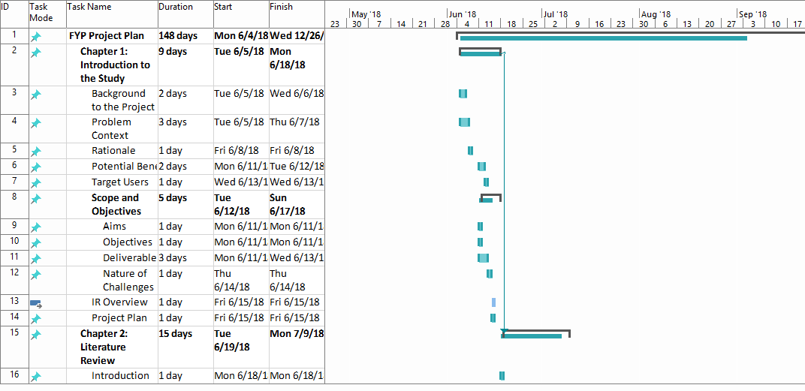

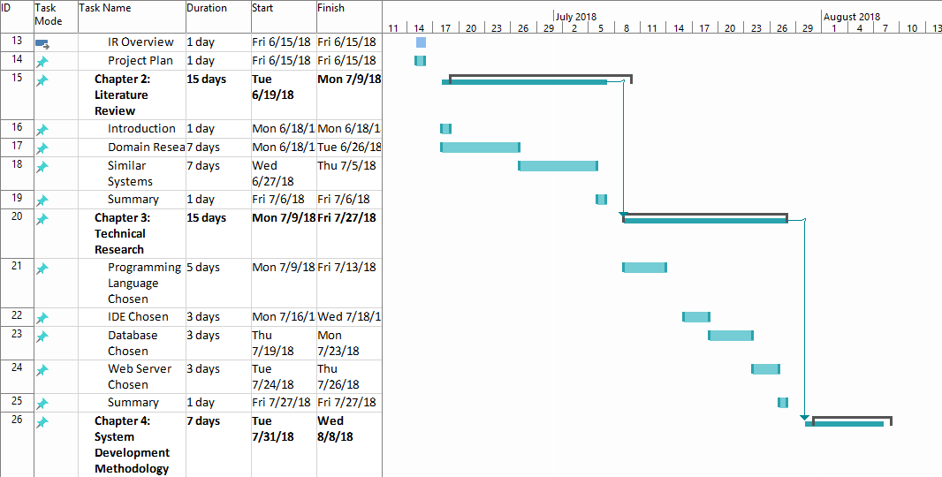

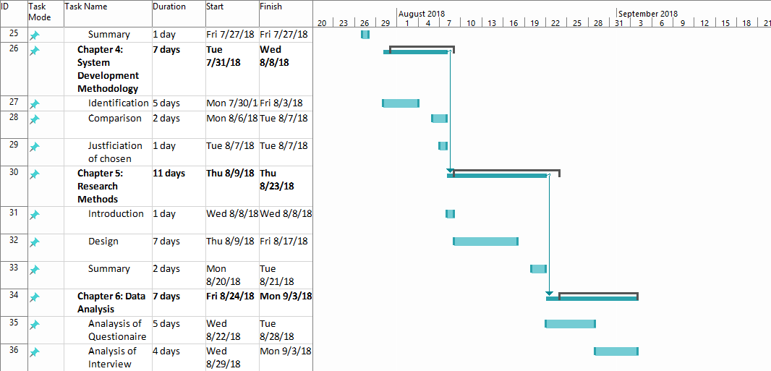

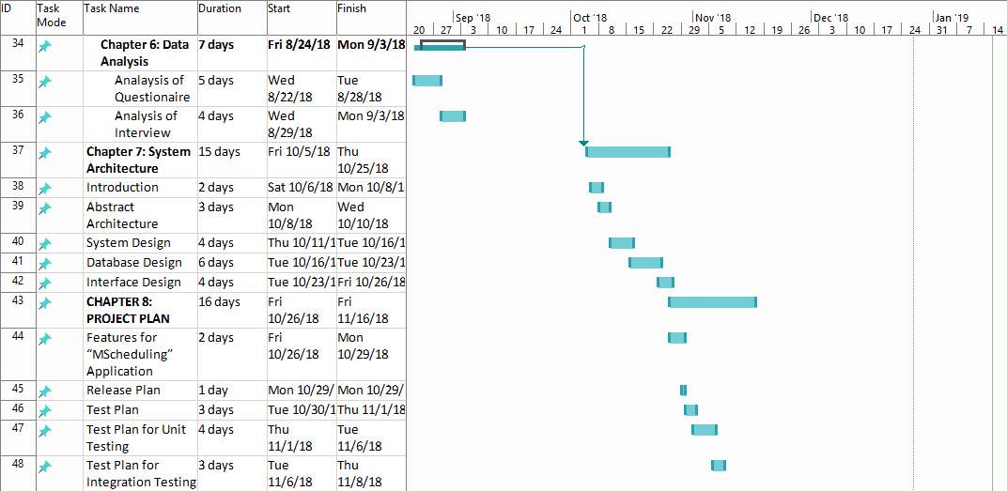

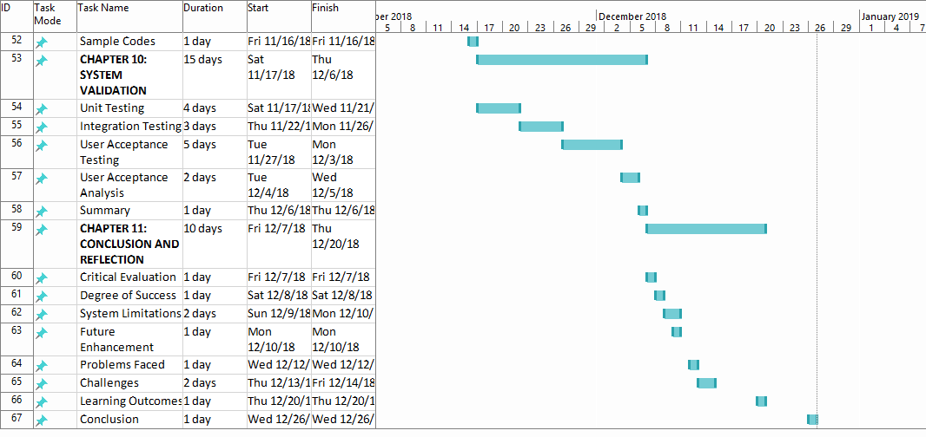

## Project Proposal Form (PPF)

FYP Title:

**Centralized Scheduling system for Lab Booking and lecturer’s Consultation Hour**

Introduction:

Scheduling time for lecturers and lab booking system is one of the most important administrative activities that take place in all academic institutions such as APU. The centralized scheduling system is an online based system that allows student to book consultation hour with lecturer to solve their problems and queries outside the class timetable. This centralized scheduling system will also help lecturer to book available computer lab and availability of their consultation hour with the student in an android application. In this system access is provided to both stuff and student.

The centralized scheduling is an online android application system that allows student to book consultation hour with the lecturer to solve their problems and queries outside the class timetable and for the lecturer this centralized lecturer scheduling system will help them for booking available computer lab, showing the timetable of the class and availability of their consultation hour for the student in an android application. Access is provided to both stuff and student in the system.

This android system considered more user-friendly than current web-based system. Security and integrity are well maintained within centralized scheduling system. This system will facilitate both the student and the lecturer. In this system Students can book their consultation hour with the lecturer and lecturers are able to book available computer lab for any additional classes or any changes of lab class. There is an auto generated email processing system in this centralized scheduling android application. Lecturer and student both will get an auto generated email once the booking has been confirmed or canceled.

Current lecturer scheduling system doesn’t provide lecturer timetable and available consultation hour in a single web-based system. It doesn’t synchronize with the system. So, lecturer need to open multiple tab for setting their available consultation timetable for the student where they need more time to do it.

On the other hand, the proposed system will show the class timetable to the lecturer in an android application system that they can easily set their available consultation hour for the student. Moreover, this system will help the student to see lecturer’s profile, their email address and office address as well.

The main purpose of the project is to develop an android application for centralized scheduling system to provide convenience in scheduling lecture time-table, available computer lab booking, lecturer’s consultation hour booking. This application will make the students life easier when they will book the consolation hour with the lecturer and on the other hand it will also help lecturers to reduce time to set their available consultation hour and available computer lab booking.

Problem Statement:

This centralized scheduling system would be the perfect platform of booking lecturer’s consultation hour and lab booking for any additional or replacement classes. Currently at Asia Pacific University (APU) consultation hour booking system is called ‘staff consultation hours system’ in the webspace. There are some features need to be enhanced for this project in an android application system to make it more user-friendly. In the webspace if lecturers want to set their available consultation hours, they need to open multiple tab for seeing their timetable and their available consultation hours which is very complicated and time effective. Everyday a lot of student book consultation hours with the lecturers at Asia Pacific University (APU). So, it is very important to maintain the lecturer’s consultation hour booking system in a well-managed and user-friendly way.

**High number of students:**

Due to the high number of lecturers to student ratio and with the limited time and lecture scope, it is not possible for the students to address all their queries in the classroom. Therefore, they require additional consultations with lecturers to address their issues. It becomes almost impossible for the lecturers to give effective feedback for everyone. In some instances, students could be performing well in some subjects but struggling in others, so they might need to book a consultation hour with the lecturers outside the classroom.

**Additional IT lab booking issue:**

Moreover, if any lecturer changes their lab class timetable or cancel any lab class, then the lecturer needs to take a replacement class, or an extra class for covering that module on time but there is no option for the lecturers to book an IT lab class in the current system. For this reason, lecturer need to go or send email to the admin people for booking an IT lab class if any lecturer need. Lecturer does not have any direct access to book the lab classes without going or sending email to admin staffs. The proposed system would be facilitating for booking an IT lab class directly from the centralized scheduling android application system which would be very helpful for the lecturers.

**Modification and changing difficulties:**

Maintaining time is very important for both the lecturers and the students for the academic purpose. A student or a lecturer can cancel or modify their consultation timing for some reason. There is no option of modifying consultation timing in the current system, they can only cancel the appointments. On the other hand, student who cancel or want to re-book the consultation hour again with due to have that lecturer’s busy schedule it’s very difficult to get that lecturer’s consultation hour again. So, the proposed system would be allowing the students and the lecturers to modify the appointment timing without doing cancelation. If there is any modification or cancelation on timing an auto generated email will send to both the lecturer and student. In addition, if anyone cancel or modify the consultation timing, they need to write the valid reason of cancelation or modification, that both can be satisfied and planed accordingly for their other work which is not facilitated in the current system.

1.3 Rationale

According to the problems stated before, having a user friendly and well managed centralized scheduling system can be a solution. In present days students and lecturers both want the centralized scheduling system (lecturer’s consultation hours and IT lab booking) to be easier to access and time effective. “MScheduling” is an android mobile application which will achieve the necessities of both the students and the lecturers. The mobile application will cover the requirement of both the lecture’s consultation hour booking and IT lab booking. Student will get the benefit of booking lecturer’s consultation hour easily and this system will also help the lectures to book available IT lab instead of going or sending mail to admin. The benefits of using the application is massive.

Project Aims:

The aim is to develop an android application and enhance the features of existing lecturer scheduling system which is used in APU by integrating IT Lab reservation, and Consultation Hour Booking.

Project Objectives

The objectives of this project are,

The objectives of this project are,

* To find out the problems which are faced by the lecturers and students while booking an IT lab or consultation hour and provide best solution based on the problem
* To develop an android application for centralized scheduling system which would be helping for lecturer’s consultation hour booking and IT lab reservation
* To design user-friendly interface in centralized scheduling system that everyone can use it without having any issues
* To create live chat system between lecturers and students for improving the communication
* To make an option for student for giving rating and feedback about the consultation hour which will improve the study system in a better way

Literature Review

SCHEDULING SYSTEM

In most educational institutions, the timetabling activity assumes considerable importance. First, as a result of this task, a set of attributions determining the entire daily activity of all the human resources involved, from students and teachers to employees, is drawn up. Secondly, alongside, a pattern of the use of the institutions physical resources is defined. (P. Carrasco & V. Pato, 05 September 2001). [Abramson & Abela 91] used some algorithms to pre-combine a class, teacher and room combination into a tuple and treat the tuple as an inseparable unit later. (Fang, 1994)

Educational timetabling problems need to be solved in schools, colleges and universities regularly. There are some similarities between these problems, for example, teacher/lecturers can only teach one group of students at a time and rooms have size limitations. However, there are also some key differences. Overall different educational timetabling problems can be divided into two mains categories: A timetabling problem is a problem with four parameters: T, a finite set of times R, a finite set of resources M, a finite set of meetings and C, a finite set of constraints. The problem is to assign times and resources to the meetings so as to satisfy the constraints as much as possible. (MirHassani & Habibi, February 2013).

During the last thirty years, starting with (Gotlieb 1963), many papers related to automated timetabling have been published in conferences proceedings and journals. In addition, several applications have been developed and employed with a good success. (Schaerf, April 1999)

The object behind making this web-based system is to make a user-friendly web-based system for the lecturer and students who can access easily. It will reduce the time and easy to maintain the class scheduling for lecturers. The goal is to minimize student clashes in a multi-disciplined scholastic environment, optimize the use of teaching facilities, and provide practical solution to better use resources and manage timetable constrains

CONSULTATION HOUR BOOKING:

Net four-tier architecture to the appointment management handling in the university/college environment. A Web based appointment management system called WBAMS is designed and implemented so that students and lecturers can arrange meetings in an effective and efficient way. (Ming Lu & Ab Hamid, 26 December 2007).

E-appointment is closely related to electronic booking, electronic reservation and other types of internet-mediated agreements on relations between time periods and resources in focus. Even though there is no clear-cut distinction, one could say that e-appointment emphasizes the agreement between two or more partners as social subjects while reservation and booking rather refers to physical resources (e.g. presentation room) or impersonal and/or highly standardized services (e.g. flight, secondary care treatment) (Klischewski, 2003). The system allows students and lecturers to simply gain access to the system by connecting to the Internet. It also enables students to any message which consists of the purpose and time of the appointment. The system was developed using Hypertext Markup Language (HTML5), Hypertext Pre-processor (PHP) as scripting language, Bootstrap framework and My Structured Query Language (MySQL) as database. This will enable the web application to be robust, cheap and capable of operating on various platforms. The system does not only fully automated, and perform excellently well, but also user-friendly, time effective and efficient. (Ridwan, et al., 2016)

One common software that be used to achieve this is Microsoft Outlook. But still there are some drawbacks which include human involvement towards recording of appointment, cancellation, confirmation and reschedule etc. Of course, these systems possess one advantage which is the automatic reminder only. Though ICT has played a good role in appointment scheduling, still there is no automation in appointment scheduling system. (Parchment1, Sankaranarayanan 2013)

Based on literature review an institution use consultation hour booking system to get some benefits such as See upcoming consultations, book consultations, see the consultations that has already booked, cancel or make changes to the current consultations etc. To give direct help to students, consolation hour is very important for the lecturers.

LAB RESERVATION SYSTEM:

The lab booking system can be designed and implemented through the investigation and analysis on the need of the management of the laboratory in Xinzhou Teachers’ College. With the auxiliary of the website news model, the system has realized the operation of four functional models: registering, appointment of users, messages of users and backstage management. The realization of the system will be conducive to the modern management of laboratory. (Li_min, et al., 2003)

A multi-layer feed forward neural network is trained on speech examples with known reverberation times generated by a room simulator. The speech signals are prepossessed by calculating short-term rms values. A second decision-based neural network is added to improve the reliability of the predictions. In the retrieve phase, the trained neural networks extract room reverberation times from speech signals picked up in the rooms to an accuracy of 0.1 s. This provides an alternative to traditional measurement methods and facilitates the occupied measurement of room reverberation times. (Darlington, et al., April 1, 2001).

From the findings, it aims to provide an efficient and convenient way of reserving rooms for all the individuals involved. By hosting the service online, the entire flow of the reservation system will not be greatly affected by the absence of important individuals. online booking system should have at least one screen where we can see the availability very quickly and clearly.

Deliverables:

Target users:

• Students

• Staffs/Admin

Allowance of the students to the system:

* To log in to the system
* To log out from the system
* To see the lecturer’s available consultation hours
* To book/cancel the consultation hour
* To see the lecturer’s timetable
* To see the lecturer’s profile

Allowance of the staffs/Admin to the system:

* To log in to the system
* To log out from the system
* To their available consultation hour
* To manage the additional lab booking if required
* To cancel the consultation hour.
* To modify the consultation hour

Propose the name of your supervisor:

1. Dr Vazeeruddin Abdul Hameed

2. Umapathy Eaganathan

3. Dr. Sumaira Muhammad Hayat Khan

## Project Specification Form (PSF)

STUDENT ID :  TP039768

INTAKE ID :  UC3F1805SE

STUDENT NAME :  MD EASIR ARAFAT

Project Title:

**Centralized Scheduling system for Lab Booking and lecturer’s Consultation Hour**

**B: Brief description on project background. (.i.e. problem context, rationale, description of problem area, nature of challenge) (Word limit: 1000 )**

Project Background

This centralized scheduling system would be the perfect platform of booking lecturer’s consultation hour and lab booking for any additional or replacement classes. Currently at Asia Pacific University (APU) consultation hour booking system is called ‘staff consultation hours system’ in the webspace. There are some features need to be enhanced for this project in an android application system to make it more user-friendly. In the webspace if lecturers want to set their available consultation hours, they need to open multiple tab for seeing their timetable and their available consultation hours which is very complicated and time effective. Everyday a lot of student book consultation hours with the lecturers at Asia Pacific University (APU). So, it is very important to maintain the lecturer’s consultation hour booking system in a well-managed and user-friendly way.

**High number of students:**

Due to the high number of lecturers to student ratio and with the limited time and lecture scope, it is not possible for the students to address all their queries in the classroom. Therefore, they require additional consultations with lecturers to address their issues. It becomes almost impossible for the lecturers to give effective feedback for everyone. In some instances, students could be performing well in some subjects but struggling in others, so they might need to book a consultation hour with the lecturers outside the classroom.

**Additional IT lab booking issue:**

Moreover, if any lecturer changes their lab class timetable or cancel any lab class, then the lecturer needs to take a replacement class, or an extra class for covering that module on time but there is no option for the lecturers to book an IT lab class in the current system. For this reason, lecturer need to go or send email to the admin people for booking an IT lab class if any lecturer need. Lecturer does not have any direct access to book the lab classes without going or sending email to admin staffs. The proposed system would be facilitating for booking an IT lab class directly from the centralized scheduling android application system which would be very helpful for the lecturers.

**Modification and changing difficulties:**

Maintaining time is very important for both the lecturers and the students for the academic purpose. A student or a lecturer can cancel or modify their consultation timing for some reason. There is no option of modifying consultation timing in the current system, they can only cancel the appointments. On the other hand, student who cancel or want to re-book the consultation hour again with due to have that lecturer’s busy schedule it’s very difficult to get that lecturer’s consultation hour again. So, the proposed system would be allowing the students and the lecturers to modify the appointment timing without doing cancelation. If there is any modification or cancelation on timing an auto generated email will send to both the lecturer and student. In addition, if anyone cancel or modify the consultation timing, they need to write the valid reason of cancelation or modification, that both can be satisfied and planed accordingly for their other work which is not facilitated in the current system.

Rationale:

According to the problems stated before, having a user friendly and well managed centralized scheduling system can be a solution. In present days students and lecturers both want the centralized scheduling system (lecturer’s consultation hours and IT lab booking) to be easier to access and time effective. “MScheduling” is an android mobile application which will achieve the necessities of both the students and the lecturers. The mobile application will cover the requirement of both the lecture’s consultation hour booking and IT lab booking. Student will get the benefit of booking lecturer’s consultation hour easily and this system will also help the lectures to book available IT lab instead of going or sending mail to admin. The benefits of using the application is massive.

There will be two types of benefits from the application are given bellow:

Tangible Benefits:

* Students do not need to browse website for booking the lecturer’s consultation hour.
* Students can see the lecturer’s profile and office address.
* Students would always have the access to modify the consultation timing with lecturers.
* Lecturers don’t need to visit admin for booking available IT lab.
* Reduce workload of the lecturers and the admin staffs. Admin stuffs do not need to help all the lecturers separately.

Intangible Benefits:

* Influence on more students to come to the lecturer for consultation hour by making the process of the scheduling system easier and user friendly.
* Improve the student-lecturer relation between them and efficient learning system.
* Reduce the complication of lab booking system and give an easy access to reduce lecturers wasting time on booking IT lab.

Nature of Challenge:

It’s not an easy task to make an android application for centralized scheduling system. Firstly, it’s very important to select the appropriate programming language for making this android mobile application. As every programming language has their exact functionalities and usability. Secondly, it’s another important thing for me to learn the specific language to develop a user-friendly application that I can ensure to the user that there is no way of facing difficulties while they will be using the system. Moving on to the next phase, the database is going to be another challenge for this project. Lastly, security maintenance is one of the most important things in this application. I must learn how can I make it secure. It becomes a popular way to make an android application by using android studio where I can implement java language as well.

**C: Brief description of project objectives. (i.e. scope of proposal and deliverables) (Word limit: 1000)**

Project Objectives:

* To find out the problems which are faced by the lecturers and students while booking an IT lab or consultation hour and provide best solution based on the problem
* To develop an android application for centralized scheduling system which would be helping for lecturer’s consultation hour booking and IT lab reservation
* To design user-friendly interface in centralized scheduling system that everyone can use it without having any issues
* To create live chat system between lecturers and students for improving the communication
* To make an option for student for giving rating and feedback about the consultation hour which will improve the study system in a better way

Deliverables

Centralized scheduling system is an online android mobile application which helps lecturers and students to book consultation hour and available IT lab with some additional features. After successfully making this application they no longer be suffering of facing any problem for using this application which they experienced before. An android device is required for the user to run this application. The main activities of this application are to give a connivance and easy way to book lecturer’s consultation hours and IT lab booking.

Some of the functionalities of this application are given below:

* To log in the system (students/lecturers)
* To log out from the system (students/lecturers)
* To show students the available consultation hour (students)
* Allow user to modify their consultation hour (students/lecturers)
* Allow user to cancel their consultation hour (students/lecturers)
* Allow students to give feedback on consultation hour (students)
* Allow lecturer to book available IT lab. (lecturers)
* An email notification will send if there is any modification and cancellation (students/lecturers)

Besides that, the additional features of the system are given below:

* Allow user (students) to view lecturer academic prolific information that they can communicate easily with the lecturers.
* Apart from that, the special features of the system will be added if there is any extra time:
* Allow users to get the mobile or email SMS notification once the booking has been made or cancelled.

**D: Brief description of the resources needed by the proposal (i.e. hardware, software, access to information / expertise, user involvement etc.) (Word limit: 1000)**

Basically, there are two types of hardware which will be desired for developing and testing this mobile application. Computer and the Smart Phone are that two hardware. The least requirements for both hardware is given below:

Smart Phone:

• Android OS 2.3

• Camera

• Touchscreen

• 3G, 4G or Wi-Fi Network

Computer:

• Monitor

• Keyboard

• Mouse

• Wi-Fi

• Intel Core 2 Duo Processor – 2.6 GHz

• 200GB Hard Drive

• Min 1GB RAM

Software:

For developing this android mobile application there are two types of software are required. And The data database management is essential, and a software is required for coding.

The minimum requirements for software are given underneath:

Coding and Developing:

• Android Studio 3.0.1

• Visual Studio 2013 Professional

Database Management System (DBMS):

• Cloud Firestore

Project Planning:

• Microsoft Word 2016

• Microsoft Project 2016 Software Documentation

Access to information / expertise

To build this project successfully, proper consultation from the IT expert will be needed. Consultation from supervisors and lecturer’s guidance are very much important for developing this centralized scheduling system android application. Apart from that, internet is a source of gathering huge knowledge of developing an android application.

User Involvement

The people who will be involving with this application are the lecturers and the students. Discussion need to be conducted with experts, students and the lecturers to acquire knowledge on troubleshooting. For testing this application there will be few more people involved.

**E: Academic research being carried out and other information, techniques being learned (i.e. what are the names of books you are going to read / data sets you are going to use) (Word limit: 1000)**

In order to carry out the deliverables, the preliminary list of books and websites that the developers will follow for the research are as follows:

Books:

* + Name: Android Application Development for Dummies
  + Author: Donn Felker & Micheal Burton
  + Publisher: John Wiley & Sons, Inc
  + Name: Sams Teach Yourself Android Application Development in 24 Hours
  + Author: Lauren Darcey
  + Publisher: Sams Pub., 2010
  + Name: Java SE7 Programming Essentials
  + Author: Micheal Emest
  + Publisher: John Wiley & Sons, Inc

Online Resources:

* raywenderlich, 2018. raywenderlich. [Online]

Available at: https://www.raywenderlich.com/category/android [Accessed 2018].

* Developers, A., n.d. Android Developers. [Online]

Available at: https://developer.android.com/training/basics/firstapp/creating-project.html

**F: Brief description of the development plan for the proposed project. (i.e. which software methodology and why, the major areas of functions to be developed and the order in which developed) (Word limit: 1000)**

There are few types of methodology like SCRUM, RAD, waterfall, Agile, etc. can be used for developing and testing this mobile android application. From my point of view Agile is most suitable methodology for developing this android application. A style of project management that focuses on early delivery of business value, continues improvement of the project’s product and process, scope flexibility, team input and delivering well tested products that reflect customer needs (Layton, 2012).

It very easy to control and planning the process of development by following Agile methodology. Agile methodology helps to decrease the wasting of time on unnecessary processes. It is also time and cost effective. Agile methodology also supports to build a solid connection among the developer and the clients because of the regular testing of the application.

**G: Brief description of the evaluation and test plan for the proposed project. (i.e. what is the success criteria and how will be evaluated & implementation will be tested, indicate the estimated size of the demonstration/test database) (Word limit: 1000)**

Evaluation and test plan for the proposed project

Success Criteria

The main goal of this project is to make an easy consultation system and lab booking system for improving the study environment. The success of this system would rely on the number of people involve of it in the academic environment. To make sure assumed features are working accurately and running well, the application will be used by the APU lecturers and students.

Few lecturers and students would use this application first to bring out succeeding testing methods and feedback from them will be improved the application before its final deployment.

Unit Testing:

During unit testing the whole application will be tasted separately into small testable component. All these units essential to go through a testing stage before integrated into a component. Unit testing involves only those characteristics that are vital to the performance of the unit under test. Once all the units in a program have been found to be working in the most efficient and error-free manner possible, larger components of the program can be evaluated by means of integration testing. (Rouse, 2008)

Integration Testing:

Integration testing is an approach where modules are developed, and testing of modules always starts at the finest level of the programming hierarchy and continues towards the lower levels. It’s the extension to unit testing. Integration testing takes smaller unit of unit testing and tests their behavior as the whole (Guruswamy, 2015). The object of this level of testing is to find any faults in the communication between these integrated units. during integration testing, there are two tested units will be integrated into a component. For instance, when the lecturers and students will cancel or modify the consultation timing hours from the back-end, from the system new data will be stored into the database.

Usability Testing:

The goal is to find any usability difficulties, gather qualitative and quantitative data and control the participant's satisfaction with the product. After building the prototype of the system the method is usually taken. The user gratification level needs to be carried out in usability testing. People who are involved in this testing would essentially run the program and they will get the real impression of an accomplished project

References

Wasserman , A. . I., 2010. Software Engineering Issues for Mobile Application. *ACM DIGITAL LIBRARY,* pp. 397-400.

A. Allison , L., 2016. Inter-App Communication between Android Apps. *ACM International Conferance,* pp. 17-18.

Abrahamsson, P. et al., 2004. Mobile-D: An Agile Approach for Mobile Application. *ACM DIGITAL LIBRARY,* pp. 174-175.

Ambler, S. W., 2014. *Agile Modeling.* [Online]   
Available at: http://agilemodeling.com/essays/agileDesign.htm  
[Accessed 4 September 2018].

Anon., n.d. *Android Developers.* [Online]   
Available at: https://developer.android.com/training/basics/firstapp/creating-project

Anon., n.d. *reywenderlich.com.* [Online]   
Available at: https://www.raywenderlich.com/

Darlington, P., Cox, T. J. & Li, F., April 1, 2001. Extracting Room Reverberation Time from Speech Using Artificial Neural Networks. *Audio Engineering Socity,* pp. 219-230.

Genc-Nayebi, N. & Abran, A., 2017. A systematic literature review: Opinion mining studies from mobile. *ScienceDirect,* Volume 125, pp. 207-219.

Guruswamy, P., 2015. *Design the Beganing.* [Online]   
Available at: https://www.linkedin.com/pulse/why-integration-testing-important-software-life-cycle-guruswamy

Ines, G., Makram, S., Mabrouka, C. & Mourad, A., 2017. Evaluation of Mobile Interfaces as an Optimization Problem. *ScienceDirect,* Volume 112, pp. 235-248.

Kaleel, S. B. & Harishankar, S., 2013. Applying Agile Methodology in Mobile Software. *Computer Science Technical Report,* pp. 1-11.

Kats, L. . C. L., Vogelij∗, R. G., Kalleberg, K. T. & Visser, E., 2012. Software Development Environments on the Web. *ACM DIGITAL LIBRARY,* pp. 99-116.

Klischewski, R., 2003. The Challenges of e-Appointment. *Hamburg University, Informatics Department ,* pp. 1-5.

Layton, M. C., 2012. *Agile Project Management For Dummies.* s.l.:Wiley.

Li_min, X., Bing_ying, L. & Ze_tao, J., 2003. Design and Implementation of the Lab Booking System. *NKI.*

Ming Lu , K. & Ab Hamid, S. H., 26 December 2007. Conceptual Design of Web-Based Appointment Management System using Object WebML. *IEEE Xplore Digital Library.*

Nam Kim, S., Cavedon, L. & Baldwin , T., 2010. Classifying dialogue acts in one-on-one live chats. *ACM DIGITAL LIBRARY,* Volume 09 - 11, pp. 862-871.

Nasution, A. I., 2015. *International Journal of Computer Science and Information Technology Research,* 3(4), pp. 112-118.

Oluwatosin, H. S., 2014. Client-Server Model. *Journal of Computer Engineering ,* 16(1), pp. 67-71.

O. et al., 2016. Student-Teacher Online Booking Appointment System in Academic Institutions. *ProQuest,* 9(2), p. 15.

Padhya, B., Desai, P. & Pawade, P. D., August 2016. Comparison of Mobile Operating Systems. *International Journal of Innovative Research in Computer,* 4( 8), pp. 15281-152086.

Parchment1, D. & Sankaranarayanan , S., 2013. Intelligent Agent based Student-Staff Scheduling. *International Journal of Computer Information Systems and Industrial Management Applications. ,* pp. 384-404.

Rouse, M., 2008. *Unit Testing.* [Online]   
Available at: https://searchsoftwarequality.techtarget.com/definition/unit-testing

Schmitt, C., Anliker, C. & Stiller, B., 2016. Pull Support for IoT Applications using Mobile Access Framework WebMaDa. *IEEE,* Issue 2016-12, pp. 377-382.

## Fast-track ethical approval form

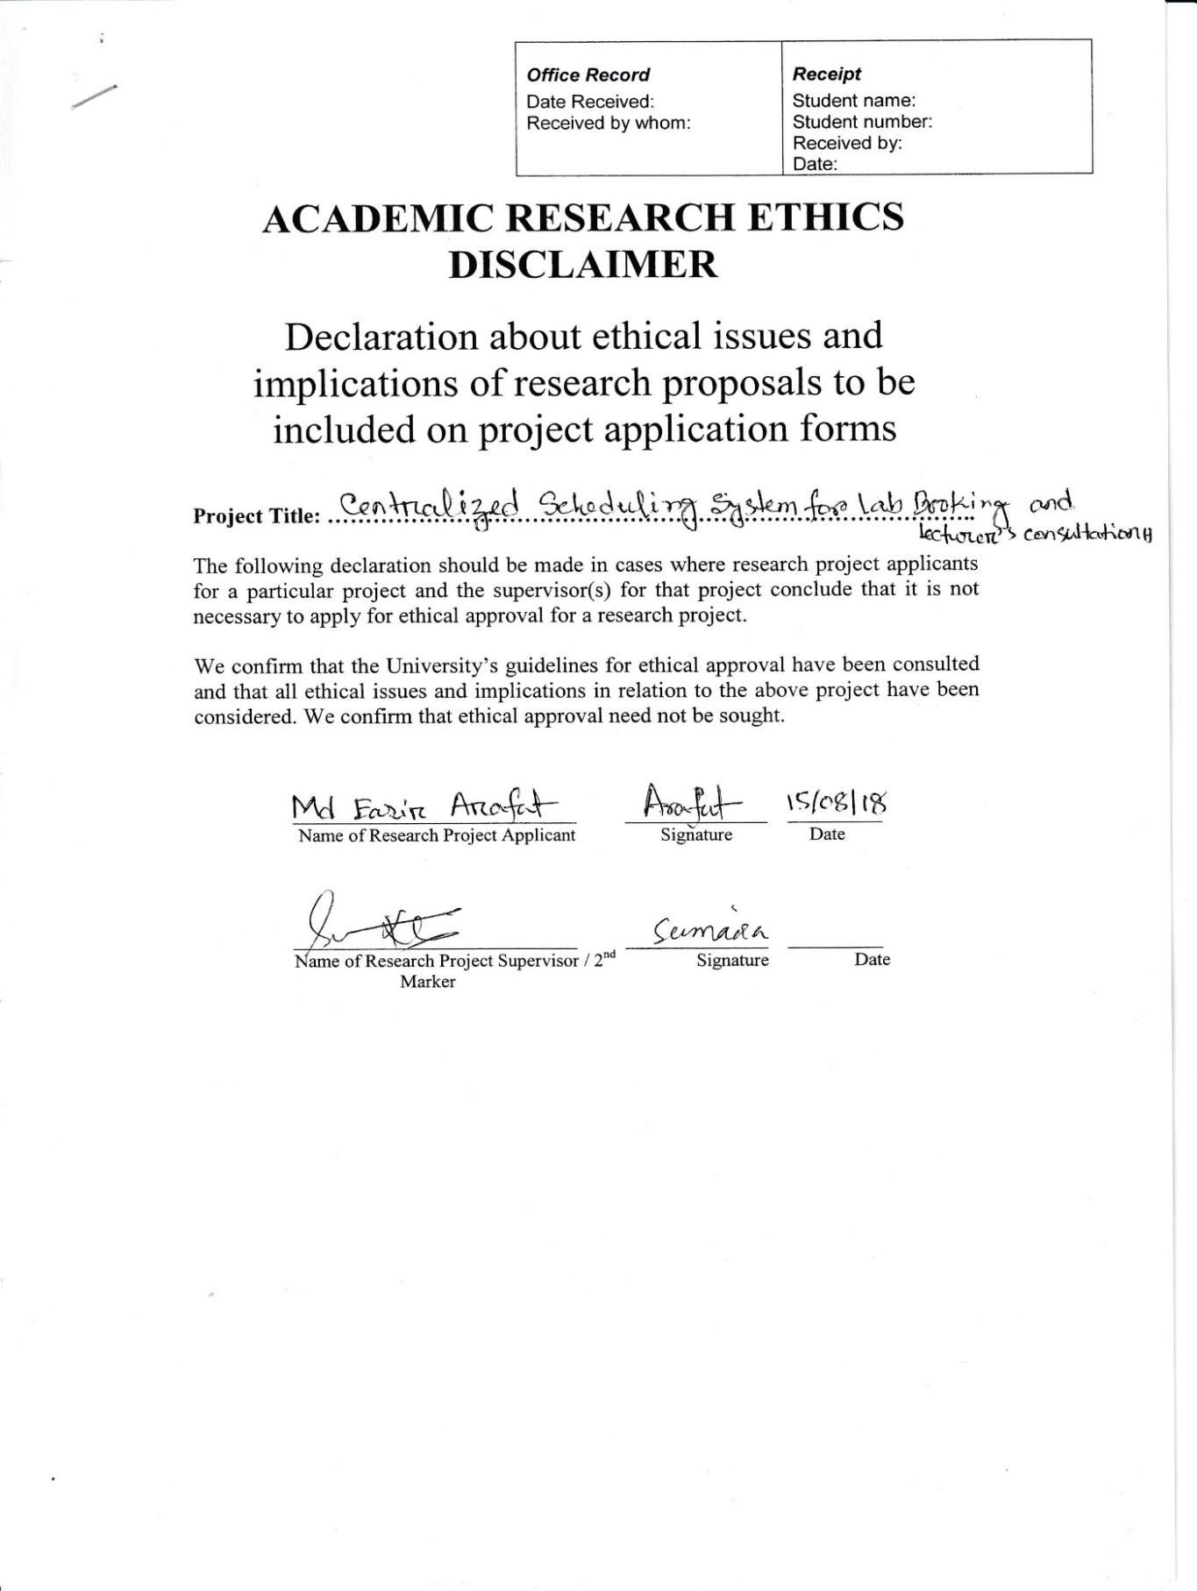

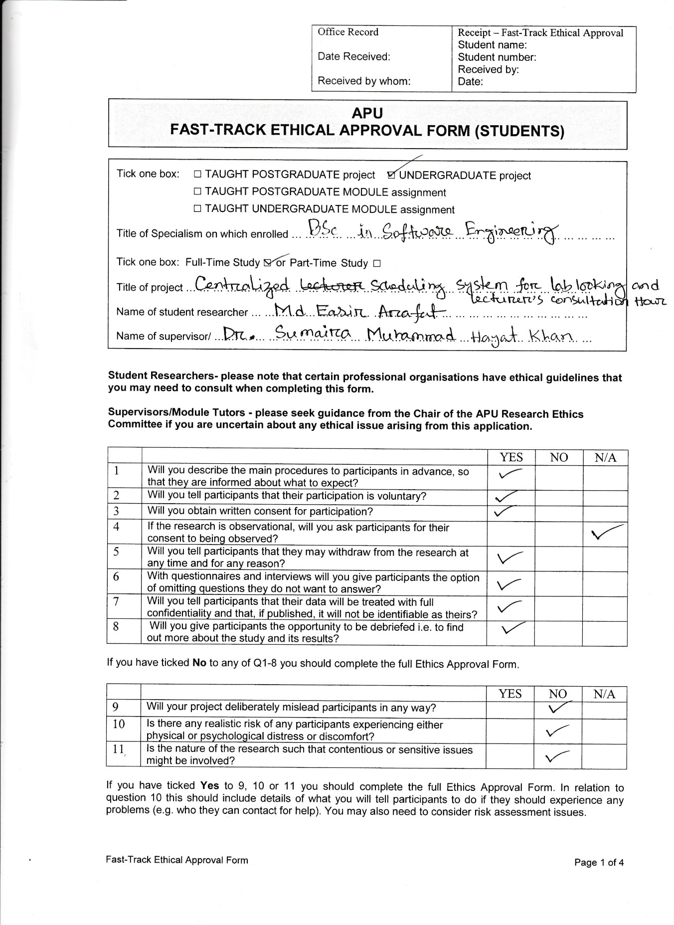

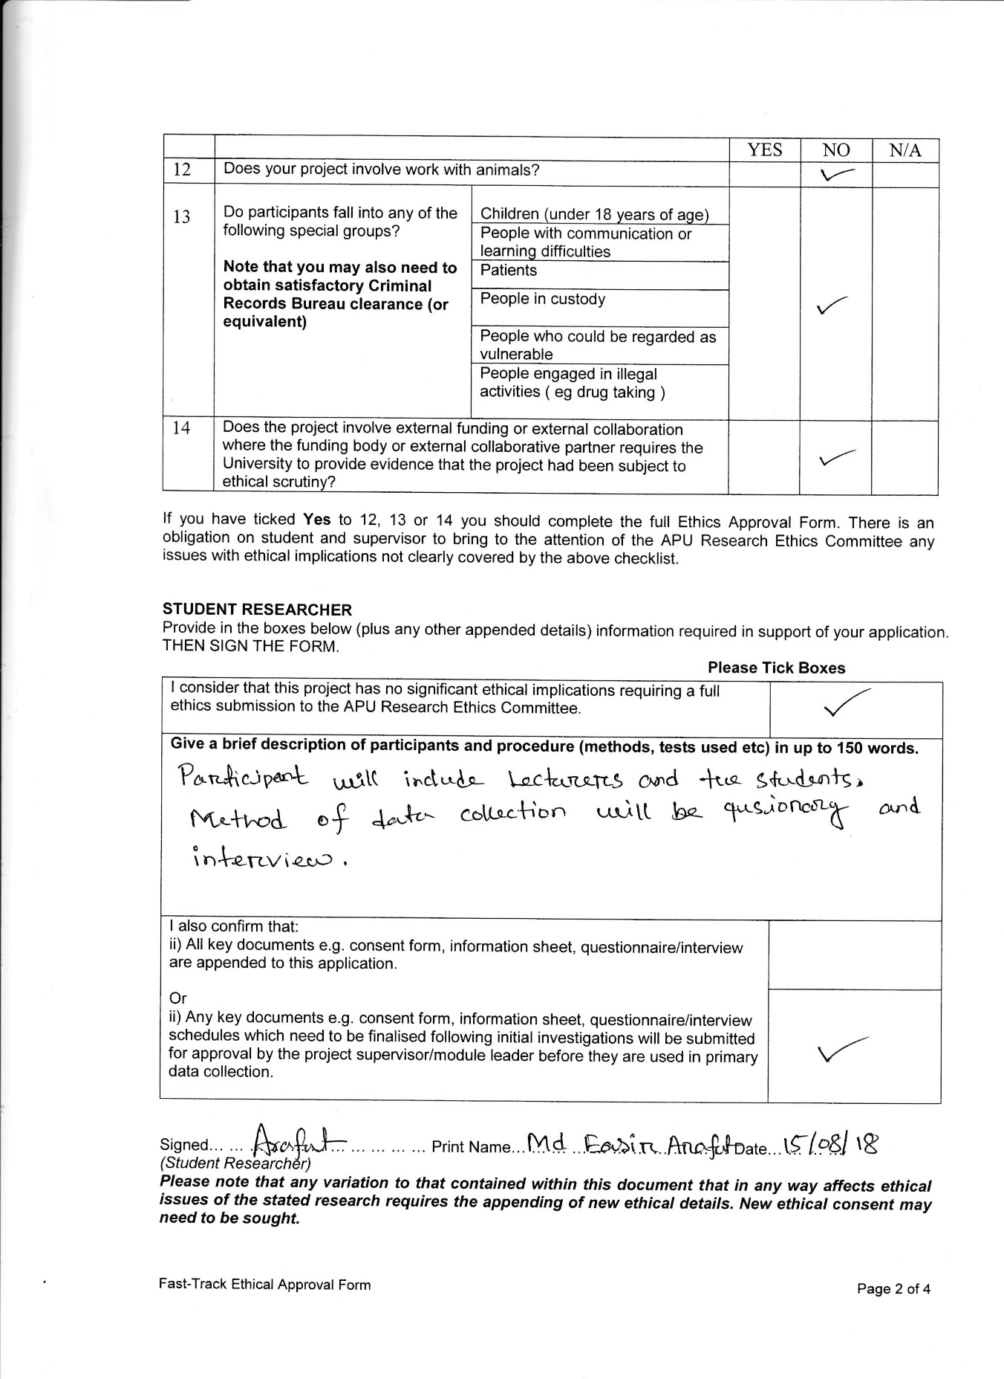

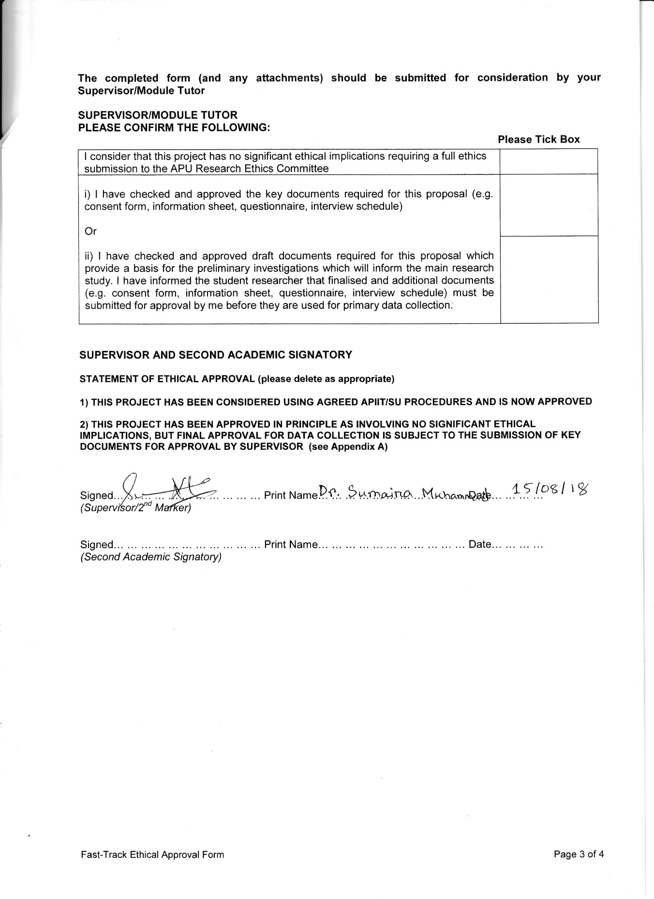

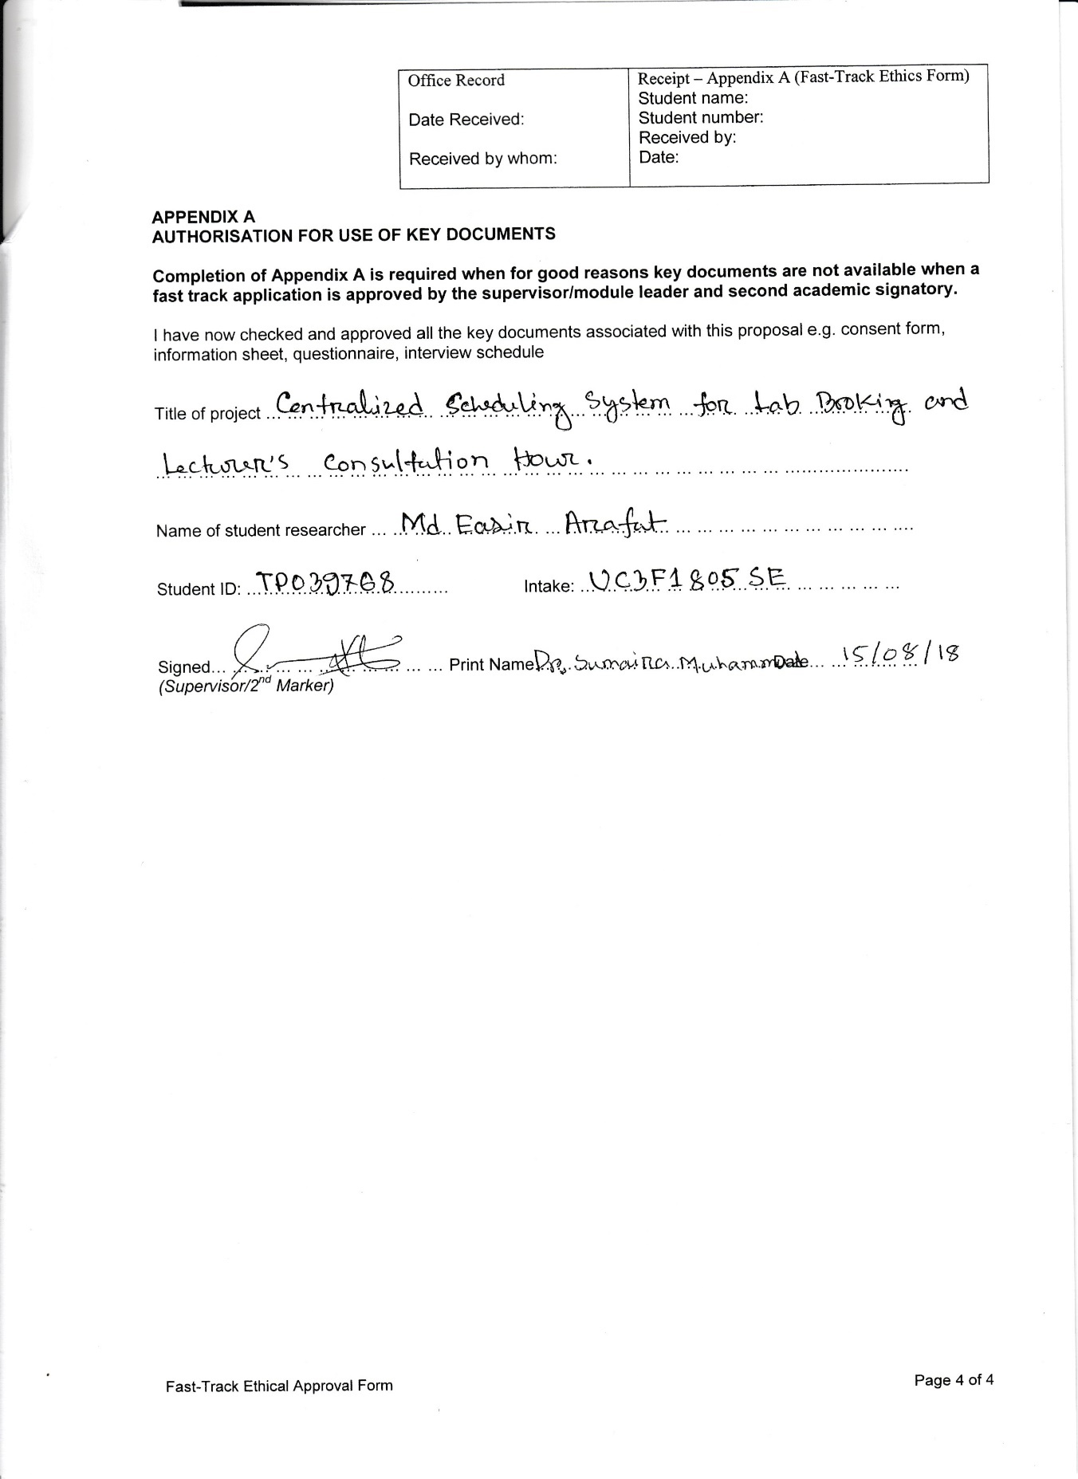

## Project Log Sheet – Supervisory Session

